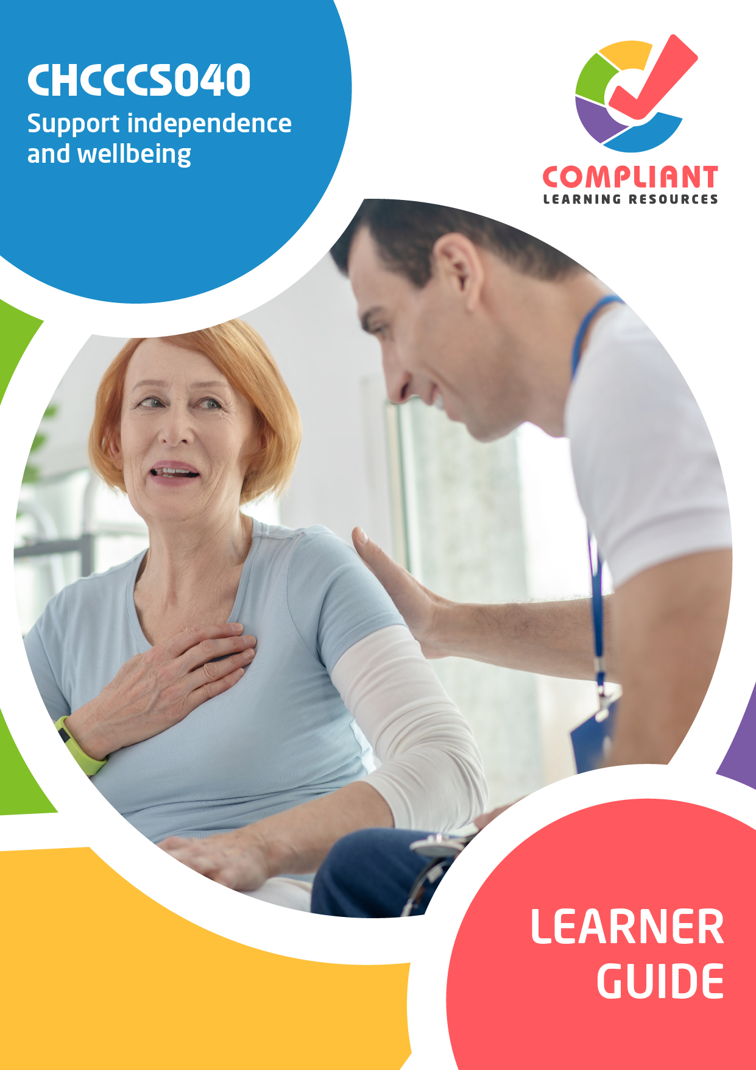

**Copyright**

This document was developed by Compliant Learning Resources.

© 2023 Compliant Learning Resources.

All rights reserved.

No part of this publication may be reproduced, stored in a retrieval system, or transmitted in any form or by any means, electronic, mechanical, photocopying, recording or otherwise without the prior written permission of Compliant Learning Resources.

**Version Control & Document History**

|  |  |  |
| --- | --- | --- |
| **Date** | **Summary of Modifications** | **Version** |
| 22 December 2022 | Version 1.0 released for publishing | 1.0 |
| 14 April 2023 | Version 1.1 released for publishing  Minor revisions for improved readability | 1.1 |
| 25 May 2023 | Version 1.2 endorsed for use  Added brief discussions to Section 4.8.2 | 1.2 |
| 22 June 2023 | Version 1.3 endorsed for use  Updated broken links | 1.3 |
| 22 August 2023 | Version 1.4 endorsed for use  Fixed wording issues | 1.4 |

# Table of Contents

This Learner Guide 5

Introduction 13

I. Recognise and Support Individual Differences 36

1.1 Recognise and Respect the Person’s Social, Cultural and Spiritual Differences 37

**1.1.1 Recognising Social, Cultural and Spiritual Differences** 39

**1.1.2 Respecting Social, Cultural and Spiritual Differences** 41

1.2 Avoid Imposing Views and Support the Person’s Expression of Identity and Preferences 44

**1.2.1 Avoiding Imposition of Own Values and Attitudes on Others** 49

**1.2.2 Supporting the Person to Express Their Own Identity and Preferences** 50

1.3 Consider the Individual Needs, Stage of Life, Development and Strengths for Support Activities 53

1.4 Recognise, Respect and Accommodate the Expression of Identity and Sexuality According to Maturity 60

1.5 Promote and Facilitate Participation in Activities That Reflect the Person’s Individual Needs 68

II. Promote Independence 74

2.1 Help the Person to Identify and Acknowledge Their Strengths and Self-Care Capacity 76

**2.1.1 Supporting the Person in Identifying Their Own Strengths and Self-Care Capacity** 76

**2.1.2 Supporting the Person in Acknowledging Their Strengths and Self-Care Capacity** 80

2.2 Help Find Opportunities That Use Their Strengths and Communicate Available Support 83

2.3 Inform and Assist the Person in Accessing Support Services and Resources 86

**2.3.1 Informing the Person on How to Access Support Services and Resources** 93

**2.3.2 Assisting the Person to Access Support Services and Resources** 97

2.4 Provide Support That Allows Appropriate Self-Management of Own Service Delivery 99

2.5 Encourage the Person to Build, Strengthen and Maintain Independence 102

III. Support Physical Wellbeing 106

3.1 Promote and Encourage Daily Living Habits That Contribute to Healthy Lifestyle 109

3.2 Support and Assist the Person to Maintain a Safe and Healthy Environment 114

3.3 Recognise Hazards and Report According to Organisational Policies and Procedures 120

3.4 Identify and Report Variations in a Person’s Physical Condition 125

3.5 Recognise and Report Physical Indications that May Affect the Person’s Wellbeing 129

3.6 Identify and Report Physical Health Situations Beyond Scope of Your Role 132

IV. Support Social, Emotional and Psychological Wellbeing 138

4.1 Promote Self-Esteem and Confidence Using Positive and Supportive Communication 140

4.2 Contribute to the Person’s Sense of Security Using Safe and Predictable Routines 143

4.3 Encourage and Facilitate Participation in Activities According to Networks and Preferences 146

4.4 Identify and Seek Help on Aspects of Support Work Outside the Scope of Job Role 152

4.5 Identify and Report Variations to a Person’s Wellbeing 155

4.6 Identify Cultural or Financial Issues Impacting on the Person’s Wellbeing 158

4.7 Identify the Person’s Risk and Protective Factors About Mental Health 162

4.8 Recognise and Report Abuse or Neglect on the Person 168

**4.8.1 Recognising Possible Indicators of Abuse or Neglect** 168

**4.8.2 Reporting of Possible Indicators of Abuse or Neglect** 174

4.9 Identify and Report Situations Beyond Scope of Your Own Role 181

References 185

# This Learner Guide

CHCCCS040 - Support independence and wellbeing (Release 1)

This unit describes the skills and knowledge required to provide individualised services in ways that support independence, as well as physical and emotional wellbeing.

This unit applies to workers in a range of community services contexts who provide frontline support services within the context of an established individualised plan.

The skills in this unit must be applied in accordance with Commonwealth and State/Territory legislation, Australian/New Zealand standards and industry codes of practice.

No occupational licensing, certification or specific legislative requirements apply to this unit at the time of publication.

A complete copy of the above unit of competency can be downloaded from the TGA website:

<https://training.gov.au/Training/Details/CHCCCS040>

About this Unit of Competency Introduction

As a worker, a trainee, or a future worker, you want to enjoy your work and become known as a valuable team member. This unit of competency will help you acquire the knowledge and skills to work effectively as an individual and in groups. It will give you the basis to contribute to the goals of the organisation which employs you.

It is essential that you begin your training by becoming familiar with the industry standards to which organisations must conform.

This Learner Guide Covers

Support independence and wellbeing

1. Recognise and support individual differences
2. Promote independence
3. Support physical wellbeing
4. Support social, emotional and psychological wellbeing

Learning Program

As you progress through this unit of study, you will develop skills in locating and understanding an organisation’s policies and procedures. You will build up a sound knowledge of the industry standards within which organisations must operate. You will become more aware of the effect that your own skills in dealing with people have on your success or otherwise in the workplace. Knowledge of your skills and capabilities will help you make informed choices about your further study and career options.

**Additional Learning Support**

To obtain additional support you may:

* Search for other resources. You may find books, journals, videos and other materials which provide additional information about topics in this unit.
* Search for other resources in your local library. Most libraries keep information about government departments and other organisations, services and programs. The librarian should be able to help you locate such resources.
* Contact information services such as Infolink, Equal Opportunity Commission, Commissioner of Workplace Agreements, Union organisations, and public relations and information services provided by various government departments. Many of these services are listed in the telephone directory.
* Contact your facilitator.

**Facilitation**

Your training organisation will provide you with a facilitator. Your facilitator will play an active role in supporting your learning. Your facilitator will help you at any time during working hours to assist with:

* How and when to make contact
* What you need to do to complete this unit of study
* What support will be provided

Here are some of the things your facilitator may do to make your study easier:

* Give you a clear visual timetable of events for the semester or term in which you are enrolled, including any deadlines for assessments
* Provide you with online webinar times and availability
* Use ‘action sheets’ to remind you about tasks you need to complete, and updates on websites
* Make themselves available by telephone for support discussion and provide you with industry updates by email where applicable
* Keep in touch with you during your studies

**Flexible Learning**

Studying to become a competent worker is an interesting and exciting thing to do. You will learn about current issues in this area. You will establish relationships with other students, fellow workers, and clients. You will learn about your own ideas, attitudes, and values. You will also have fun. (Most of the time!)

At other times, studying can seem overwhelming and impossibly demanding, particularly when you have an assignment to do and you aren’t sure how to tackle it, your family and friends want you to spend time with them, or a movie you want to see is on television.

Sometimes being a student can be hard.

Here are some ideas to help you through the hard times. To study effectively, you need space, resources, and time.

**Space**

Try to set up a place at home or at work where you can:

* Keep your study materials
* Be reasonably quiet and free from interruptions
* Be reasonably comfortable, with good lighting, seating, and a flat surface for writing.

If it is impossible for you to set up a study space, perhaps you could use your local library. You will not be able to store your study materials there, but you will have a quiet place, a desk and chair, and easy access to the other facilities.

**Study Resources**

The most basic resources you will need are:

* A chair
* A desk or table
* A computer with Internet access
* A reading lamp or good light
* A folder or file to keep your notes and study materials together
* Materials to record information (pen and paper or notebooks, or a computer and printer)
* Reference materials, including a dictionary

Do not forget that other people can be valuable study resources. Your fellow workers, work supervisor, other students, your facilitator, your local librarian, and workers in this area can also help you.

**Time**

It is important to plan your study time. Work out a time that suits you and plan around it. Most people find that studying, in short, concentrated blocks of time (an hour or two) at regular intervals (daily, every second day, once a week) is more effective than trying to cram a lot of learning into a whole day. You need time to ‘digest’ the information in one section before you move on to the next, and everyone needs regular breaks from study to avoid overload. Be realistic in allocating time for study. Look at what is required for the unit and look at your other commitments.

Make up a study timetable and stick to it. Build in ‘deadlines’ and set yourself goals for completing study tasks. Allow time for reading and completing activities. Remember that it is the quality of the time you spend studying rather than the quantity that is important.

**Study Strategies**

Different people have different learning ‘styles’. Some people learn best by listening or repeating things out loud. Some learn best by ‘doing’, some by reading and making notes. Assess your own learning style and try to identify any barriers to learning which might affect you. Are you easily distracted? Are you afraid you will fail? Are you taking study too seriously? Not seriously enough? Do you have supportive friends and family? Here are some ideas for effective study strategies:

1. **Make notes.** This often helps you to remember new or unfamiliar information. Do not worry about spelling or neatness, as long as you can read your own notes. Keep your notes with the rest of your study materials and add to them as you go. Use pictures and diagrams if this helps.
2. **Underline keywords** when you are reading the materials in this Learner Guide. (Do not underline things in other people’s books.) This also helps you to remember important points.
3. **Talk to other people** (fellow workers, fellow students, friends, family, or your facilitator) about what you are learning. As well as help you to clarify and understand new ideas, talking also gives you a chance to find out extra information and to get fresh ideas and different points of view.



**Using this Learner Guide**

A Learner Guide is just that, a guide to help you learn. A Learner Guide is not a textbook. Your Learner Guide will:

1. Describe the skills you need to demonstrate to achieve competency for this unit.
2. Provide information and knowledge to help you develop your skills.
3. Provide you with structured learning activities to help you absorb knowledge and information and practice your skills.
4. Direct you to other sources of additional knowledge and information about topics for this unit.

**How to Get the Most Out of Your Learner Guide**

Some sections are quite long and cover complex ideas and information. If you come across anything you do not understand:

1. Talk to your facilitator.
2. Research the area using the books and materials listed under Resources.
3. Discuss the issue with other people (your workplace supervisor, fellow workers, fellow students).
4. Try to relate the information presented in this Learner Guide to your own experience and to what you already know.
5. Ask yourself questions as you go. For example, ‘Have I seen this happening anywhere?’ ‘Could this apply to me?’ ‘What if...’ This will help you to ‘make sense’ of new material, and to build on your existing knowledge.
6. Talk to people about your study. Talking is a great way to reinforce what you are learning.
7. Make notes.
8. Work through the activities. Even if you are tempted to skip some activities, do them anyway. They are there for a reason, and even if you already have the knowledge or skills relating to a particular activity, doing them will help to reinforce what you already know. If you do not understand an activity, think carefully about the way the questions or instructions are phrased. Read the section again to see if you can make sense of it. If you are still confused, contact your facilitator or discuss the activity with other students, fellow workers or with your workplace supervisor.

Additional Research, Reading and Note-Taking

If you are using the additional references and resources suggested in the Learner Guide to take your knowledge a step further, there are a few simple things to keep in mind to make this kind of research easier.

Always make a note of the author’s name, the title of the book or article, the edition, when it was published, where it was published, and the name of the publisher. This includes online articles. If you are taking notes about specific ideas or information, you will need to put the page number as well. This is called the reference information. You will need this for some assessment tasks, and it will help you to find the book again if you need to.

Keep your notes short and to the point. Relate your notes to the material in your Learner Guide. Put things into your own words. This will give you a better understanding of the material.

Start off with a question you want answered when you are exploring additional resource materials. This will structure your reading and save you time.

# Introduction

This unit explores how to support a person’s independence and wellbeing. There are two critical points to consider for this concept. The first one is interpersonal skills, or how you communicate and interact. The second is emotional intelligence, or your ability to read and control emotions. You will use these skills to recognise the unique needs of a person. Then, you will support them in ways that align with their needs, goals, and preferences.

You may support a diverse set of people, including, but not limited to, the following:

You may work in the environments such as the following:

* Community centres
* Employment services
* People’s houses
* Residential aged care facilities
* Independent living accommodations

Support work comes with a lot of considerations. Foremost of these considerations are legal and ethical. These considerations help ensure the person’s safety and dignity. You will learn these considerations first. Then, you can start with the first chapter of this Learner Guide.

**Legal and Ethical Considerations**

*Legal considerations* are things that you must do or follow according to written laws. *Ethical considerations* are what you do following human beliefs of right and wrong. Most legal considerations come from ethical considerations. This makes sense because everyone must follow laws. If something is ethical, then writing it into law requires everyone to follow it. Take note that some ethical considerations have no direct legal counterpart. Also, some ethical considerations appear in many laws.

You may use the word obligation in place of consideration. You will encounter this word switch from time to time. The word obligation only emphasises that everyone must follow the consideration.

In your work, legal and ethical considerations go together. You do things because they are the right ones, and the law requires you to do them.

**Organisational Policies and Procedures**

*Policies* describe what an organisation does and why they do it. An organisation’s policies are the principles that influence all decisions made. *Procedures* are the actions and processes that make the policies possible.

Policies and procedures ensure that organisations apply all legal and ethical considerations. By extension, all individuals practising under an organisation follow these considerations. This happens if all individuals follow the organisation’s policies and procedures.

You must be familiar with your organisation’s policies and procedures. Your organisation’s policies and procedures should at least cover the following considerations:

The next few pages will introduce all of these considerations, except *discrimination* and *mandatory reporting*. The last two are in Chapters 1 and 4, respectively. As you progress in the Learner Guide, you will encounter these considerations. You will learn more about the considerations that apply to your work.

**Duty of Care**

*Duty of care* is a legal obligation that requires workers to always act in the person’s best interests. It involves ensuring that a person is safe and will not cause harm to themselves or others. When you have a duty of care to a person, you must always prevent them from experiencing any form of harm. Harm can be but is not limited to physical, emotional, and mental damage. Not causing harm to a person is the right thing to do. This means it is also ethical. In this sense, the duty of care is a legal obligation with ethical origins.

A *breach of duty of care* happens when the person experiences harm during your work with them. Consequences may come up, depending on your organisation’s policies and procedures.

Each state or territory may have different laws about the duty of care. Other documents and standards exist to ensure that duty of care is followed. In Subchapter 2.3 of this Learner Guide, you will encounter some of them. The following table summarises the relevant state and territory laws:

|  |  |
| --- | --- |
| **State or Territory** | **Laws Covering Duty of Care** |
| Australian Capital Territory | [Work Health and Safety Act 2011](https://www.legislation.act.gov.au/a/2011-35/) |
| New South Wales | [Civil Liability Act 2002 No 22](https://legislation.nsw.gov.au/view/whole/html/inforce/current/act-2002-022#pt.1A-div.2) |
| Northern Territory | [Work Health and Safety (National Uniform Legislation) Act 2011](https://legislation.nt.gov.au/Legislation/WORK-HEALTH-AND-SAFETY-NATIONAL-UNIFORM-LEGISLATION-ACT-2011) |
| Queensland | [Civil Liability Act 2003](https://www.legislation.qld.gov.au/view/html/inforce/current/act-2003-016) |
| South Australia | [Civil Liability Act 1936](https://www.legislation.sa.gov.au/lz/c/a/civil%20liability%20act%201936.aspx) |
| Tasmania | [Civil Liability Act 2002](https://www.legislation.tas.gov.au/view/whole/html/inforce/current/act-2002-054) |
| Victoria | [Wrongs Act 1958](https://www.legislation.vic.gov.au/in-force/acts/wrongs-act-1958/127) |
| Western Australia | [Civil Liability Act 2002](https://www.legislation.wa.gov.au/legislation/statutes.nsf/main_mrtitle_149_homepage.html) |

|  |  |
| --- | --- |
|  | **Further Reading**  *Duty of care* goes together with work health and safety. The Work Health and Safety Act 2011 secures the health and safety of workers and workplaces. It is a national law that works together with the existing state laws. Read more about it below:  [Work Health and Safety Act 2011](https://www.legislation.gov.au/Series/C2011A00137) |

Much of the legal and ethical requirements of the duty of care boils down to maintaining a safe and hazard-free environment. Services and organisations then address these requirements related to duty of care with practices such as the following:

As a support worker, following the relevant organisational policies and procedures are best. Practices that also align with the requirements include the following:

* Maintaining people’s privacy
* Preventing abuse and neglect
* Providing safe and high-quality service
* Helping people maintain independence
* Treating people with dignity and respect
* Giving people control over their decisions
* Listening to people’s opinions and feedback
* Reporting hazards in the workplace immediately
* Eliminating or minimising risks within the scope of one’s role and responsibilities

**Dignity of Risk**

The concept of *dignity of risk* says that a person has the right to choose what they want to do. The person also recognises that their choices come with possible dangers. Simply put, a person can make decisions for their own growth and development, even if that involves a level of risk. The legal and ethical requirements for the dignity of risk can be summarised below.

Recognising that making life decisions, and having those decisions respected, is an essential right of each consumer. This includes giving a person the opportunity to participate in activities with manageable risk.

You have the responsibility to respect the person’s dignity of risk. But you must help minimise the risk involved with the person’s choices. Study your organisation’s policies and procedures about the dignity of risk. The following best practices may help:

|  |  |
| --- | --- |
|  | **Further Reading**  The dignity of risk comes up in a lot of laws and regulations. The Standard 1 of the Aged Care Quality Standards covers the dignity of risk. The same is true with the National Standards for Disability Services. You can read both Standards before proceeding to the next parts. The links are available below:  [Standard 1. Consumer dignity and choice](https://www.agedcarequality.gov.au/providers/standards/standard-1)  [National Standards for Disability Services](https://www.dss.gov.au/our-responsibilities/disability-and-carers/standards-and-quality-assurance/national-standards-for-disability-services) |

**Human Rights**

Human rights are standards that recognise and safeguard the dignity of all humans. These are the rights of every person to make choices about their own lives and live free from fear, harm or discrimination. Everyone has human rights. Also, everyone must respect others based on their human rights.

Human rights have always been part of different legislation. These laws aim to protect the rights of everyone. Necessary rights for everyone include the following:

* **Right to healthcare**

Everyone has the right to receive quality healthcare. Existing laws and regulations ensure that medical goods and services are:

As a support worker, you must also ensure that the person has the following:

* + The proper healthcare as soon as needed
  + The ability to choose their preferred healthcare service
  + The ability to decide on how their healthcare service proceeds
* **Freedom from discrimination**

Discrimination in any form is illegal and unethical. Laws are in place to eradicate discrimination. For example, there is the Age Discrimination Act 2004. This law protects older people from discrimination based on their age. The Disability Discrimination Act 1992, meanwhile, protects people with disability. In terms of spiritual needs, a person must be allowed to practice their faith and beliefs without being discriminated against.

As a support worker, you must always avoid discrimination. Consider the following:

* + **Avoid imposing your values and attitudes.** Be aware of and respect any differences that you and the person may have.
  + **Support the person to express their own identity and preferences.** If the person gets to be themselves, they will respond better to the service.
* **Right to information**

Everyone has a right to access and control all information about them. This right includes information about their service options and medical records. The following discussion on privacy and confidentiality will cover this right in detail.



* **Right to autonomy**

Autonomy means having control over one’s decisions for themselves. Everyone has a right to make decisions in matters affecting them. They may consult with others, but the final call must come from the person.

As a support worker, you may encounter instances where a person’s decision puts them at risk. In such cases, here is a review of practices that might help in this situation:

* **Right to participation**

Everyone has the right to take part in activities within their community. The community must ensure that older people can join in these activities. Everyone must be safe when joining these activities.

It is your responsibility to assist the person’s participation. In a way, you must make it easier for them to join any activity they wish. The person’s individualised plan must contain all these. If the activity is risky, recall the best practices on the right to autonomy. You may have to encourage and motivate them as well. In all, you must follow your organisation’s related policies and procedures.

|  |  |
| --- | --- |
|  | **Further Reading**  The United Nations Universal Declaration of Human Rights is a common standard recognised and adopted by many nations. See the declaration using the link below:  [Universal Declaration of Human Rights](https://www.un.org/en/about-us/universal-declaration-of-human-rights) |

**Privacy, Confidentiality and Disclosure**



*Privacy* ensures every person can keep their information to themselves. It gives every person the choice of who can interact with them and what others can know about them. Privacy ensures that every person can set boundaries that match their preferences. It is a right that you must recognise and respect. Listed below are examples of private information:

*Confidentiality* is the responsibility of keeping a person’s information private. This responsibility ensures that any information shared will be safe from unauthorised access. Meanwhile, *disclosure* is the act of sharing or revealing information.

The *Privacy Act 1988* is a national law protecting people’s private information. It applies to Australians of all ages. The Act includes special cases where disclosure of private information is acceptable. These special cases cover *health services*. According to Part 3, Division 2 (16B) of the Act, exceptions include situations where:

*Based on content from the Federal Register of Legislation at 11 November 2021. For the latest information on Australian Government law please go to* [*https://www.legislation.gov.au*](https://www.legislation.gov.au/). [*Privacy Act 1988*](https://www.legislation.gov.au/Series/C2004A03712)*, used under* [*CC BY 4.0*](https://creativecommons.org/licenses/by/4.0/)

The following state laws cover privacy, confidentiality and disclosure:

|  |  |
| --- | --- |
| **State or Territory** | **Legislation** |
| Australian Capital Territory | [Privacy Act 1988](https://www.legislation.gov.au/Series/C2004A03712) |
| Queensland | [Information Privacy Act 2009](https://www.legislation.qld.gov.au/view/html/inforce/current/act-2009-014) |
| Victoria | [Privacy and Data Protection Act 2014](https://www.legislation.vic.gov.au/in-force/acts/privacy-and-data-protection-act-2014/027) |
| New South Wales | [Privacy and Personal Information Protection Act 1998 No 133](https://legislation.nsw.gov.au/view/html/inforce/current/act-1998-133) |
| Northern Territory | [Information Act 2002](https://legislation.nt.gov.au/en/Legislation/INFORMATION-ACT-2002) |
| Tasmania | [Personal Information Protection Act 2004](https://www.legislation.tas.gov.au/view/html/inforce/current/act-2004-046) |
| Western Australia | [Freedom of Information Act 1992](https://www.legislation.wa.gov.au/legislation/statutes.nsf/law_a290.html) |
| South Australia | SA does not currently have specific legislation regarding the protection of privacy, but it has the following:  [Privacy in South Australia](https://archives.sa.gov.au/managing-information/releasing-information-and-privacy/privacy-south-australia) |

**Best Practices on Privacy and Confidentiality**

Below are some of the best practices to maintain privacy and confidentiality.

Always follow your organisation’s policies and procedures and all relevant legal requirements. If you are unsure how to deal with some situations, consult with your supervisor.

|  |  |
| --- | --- |
|  | **Further Reading**  The *Privacy Act 1988* contains the 13 Australian Privacy Principles. These are the principles that you must follow to ensure confidentiality. You will find a summary of the 13 privacy principles below:  [Australian Privacy Principles quick reference](https://www.oaic.gov.au/privacy/australian-privacy-principles/australian-privacy-principles-quick-reference/) |

**Work-Role Boundaries**

Providing support raises many challenges. You may find yourself in personal situations with the person. You will have access to private or confidential information. You may also have to provide services or support beyond your role.

It is necessary to set clear boundaries on what you can and cannot do. Work-role boundaries define your exact responsibilities when supporting the person. It limits what the person can ask from you. It restricts you from going beyond your duty and responsibility.

Setting clear boundaries has the following benefits:

* You can provide effective and goal-directed service.
* You can avoid receiving excessive or unnecessary demands.
* You can secure your own information and that of the person.
* You can prevent the person from showing inappropriate behaviour.
* You can avoid having to balance personal and professional relationships at work.
* You will maintain professionalism when interacting with and caring for the person.

Work-role boundaries are fundamentally ethical. Separating personal relationships from work is the right thing to do. It ensures that your service is only based on your defined role. Doing so allows for accuracy and efficiency.

As a legal consideration, boundaries protect you from any liabilities. Doing anything beyond your role can be a ground for complaints. You may also face legal issues if you are not careful.

Work-role boundaries are inherent in any service work. Your organisation may have more detailed policies and procedures. The following best practices can help establish an effective work-role boundary:

* Maintain a professional relationship with the person.
* Do not disclose information about the person to other people.
* Limit the services you provide according to your job description.
* Do not discuss personal or sensitive information with the person.
* Do not take advantage of your person’s kindness by asking for items and other favours.

Other documents and standards exist to ensure that work-role boundaries are present. You will encounter some of them in Subchapter 2.3 of this Learner Guide.

**Restrictive Practices**

A *restrictive practice* is any process or intervention that limits rights or freedom. Organisations and institutions use restrictive practices as a last resort for people displaying behaviours of concern. These behaviours may cause harm to the person or others. Restrictive practices try to stop or slow down these behaviours. Restrictive practices then ensure the safety of everyone.

Forms of restrictive practices regulated by law include the following:

* **Chemical restraint**

Chemical restraint involves the use of a chemical substance. The primary purpose of this use is to influence a person’s behaviour.

Chemical restraints do not include the use of medication prescribed for the following:

* + **Treatment of the person** – The following are examples:
  + **End-of-life care for the person**

Workers must only use substances as prescribed for the reasons mentioned above. There must be appropriate monitoring and consent to use. Examples of chemical restraint are administering any medication prescribed by a health professional.

* **Environmental restraint**

Environmental restraint involves restricting access to all parts of their surroundings.

Examples of environmental restraints include:

* + Restricting a person’s access to an outside space
  + Removing access to an activity or the outside environment
  + Limiting or eliminating access to a wanted or needed item, such as a walking frame, by putting it out of reach

Environmental restraints are commonly used for a person’s safety, but they can impact how you empower those under your care. You must then monitor its use carefully.

* **Mechanical restraint**

Mechanical restraint involves devices that restrict the movement of a person. These do not include devices for therapeutic or non-behavioural purposes. Such non-restraining devices include splints for broken bones or wheelchairs.

Examples of mechanical restraints include the use of the following:

Devices for safety purposes or to prevent harm may become mechanical restraints. A wheelchair is a good example. It becomes a mechanical restraint if a worker takes control. The worker may hold the wheelchair in place or lock its wheels.

* **Physical restraint**

Physical restraint involves using physical force to restrict a person. This restriction includes subduing part of or the whole body of the person.

Examples of physical restraints include the following:

* + Physically holding a person down in a specific position to force personal care, such as:
    - Showering and cleaning
    - For the administration of medication
  + Pinning a person down.
  + Physically moving a person to stop them from moving into an area they may wish to go.

Physical restraint does not include techniques to guide the person away from harm. An example of this would be holding a person back from crossing the road to avoid oncoming traffic.

* **Seclusion**

Seclusion involves the solitary confinement of a person. The person stays in a room or physical space at any hour of the day or night. Voluntary exit from confinement is either prevented or not facilitated.

Examples of seclusion include the following:

A person choosing to go to or lock themselves in their room or bathroom is not secluded. This is on the provision that they are free to leave when they wish to. Seclusion is an extreme form of restrictive practice. It significantly affects a person’s dignity and rights and should only be a last resort.

In Australia, care workers can use authorised restrictive practices. But one only uses it as a last resort and in its least restrictive form. A care worker should use it to prevent or protect a person and others from harm.

The authorised use of restrictive practices must also follow the requirements below. Organisational policies and procedures must reflect these requirements:

* **The person must pose plausible harm to themselves or others.** An approved health professional can assess this. This professional must have extensive knowledge of the person. They must also have evaluated the restrictive practice as necessary. The person’s care plan must document these assessments.
* **Chemical restraints need assessments from medical or nurse practitioners.** The person’s care plan must document these assessments.

Organisations must also consider the following:

* + The assessment of the person as a risk of harm to themself or another person
  + The person’s behaviour relevant to the need for the chemical restraint
  + The practitioner’s decision to use the chemical restraint
  + The reasons the chemical restraint is necessary
  + The data that informed the practitioner’s decision
* 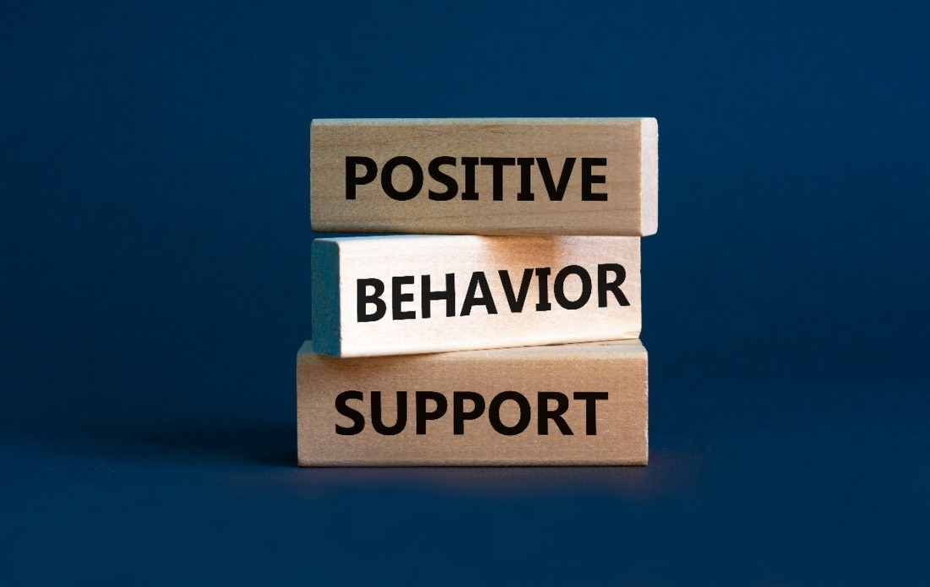**Workers must use all the best possible alternative behaviour support strategies beforehand.** Alternative strategies ensure the ethical treatment of the person. The person’s care plan must document these strategies.
* **Workers will only use restrictive practices proportional to the risk of harm.** Proportionality ensures the ethical treatment of the person. Practices must be least restrictive and for the shortest period possible.
* **Organisations must continuously monitor, review and document.** Apply this to the following:
  + The use of restrictive practices
  + The need for restrictive practices
  + The effectiveness of restrictive practices
* Workers must be aware of when to reduce or stop the use of restrictive practices. Limited restrictive practices ensure that high ethical standards are still within reach.
* There must be informed consent to use a restrictive practice from the person. If the person cannot consent, it must come from their guardian. Consent collection and documentation must follow state and territory requirements.
* The use of restrictive practices must adhere to the applicable requirements. These requirements are the following:
  + Aged Care Quality Standards
  + Charter of Aged Care Rights
  + National Standards for Disability Services (NDIS)
  + Applicable regulations of the State or Territory of practise
  + Any relevant provisions of the person’s care or behaviour support plan



To date, there is no single law or regulation for restrictive practices. States and Territories have varying requirements and regulations for these practices. Some sectors may also have requirements unique to them. Your organisation must guide you if you are to use restrictive practices.

Consider the Aged Care sector as an example. The *Aged Care Act 1997* requires that, to the extent possible, alternative strategies are used before a restrictive practice in relation to a care recipient is used. Restrictive practices should then be used as the last resort after other strategies have been exhausted.

Implemented policies and procedures usually also arise from disability and mental health laws. Consider the following:

* Victoria, Queensland and Tasmania have restrictive practice regulations in their disability services laws.
* Victoria and Queensland have detailed provisions and guidelines in their mental health laws.
* Other States and Territories have yet to formalise their relevant laws.

The *NDIS Restrictive Practices and Behaviour Support Rules 2018* require that in developing and reviewing a behaviour support plan for a person with disability, the specialist behaviour support provider must take all reasonable steps to reduce and eliminate the need for the use of regulated restrictive practices in relation to the person with disability. The behaviour support plan should then consider other support strategies so that restrictive practices will be less needed to implement restrictive practices.

With regards to the behaviour support plan, workers must have a plan in place for every person who:

* Exhibits behaviours of concern or change in behaviour
* Has restrictive practices considered, applied, or used as part of their care

The behavioural support plan only forms part of the individual care plan and does not replace it. The plan must set out information about the person. This information helps the care worker understand their background and changed behaviour.

This information includes but is not limited to the following:

*Sourced from* [*Overview of restrictive practices*](https://www.agedcarequality.gov.au/resources/overview-restrictive-practices)*, used under* [*CC BY 4.0*](https://creativecommons.org/licenses/by/4.0/)*.* [*© Commonwealth of Australia*](https://www.agedcarequality.gov.au/)

The behavioural support plan must include evidence of consent from the person. There must also be ongoing documentation in place. The documentation helps to inform other staff of continuing care.

The National Disability Insurance Scheme (NDIS) has guidelines on the care provider’s obligations. These obligations are when they use restrictive practices. All providers using authorised restrictive practices must meet the following conditions of registration:

* A restrictive practice is only possible in a behaviour support plan. An NDIS behaviour support practitioner must have developed the plan.
* When using a restrictive practice, it must:
  + Be the least restrictive response possible in the circumstances
  + Reduce the risk of harm to the person or others
  + Last for the shortest possible time to ensure the safety of the person or others
* Where required, the implementing provider must have authorisation. The authorisation comes from the State or Territory.
* The implementing provider must follow monthly reporting requirements.

*Based on* [*Understanding behaviour support and restrictive practices - for providers*](https://www.ndiscommission.gov.au/regulated-restrictive-practices)*, used under* [*CC BY 3.0 AU*](https://creativecommons.org/licenses/by/3.0/au/)*.* [*© Commonwealth of Australia*](https://www.ndiscommission.gov.au/)

States and Territories have jurisdiction over restrictive practices on their borders. The following table provides links to relevant authorities per State or Territory:

|  |  |
| --- | --- |
| **State or Territory** | **Relevant Authority** |
| Australian Capital Territory | [Office of the Senior Practitioner](https://www.communityservices.act.gov.au/quality-complaints-and-regulation/office-of-the-senior-practitioner) |
| New South Wales | [Restrictive Practice](https://www.facs.nsw.gov.au/providers/deliver-disability-services/restrictive-practices-authorisation-portal) Authorisation Portal |
| Northern Territory | [Northern Territory National Disability Insurance Scheme](https://health.nt.gov.au/professionals/restrictive-practices-authorisation) Restrictive Practices Authorisation |
| Queensland | [Department of Seniors, Disability Services and Aboriginal and Torres Strait Islander Partnerships](https://www.dsdsatsip.qld.gov.au/our-work/disability-services/disability-connect-queensland/positive-behaviour-support-restrictive-practices/publications-resources) |
| South Australia | [Office of the Public Advocate](http://www.opa.sa.gov.au/) |
| Tasmania | [Office of the Senior Practitioner](https://www.communities.tas.gov.au/disability/senior_practitioner) |
| Victoria | [Authorisation process for the use of regulated restrictive practices by registered NDIS providers](https://providers.dhhs.vic.gov.au/authorisation-process-use-regulated-restrictive-practices-registered-ndis-providers) |

*Based on* [*Understanding behaviour support and restrictive practices - for providers*](https://www.ndiscommission.gov.au/regulated-restrictive-practices)*, used under* [*CC BY 3.0 AU*](https://creativecommons.org/licenses/by/3.0/au/)*.* [*© Commonwealth of Australia*](https://www.ndiscommission.gov.au/)

Careful clinical and ethical considerations take precedence when restrictive practices become options. These considerations consider the *person’s human rights* and *right to self-determination*. Ethical considerations relevant to restrictive practices include the following:

* Restrictive practices must only be used as a last resort where the physical and mental integrity of the person is in serious and imminent danger.
* The use of restrictive practices must be discontinued if there is a decreasing trend in a person’s negative behaviour.
* The use of restrictive practices must be based on a consideration of both the carer’s duty of care and the person’s dignity of risk.
* Before considering how to deal with difficult symptoms and challenging behaviour, it should be determined for whom such symptoms and behaviour are disturbing.
* The restraint of a person who is unable to consent should be permitted only after discussion within a multidisciplinary care team and with the relatives, carers and advocates.

There will also be documentation requirements to accomplish. This may vary depending on the sector and state/territory. Your organisation must guide you when dealing with these requirements. Consider those required by the following:

* The *Aged Care Act 1997* requires the following to be properly documented:
  + The person’s behaviour/s that caused the need for restrictive practice
  + The reasons that rendered the restrictive practice used necessary
  + The alternative strategies considered or used before the restrictive practice was used
  + The care or support provided to the person in relation to their behaviour
  + If the person’s substitute decision-maker was informed and the related documents

*Based on content from the Federal Register of Legislation at 11 November 2021. For the latest information on Australian Government law please go to* [*https://www.legislation.gov.au*](https://www.legislation.gov.au/). [*Aged Care Act 1997*](https://www.legislation.gov.au/Series/C2004A05206)*, used under* [*CC BY 4.0*](https://creativecommons.org/licenses/by/4.0/)

* The *NDIS Restrictive Practices and Behaviour Support Rules 2018* requires that providers implementing regulated restrictive practices need to keep records of their use of restrictive practices and report use to the NDIS Commission.



|  |  |
| --- | --- |
|  | **Further Reading**  The *NDIS Restrictive Practices and Behaviour Support Rules 2018* has been referred to in the previous discussion. Access it using the link below:  [National Disability Insurance Scheme (Restrictive Practices and Behaviour Support) Rules 2018](https://www.legislation.gov.au/Series/F2018L00632)  Another good reference in disability support is the *Regulated Restrictive Practices Guide*, which is found in the link below:  [Understanding behaviour support and restrictive practices - for providers](https://www.ndiscommission.gov.au/providers/understanding-behaviour-support-and-restrictive-practices-providers) |

There is a continuous effort to reduce the use of restrictive practices significantly. The earlier discussion mentions alternative behaviour support strategies. You may address them as positive strategies for brevity.

Examples of positive strategies include the following:

This Learner Guide focuses on supporting a person’s wellbeing. In this context, the discussion avoids restrictive practices as much as possible. The Learner Guide instead focuses on the positive strategies listed above. The strategies are all embedded in the Learner Guide where they are appropriate.

**Individualised Plan**

****Your main role is to provide frontline support services. It must also be within the context of an established individualised plan.

An *individualised plan* addresses a person’s needs. The plan will have goals corresponding to these needs and actions to address the needs aligned with the person’s identity. During service planning and delivery, the person’s preferences always matter before others. Because of these properties, an individualised plan follows a person-centred approach.

The discussion on individualised plans is beyond this Learner Guide’s coverage. But in your actual work, you may encounter them. You must then be familiar with how your organisation implements an individualised plan.

|  |  |
| --- | --- |
|  | **Lotus Compassionate Care**  Earlier, you learnt the importance of your organisation’s policies and procedures. It is your first reference to identify the correct actions for any situation.  Lotus Compassionate Care is the simulated organisation that provides services in disability support, home and community support, and residential care referenced in our learning resources.  Their policies and procedures are published on their site. You can study it before proceeding to the first chapter. You can access it through the link below:  [Policies & Procedures](https://compliantlearningresources.com.au/network/lotus-v2/policies-procedures/)  Access Lotus Compassionate Care’s action plan on their site. It is another way of writing an individualised plan. You can access them through the link below.  [Forms and Templates](https://compliantlearningresources.com.au/network/lotus-v2/forms/)  *(username: newusername password: newpassword)* |

Self-awareness is essential in your role. You must recognise that everyone has their values, opinions and experiences. People carry their day-to-day lives using these unique personal qualities. You must recognise these different qualities from person to person.

You may have to change the way you talk. You will have to control your own emotions. You are likely to work with people you may disagree with. All these together mean that you must adjust for the person. This ability to adapt is the essence of your supporting role.

In your role, you will have to promote the person’s independence. You will enable them to practise self-care and self management. Along the process, you will support their physical wellbeing. You may have to identify and reduce risks around them. All these are to establish their right to autonomy and maintain their safety and security.

In this Learner Guide, you will learn how to do the following:

* Recognise and support individual differences
* Promote independence
* Support physical wellbeing
* Support social, emotional and psychological wellbeing



# I. Recognise and Support Individual Differences



No two people are genuinely the same. Everyone experiences the world in their own way. Even siblings with the same upbringing will develop separate identities. They will have differences that make them unique from each other.

This chapter is the foundation for the rest of this unit. Here, you will learn to recognise individual differences. *Individual differences* include the characteristics, behaviours, experiences and values of a person. You will realise that recognition of differences is essential to your work in supporting the independence and wellbeing of others.

In this chapter, you will learn to do the following:

* Recognise and respect the person’s social, cultural and spiritual differences
* Avoid imposing views and support the person’s expression of identity and preferences
* Consider the individual needs, stage of life, development and strengths for support activities
* Recognise, respect and accommodate the expressions of identity and sexuality according to maturity
* Promote and facilitate participation in activities that reflect the person’s individual needs

## Recognise and Respect the Person’s Social, Cultural and Spiritual Differences

A society is an ordered collection of interacting populations. Through order and interaction, a society advances in all aspects. But because everyone is unique, a society will encounter many individual differences. Many traits, such as the following, cause these individual differences:

Individual differences based on traits are interrelated. One trait may directly or indirectly affect one or more traits. For instance, a person’s culture can affect other traits, such as communicating or expressing sexuality. One trait affects other personal traits.

**Social Differences**

Social differences concern how people interact with each other. Interaction can be simple communication between people. It can also be the complex structures built over time. Social differences may involve variations in the following:

* Educational background
* Economic power and class
* Relationships with the family
* Personal preferences on gathering

**Cultural Differences**

Cultural differences are related to the following:

* **Values** – These are guiding principles that a group follows.
* **Norms** – These are behaviours accepted in a cultural group.
* **Beliefs** – These are ideas accepted as accurate even with minimal proof.

**Spiritual Differences**

Spiritual differences refer to varying traits and characteristics relevant to the human spirit or soul. These differences are usually evident in people’s spiritual beliefs and religious beliefs.

Spiritual and religious beliefs are related but not the same. For instance, A person’s spiritual beliefs may be influenced by their religious beliefs. Both spiritual and religious beliefs are also affected by a person’s moral views or perception of what is right and wrong.

The difference between spiritual and religious beliefs is that people learn their religious beliefs through cultural conditioning, while spiritual beliefs are developed individually.

Most religious beliefs are passed down through families, learned in institutions or absorbed through social contact. They are a set of beliefs practised by a community or a group that shares a religion. In comparison, spiritual beliefs are acquired through personal experiences. It often deals with more personal or intimate nature, like having a sense of peace and purpose. All religious beliefs are part of a person’s spiritual beliefs, but a person can have a spiritual belief that is not influenced by their religion.

As a support worker, you must always take people’s spiritual and religious beliefs into consideration. You will be caring for people with different beliefs that may affect their preferences. You may need to assist people with their spiritual and religious practices or adjust your services to match their spiritual needs and religious beliefs.

For instance, you may need to work with the Aboriginal and Torres Strait Islander community. This may require you to alter your services to respect, protect and uphold their beliefs:

Here are other examples of different spiritual beliefs that you may come across when supporting other people’s independence and wellbeing:

### **1.1.1 Recognising Social, Cultural and Spiritual Differences**

To *recognise*, in this context, is to identify the differences. As a support worker, it must be natural to recognise these three differences. Consider the following differences that may exist from person to person:

* **Social differences**
* As of 2019, around 63% of Australians aged 15 to 64 had a non-school qualification (Australian Bureau of Statistics, 2021c).
* As of May 2021, around 59% of Australians aged 15 to 79 are working, studying, or both (Australian Bureau of Statistics, 2021c).
* In 2020, around 4% of all Australians identified as gay, lesbian or bisexual (Australian Bureau of Statistics, 2020a).
* **Cultural differences**
* In 2019, 31.4% of Australians aged 15 and up participated in cultural activities (Australian Bureau of Statistics, 2021a).
* According to the latest government estimates, there are around 798,400 Aboriginal and Torres Strait Islander people (Australian Bureau of Statistics, 2016b).
* As of 2020, there are 7.6 million migrants who live in Australia (Australian Bureau of Statistics, 2021b).
* **Spiritual differences**
* As of 2016, 52% of all Australians are Christians (Australian Bureau of Statistics, 2016b).
* As of 2016, 2.6% of Australians are Muslims, and 2.4% are Buddhists (Australian Bureau of Statistics, 2016b).
* As of 2016, around 30% of Australians do not subscribe to a religion (Australian Bureau of Statistics, 2016b).

The list above is not exhaustive. The diversity between individuals is a broad topic. It would be best to educate yourself about the many differences between people. Educating yourself is a personal task for support workers like you.

**Best Practices**

The following are some of the best practices for recognising differences:

* **Ask the person.**

The best way to identify any difference is by politely asking the person. This avoids any confusion between you and them.



* **Ask the family, carer, or friends.**

The person may be unable to communicate with you. People closest to them will be the next best source of information.

* **Read the person’s file.**

Your organisation may have accessible information about the person. Studying their file before interacting with them will be best.

### **1.1.2 Respecting Social, Cultural and Spiritual Differences**



To respect is to provide a good feeling or action to someone. Respect is something that you show and give the person. Showing respect can be not talking bad about something. Giving respect can be following a person’s lead. Simply put, you must strive never to hurt or harm the person through your actions. Here are the best practices for respecting the three key differences:

* **Respecting social differences**
* Acknowledge the person’s preferences in social gatherings and events. Some people choose to be quiet when in a group. Some choose to skip gatherings and events in their entirety.
* Do not belittle a person by their background. Education and economic class alone do not define a person.
* Call the person by their preferred name and/or pronoun. It is best to know this early in your work.
* **Respecting cultural differences**
* Avoid cultural taboos applicable to the person. Taboos are items or actions that are not allowed in a group of people.
* Follow basic courtesy according to the person’s culture. Some cultures may have different etiquette and ways of interacting.
* Avoid stereotypes. You will learn more about stereotypes in the next section.
* **Respecting spiritual differences**
* Try to avoid discussing topics related to spirituality. It is a very personal subject to many that differences are inevitable.
* Provide the person with their own space for religious practices. A space for prayer, meditation or solitude is common in many religions.
* Like cultural taboos, some religions will have banned items and actions. This can extend even to the food consumed. Make sure to consider these banned items and actions in your work.

It would be best if you never made assumptions or judgements about someone’s individual differences. Listen to the person and acknowledge their views and opinions. In support work, individual differences must be considered. Support workers address the person’s beliefs, values and expectations. Doing this ensures that the person is comfortable and provided with a non-judgmental environment.

**Privacy, Confidentiality and Disclosure**

As a final note in this section, remember to respect the person’s privacy. You must maintain the confidentiality of any information shared with you. Only disclose information to authorised personnel. When in doubt, consult your organisation’s policies and procedures.

|  |  |
| --- | --- |
|  | **Further Reading**  Australia is a multicultural country. There are more than 270 cultural groups within the borders. Migrants brought some as one in four Australians were born overseas. But at the same time, Australia is home to one of the oldest continuous cultures. Learn more about Australia’s diversity through the link below:  [Face the facts: Cultural Diversity](https://humanrights.gov.au/our-work/education/face-facts-cultural-diversity#:~:text=About%20cultural%20diversity%20in%20Australia%20One%20in%20four,speak%20a%20language%20other%20than%20English%20at%20home.) |

|  |  |
| --- | --- |
|  | **Checkpoint! Let’s Review**   1. Individual differences include a person's characteristics, behaviours, experiences and values. 2. Social differences focus on how people interact with each other. 3. Cultural differences are related to people's values, norms, and values. 4. Spiritual and religious beliefs are related but not the same. They are both affected by a person’s moral views or their perception of right and wrong. 5. To respect is to provide an acceptable feeling or action to someone. 6. You must maintain the confidentiality of any information shared with you. |



## Avoid Imposing Views and Support the Person’s Expression of Identity and Preferences



People assess and judge the world around them. It is what allows us to:

* Make sense of the world
* Identify risks and dangers
* Gather information for decision-making

A person will follow their values and attitudes. Values are what a person holds to be necessary. Meanwhile, attitudes refer to how a person thinks and behaves towards someone or something.

People also assess and judge other people. In doing so, they can determine a person’s identity and preferences. Identity combines all the unique characteristics that make up a person. When presented with different options, preferences refer to what a person likes and/or chooses.

To impose is to practise your own values and attitudes on others. Imposing values and attitude is normal in a healthy society. It is part of interactions between people. But imposing values and attitudes can be problematic. This is true when the imposer harms the other person. This is the case with discrimination.

**Discrimination**



*Discrimination* refers to acts that infringe upon the rights of others. When deprived of rights, people may be in harm’s reach. Discrimination may also include withholding privileges and opportunities.

The following laws help prevent discrimination from happening:

| **National Laws** | **Short Description** |
| --- | --- |
| [Australian Human Rights Commission Act 1986](https://www.legislation.gov.au/Series/C2004A03366) | This law established the Australian Human Rights Commission (AHRC). It is the authority on matters involving human rights and breaches of these rights. |
| [Disability Discrimination Act 1992](https://www.legislation.gov.au/Series/C2004A04426) | This law aims to prevent discrimination against people with disability. The Act covers both indirect and direct discrimination. |
| [Racial Discrimination Act 1975](https://www.legislation.gov.au/Series/C2004A00274) | A person may be discriminated against based on their race, ethnic origin, skin colour, or country of birth. The Racial Discrimination Act aims to end this. |
| [Sex Discrimination Act 1984](https://www.legislation.gov.au/Series/C2004A02868) | This law makes it illegal to discriminate against someone based on their sex, gender identity and other gender-related aspects. This Act also outlaws sexual harassment. |
| [Age Discrimination Act 2004](https://www.legislation.gov.au/Series/C2004A01302) | This law prohibits discrimination in work opportunities based on age. It also ensures that young and older Australians receive their rights and privileges. |

**Community Values and Attitudes**

Discrimination becomes persistent and harmful when many people do it. In this sense, one may trace its origins to the community. A community can have the same negative values and attitudes over time. These may result in myths and stereotypes.

*Myths* in the context of discrimination are about false relationships between two ideas. Often, a harmless idea gets associated with a harmful one. This creates a myth that may persist and cause harm. Consider the following examples:

|  |  |  |
| --- | --- | --- |
| **Harmless Idea** | **Harmful Idea** | **Myth** |
| Education | Addiction | Only people with no formal education suffer from addiction. |
| Economic class | Entitlement | Being rich makes you immune to laws. |
| Age | Low productivity | You become less productive as you age. |
| Age | Loneliness | You get lonelier as you grow older. |
| Disability | Helplessness | People with disability need help all the time. |
| Disability | Low productivity | People with disability are not productive. |
| Liability | Discrimination | You are only liable for your actions if you commit intentional discrimination. |

*Stereotypes* are general beliefs and attitudes towards a specific group of people. These beliefs and attitudes are usually too simplistic and sometimes offensive. Stereotypes and myths are closely related and sometimes used interchangeably. In history, stereotypes are typically associated with sex, gender and race.

Common stereotypes include the following:

* Some races are superior to others.
* Childcare is only a woman’s responsibility.
* Men are not and must never be emotional.
* Jobs that need physical work are only for men.
* Women lack rationality and are prone to influence.
* Older people are wise. Their opinions are equal to the truth.
* People with disability prefer the company of other people with disability.

Consider the possible impact of some myths and stereotypes:

| **Myth or Stereotype** | **Possible Impact** |
| --- | --- |
| Childcare centres can negatively affect the relationship between parents and children | This myth can cause anxiety in parents dropping their children at a childcare centre. It can cause worry and concern that they are leaving their child in the care of someone else to the detriment of their relationship with their child. |
| Older people can’t learn or change | This myth can limit older people, many of whom are keen to learn, evolve and develop in their later years. Limiting exposure and access to new and interesting ideas and experiences can cause a rapid decline in an older person’s cognitive abilities and engagement with the world. |
| People with disability always need help | This stereotype puts people with disability all in the same category. It perpetuates the idea that they cannot care for themselves and always need the support of another person to get through day-to-day life. While this may come from a place of wanting to help, the impact for a person with disability that they manage effectively can cause them to be disempowered and have their capabilities invalidated. |
| Older people can’t contribute to the workplace and workforce | This stereotype can cause older Australians to feel a sense of shame, anger or sadness and directly impact how older Australians view themselves and their self-worth. |

Community values and attitudes can also be viewed from a positive perspective. The values of a community can provide comfort, familiarity and full expression of a person’s identity. Incorporating these positive values into the care of an individual then provides an environment for them to express their identity and preferences comfortably and without judgement. A greater understanding of community attitudes can also improve interactions and minimise misunderstandings in communication between the support worker and the person.

**Stopping Discrimination**



Discrimination is a persistent problem that everyone must stop from doing. It starts with the person and must extend to the community. As a support worker, you must always avoid discrimination. The next two sections will help you with this.

|  |  |
| --- | --- |
|  | **Further Reading**  The Australian Human Rights Commission (AHRC) is the authority on human rights and breaches of these rights. Their efforts include eliminating discrimination. Visit their website below to see their works:  [Australian Human Rights Commission](https://humanrights.gov.au/) |

### **1.2.1 Avoiding Imposition of Own Values and Attitudes on Others**



You must first recognise your personal values and attitudes in your work. This means having a high level of self-awareness. Some actions that can help you build up your self-awareness include the following:

1. **Notice your reactions.** Acknowledge and identify your reactions to words, situations, or events. This can help you identify unconscious beliefs. Take note of when your reaction is a powerful or negative one.
2. **Name your feelings.** Feelings can be anger, joy, disgust, admiration, or others. Avoid dismissing them out of hand because you see them as ‘negative’ emotions.
3. **Reflect on your thoughts.** Take the time to unpack these feelings and understand what they mean to you. Take your time to reflect. This brings out all your unconscious thoughts and beliefs.

Self-awareness is the key to avoiding imposing your own values and attitudes onto others. You can avoid putting pressure on others to think and behave the same way you do. This creates room for you to focus on supporting a person in the community. It also gives the person the space to express their own identity and preferences. In this context, you can practise your duty of care.

### **1.2.2 Supporting the Person to Express Their Own Identity and Preferences**

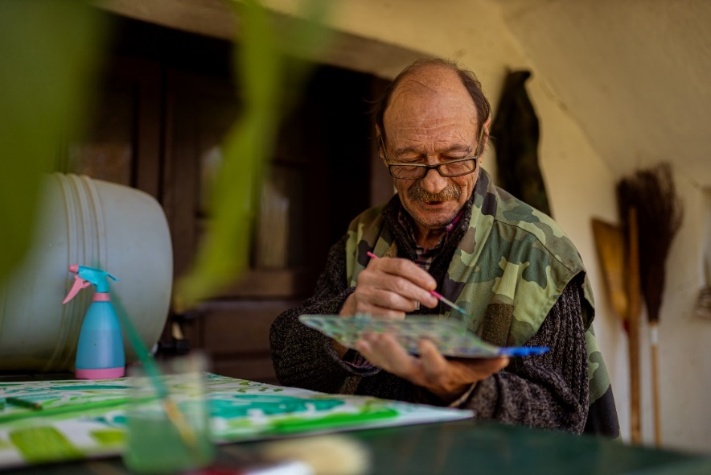

A person must be able to express their own identity and preference. To express is to practise any beliefs, values, norms, or actions without discrimination. You must learn to respect the person’s identity and preferences. This is part of your duty of care as a support worker.

The best way to support the person’s expression in your role is to involve them in all processes. Decisions about their care or other services must come from them. Other ways can include the following:

* Calling them by their preferred name
* Asking permission before helping them
* Listening to feedback about how they feel
* Providing choices for their meals and drinks
* Having a flexible routine in your day-to-day support tasks
* Providing information so that a person can make an informed decision
* Involving the person in daily decisions like what outfit they will wear that day
* Enabling the person to maintain contact with friends and the local community

Consider the illustration below supporting a person’s expression.

Callum is an 80-year-old man in an aged care facility. Everyone considers him to be fun and expressive. Others find him odd but still a great character.

Callum would sometimes wear unconventional outfits. One day, he insisted on wearing camo print overalls. He added a polka dot long-sleeved shirt, bright pink sneakers and a top hat with a purple feather in it. This type of outfit embodies his community nickname Calum the Colourful.

You may be a support worker in Callum’s facility. If someone asks you about your opinion on Callum’s outfit, you may respond with as follows:

Both options express different personal values. Neither option is right or wrong; they are just opinions. What matters is which option can better help you do your work. If Callum is comfortable and happy with his outfit, then the first option helps you in your role. The first option will provide Callum with the space to express himself.

You do not have to agree with everything a person does. But they should be encouraged and allowed to be honest, say exactly how they feel and tell you exactly what they want. Your job is to encourage them to share their identity and preferences with you so that you can support them in expressing them. As a support provider, you should ask yourself, ‘Am I fulfilling the purpose and scope of my job role?’

In Callum’s case, being happy with his harmless outfit matters a lot. It is all that matters in your role.

There may be instances where you must act. This is true if a person may cause harm to themselves or others. Consider the following scenarios:

* **The overalls are too long and loose.**

The overalls may cause Callum to trip or slide. You must explain this to him politely. You can then help him find alternative outfits.

* **The outfit is not suitable for the cold weather.**

Callum’s outfit may not be enough to protect him from the cold. You may help him add a few more layers of clothing to bring warmth.

This section covers the aspects of the dignity of risk. The above examples make this obvious. Recall that a person has the right to decide for themselves. You must also acknowledge that they understand any risks they may face. But it would be best if you still exhausted all possible options to minimise these risks. These situations are where the duty of care and dignity of risk come together. Your organisation should have relevant policies and procedures.

|  |  |
| --- | --- |
|  | **Further Reading**  Racism is a systemic problem experienced around the world. Australia, being a multicultural country, is also prone to racism. Learn more about the government’s efforts to end racism through the link below:  [Racism is not acceptable](https://www.australia.gov.au/helpstopracism) |

|  |  |
| --- | --- |
|  | **Checkpoint! Let’s Review**   1. Identity combines all the unique characteristics that make up a person. When presented with options, preferences refer to what a person likes and/or chooses. 2. To *express* is to practise any beliefs, values, norms, or actions without discrimination. A person must be able to express their own identity and preference. 3. To *impose* is to practise your own values and attitudes on others. 4. Discrimination refers to acts that infringe upon the rights of others. 5. Self-awareness is the key to avoiding imposing your own values and attitudes onto others. 6. You do not have to agree with everything a person does. But you must perform your role and responsibilities. |



## Consider the Individual Needs, Stage of Life, Development and Strengths for Support Activities

You can consider many factors in supporting individuals, although you are likely working with an individualised plan. You must then follow a person-centred approach.

A person-centred approach involves the person from start to finish. Here, it is crucial that you address the person’s needs, goals and preferences. In doing so, you may consider the following factors:

**Individual Needs**

Individual needs may refer to a person’s basic human needs to be safe, healthy and happy. These needs are also crucial for a person’s survival. You can group these needs into the following groups:

* **Physical needs**

Physical needs refer to the biological requirements to sustain life. This can include air, drink, food, sleep, warmth, clothing, shelter and more.

* **Psychological needs**

Psychological needs are the needs of the brain and consciousness. Humans are self-aware and social creatures. Because of this, humans have needs related to emotions, interaction, control and more. These can include the following:

* + The need to feel safe and secure
  + The need to feel love and belonging
  + The need for developing one’s self-esteem, confidence and self-image
* **Spiritual needs**

Spiritual needs relate to people’s efforts to find meaning and purpose based on their spiritual and religious beliefs. Any conscious person will have needs relevant to their spiritual identity and character, such as the following:

* + The need to express one’s spiritual ideas and beliefs in an open and non-judgmental environment
  + The need to practise important religious practices and explore spiritual beliefs



* **Cultural needs**

Some needs and preferences trace their origin to culture. Cultural needs are set by a particular tradition or way of life. Different cultures have instilled different needs in their people. Cultural needs can include the following:

* + The need to express one’s cultural identity in an open and non-judgmental environment
  + The need to maintain important cultural practices, beliefs and customs
  + The preference to eat specific types of food and avoid specific types of food
  + The preference to appear or dress a certain way
* **Sexual needs**

Humans, like other creatures, have the natural tendency to reproduce. Sexual needs are the body’s way of compelling an individual to meet this. Sexual needs can include the following:

* + Need for sexual intimacy
  + Maintain healthy sexual relationships

**Stage of Life and Development**

One way of understanding a person is to know what stage of life they are in. There are lots of ways to categorise stages of life. One may consider the following:

|  |  |
| --- | --- |
| **Stage of Human Development** | **Description** |
| **Infancy** | The child is completely dependent on others during the first stage of life. |
| **Early Childhood** | The child’s growing self-control is expressed through climbing, touching, exploring, etc. They develop a general desire to do things for themselves. |
| **School-Age** | In school, the child begins to learn skills valued by society, and success or failure can have a lasting effect on their feelings of adequacy. |
| **Adolescence** | Mental and physical maturation brings new feelings, physical development and attitudes. |
| **Adulthood** | The person strives to create or nurture things that will outlast them, generally through parenting or contributing positive changes that benefit other people. |
| **Maturity** | The person reflects on their life and either acquire a sense of fulfilment from a well-lived life or a regret over a life misspent. |

Each stage of life brings different experiences, needs, and goals. Development also occurs in many aspects. The following developments may happen:

* The human body grows, matures, and then declines as it ages.
* Intellectual, emotional and social capabilities generally mature with age.
* A person may lose the need to meet their sexual tendencies as they age.
* Some people take part in more spiritual activities as they reach older age.
* A person may move to different places with different cultures in their lifetime.

Understanding what stage of life a person may be in is vital to your role. It tells you their current qualities and where they may go as they age. These will help you support the person.

The following information may change or develop as a person ages. Do not forget your organisation’s policies and procedures when handling this information. You must respect the person’s privacy and uphold confidentiality at all times. Take note of these:

|  |  |
| --- | --- |
|  | **Further Reading**  Government statistics and surveys are good indicators of current trends. It gives you a general picture of what you may encounter as you provide support. The following link is an excellent place to start for government-sponsored statistics:  [Statistics](https://info.australia.gov.au/about-australia/facts-and-figures/statistics) |

**Strengths**

Supporting a person involves addressing their needs. Supporting a person is a form of service. A service that follows an individualised plan must be person-centred. Another method often incorporated in individualised plans is the strengths-based approach.

In support work, you must also incorporate strategies that develop the person’s strengths. A strengths-based approach involves collaboration between you and the person. The approach is effective because it increases the person’s participation. They gain some sense of control in the service.

Generally, you can follow the steps below for a strengths-based approach.

1. Assess and understand the person’s capabilities and skills.
2. Consider these strengths in the person’s individualised plan.
3. Incorporate activities and methods that take advantage of the person’s strengths.

You may be working with an individualised plan that someone has prepared. But the important thing to remember is that the plan undergoes regular checking. Adjustments are possible as a person’s needs change. Sometimes, their strengths change depending on their condition. This is why you must be familiar with their capabilities and skills.

The following is a set of good information for identifying a person’s strengths. Take note not to discriminate against a person when assessing. The following are used and gathered to support the person, not harm them:

**Support Activities**

You have established the importance of the following factors when supporting a person:

* Individual needs
* Stage of life and development
* Strengths

It is important to remember that these factors work together. This gives the person the best support activities that address their needs. Also, it makes the support activities more compatible with the person’s condition.

The support activities that you will join will depend on your job role. This means that your organisation may specialise in a particular service. It is then essential to be familiar with the relevant policies and procedures. Also, never forget to recognise and respect any differences that you may encounter.

Consider the following support activities and how some factors can affect the delivery:

|  |  |
| --- | --- |
| **Support Activity** | **Factors to Consider** |
| Facilitating speech therapy sessions for an eight-year-old individual | * Coordinate closely with the parents of carers. * Consider their school schedule for the therapy sessions. * Ensure that the therapist must be someone capable of working with children. |
| Facilitating food services for a 40-year-old who is recovering from an accident | * Ask the person for any personal, cultural, or religious preferences. * Check for any dietary restrictions based on their health condition. * Include the person if they offer help with some cooking tasks as they recover |
| Doing care work for a 70-year-old in an aged care facility | * Familiarise yourself with the person’s health condition and general wellbeing. * Coordinate closely with their families and assigned health professionals. * Ask permission before helping them in any way. |

|  |  |
| --- | --- |
|  | **Checkpoint! Let’s Review**   1. Individual needs may refer to a person’s basic human needs to be safe, healthy and happy. 2. Each stage of life brings different experiences, needs, and goals. Development also occurs in many aspects. 3. Understanding what stage of life a person may be in is vital to your role. 4. In support work, you must also incorporate strategies that develop the person’s strengths. 5. Generally, you can follow the steps below for a strengths-based approach:    1. Assess and understand the person’s capabilities and skills.    2. Consider these strengths in the person’s individualised plan.    3. Incorporate activities and methods that take advantage of the person’s strengths. |

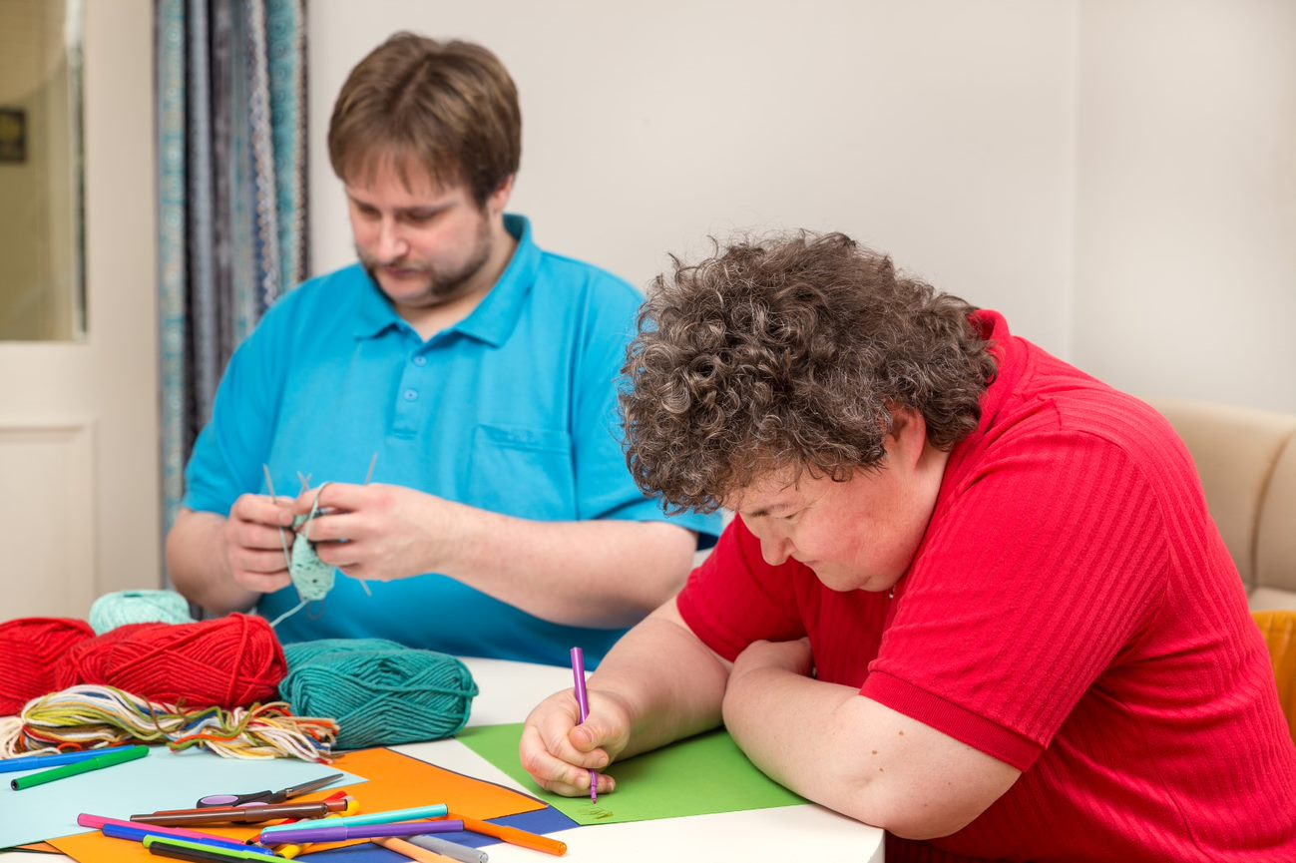

## Recognise, Respect and Accommodate the Expression of Identity and Sexuality According to Maturity

Identity and sexuality are factors to consider in the modern world. Recognition, respect and accommodation of these factors are necessary. But a critical context to always consider is the person’s maturity level. Maturity can be the age and stage of life an individual is in. How a person identifies themself can change over time.

Sex and sexuality have traditionally been sensitive topics, and it still is for many people. Some people are not comfortable talking about it. Being aware of this is essential. You must respect the person’s views on it.

**Expressions of Identity and Sexuality**

*Identity* is the combination of qualities that make up a person or group. A person’s identity can have many attributes. The list below is a starting point for understanding what forms a personal identity.

Biological sex is the person’s conventional identity based on their reproductive role. The traditional biological sexes are ‘male’ and ‘female’. The word ‘sex’ is often used to mean biological sex. This can confuse sexual intercourse, which is also shortened to ‘sex’. Context is important when discussing these.



In recent years, there has been a growth in public awareness and understanding of *sexuality*. Consider the following terms and their definitions:

* **Sexuality** – This refers to the person’s views and attitudes towards sex and physical intimacy.
* **Sexual identity** – This is how a person sees themself according to their sexuality.
* **Sexual expression** – This is how a person behaves according to their sexuality.

Take note that identity is fundamentally personal. This means that some may not fit into the arbitrary categories of sexual identity. Also, some people may know their sexual identity. But they may choose to have a different sexual expression. Such is the case when they experience discrimination.

The following list shows the many recognised sexual identities:

* **Heterosexual** – A person attracted to the opposite biological sex
* **LGBTIQA+** – This is an acronym for a variety of sexual identities, such as the following:
  + **Lesbian** – A biological woman who identifies as a woman and is attracted to someone who identifies as a woman
  + **Gay** – A biological man who identifies as a man and is attracted to someone who identifies as a man
  + **Bisexual** – A person attracted to both biological sexes
  + **Transgender** – A person who identifies with their opposite biological sex and may have undergone physical changes to match their identity
  + **Intersex** – A person with a condition in their reproductive anatomy that makes it difficult to identify their biological sex
  + **Queer** – A person who does not follow a conventional sexuality
* **Asexual** – A person who has low to no sexual attraction or activities with anyone

|  |
| --- |
| **Multimedia**  Graphical user interface, application  Description automatically generated  The discussion on sexual orientation and gender identity has progressed in recent years. You may confuse terms that relate to sexuality and gender. The video provided below is an excellent place to start:  [Sexual orientation? Gender identity? What’s the difference?](https://www.youtube.com/watch?v=C63Xn--i13o) |

**Issues Surrounding Sexuality and Sexual Expression**

Different views and possible discrimination are primary issues regarding sexuality and sexual expression. The topic is beyond the coverage of this Learner Guide. But as a support worker, you need to learn more about these issues. The reading provided at the end of this section is a good start. Also, never forget your organisation’s policies and procedures on these topics.

Recall that sexuality and sexual expression are closely linked. Sexuality is the person’s views and attitudes on sex. Sexual expression is the person’s behaviour based on their sexuality. In this context, issues surrounding them are also related. A problem rooted in sexuality can affect sexual expression. Conversely, subjects that hinder sexual expression may also affect a person’s sexuality.

Issues surrounding sexuality affect a person’s personal view or attitude towards sex and physical intimacy. These can include the following:

Issues surrounding sexual expression, meanwhile, affect a person’s behaviour and way of showing their sexual identity or intimacy. Examples include the following:

* Having no partner
* Loss of the sensation of ejaculation
* Reduced mobility due to arthritis or stroke
* Reduced penile rigidity and vaginal lubrication
* Drugs that can cause impotence or lack of libido
* Physical barriers (such as catheters or pessaries)
* Lack of privacy in nursing and residential homes
* Diseases (such as diabetes) that lead to impotence
* Delay in arousal with a greater need for genital stimulation
* Traumatic experiences causing anxiety during intimate physical contact

**Recognising, Respecting and Accommodating the Person**

Recognition, respect and accommodation are important when dealing with identity and sexuality. Recognising a person’s sexuality starts with something as simple as talking to them. Often, people of some sexual identities feel discouraged from being social. Being approachable makes it better for them and you.

Asking the appropriate questions also makes it easier for the person. This is one way to show respect to them. Appropriate questions are those that do not convey any form of discrimination. When you need to ask something, make sure that they are appropriate. This is especially true for questions that may refer to their sexual identity. Examples of these questions in their proper form may include the following:

* Do you have a partner or a spouse?
* Are you dating or seeing anyone now?
* Are you married, or have you been married?
* Would you like to go on a date with someone?

To accommodate is to adjust for the person. As a support worker, accommodating must be a skill for you. All people have the right to have their sexual needs met in privacy and dignity. In your role, you can accommodate a person’s sexuality and needs by doing the following:

* Supporting how they dress
* Facilitating their privacy when required
* Supporting their preferred social activities
* Supporting who they would like to develop healthy relationships with

There are also support and professional services that can help with sexual needs. These services include the following:

**Working in the Context of Age or Stage of Life**

Consider the following scenarios and how identity and sexuality may play a role. The scenarios emphasise the person’s stage of life. Remember also to consider your organisation’s policies and procedures:

* **First scenario**

You may have to speak to a 10-year-old about sexuality and identity. In doing so, you must be calm and composed. Use simple language and focus on educating the young person.

Compare this to talking to a 60-year-old. In general, older people have a more mature understanding of sexuality. They are likely more familiar with their needs. You must respect their needs and help them address these in your role.



* **Second scenario**

Individuals with psychosocial disabilities may express their sexuality in a way that can harm others. Psychosocial disabilities due to deterioration are common in older people. Your duty of care also extends to these people. You must then address both the person’s needs and the safety of others. The individualised plan of the person should have considered this. It is then essential to follow the support strategies outlined in the plan.

* **Third scenario**

A person may disclose their secret sexual identity to you. In this case, you must still respect their privacy. But there may be instances where you must practise your duty of care. For example, the person may be participating in sexual activities that may bring harm. This situation is common for young adults (20 to 40 years old). In this case, you must respect their dignity of risk but educate them about the risks.



|  |  |
| --- | --- |
|  | **Further Reading**  Gender stereotypes and norms are persistent issues in modern society. The Australian government continues its efforts in changes some of these outdated ideas. The following reading is one of their educational contents for Years 10 to 12 students:  [Gender stereotypes and norms](https://thegoodsociety.gov.au/guidebook/years-10-12-guidebook/chapter-2---influences/gender/gender-stereotypes-and-norms)  Consider the following case studies that cover sexuality. It is important to remember that sexual discrimination and abuse are serious problems. The actual stories in the reading will help you understand this:  [Sexuality case studies](https://www.qhrc.qld.gov.au/resources/case-studies/sexuality) |

|  |  |
| --- | --- |
|  | **Checkpoint! Let’s Review**   1. Identity is the combination of qualities that make up a person or group. Sexuality is the person’s views and attitudes towards sex and physical intimacy. 2. Different views on sexuality and sexual expression can lead to discrimination. 3. Recognising a person’s sexuality starts by being approachable to them. 4. Asking appropriate questions when needed is one way to show respect. 5. Accommodating a person’s sexual needs means providing them with the support they need. |



## Promote and Facilitate Participation in Activities That Reflect the Person’s Individual Needs

Earlier in this chapter, you have learned how individual needs may be grouped:

**Activities That Reflect the Person’s Individual Needs**

You will support the person on activities related to the first four needs listed above in your role. Supporting psychological needs will need further training beyond this Learner Guide.

The following activities are related to physical, social, cultural and spiritual needs:

* **Physical needs**
  + Eating
  + Drinking
  + Sleeping
  + Bathing
  + Exercising
* **Social needs**
  + Dating
  + Playing group sports
  + Attending hobby classes
  + Attending family gatherings
  + Meeting up with friends
* **Cultural needs**
  + Doing rituals and rites
  + Attending community events
  + Attending cultural celebrations
  + Learning new languages
  + Meeting other people of the same ethnic origin
* **Spiritual needs**
  + Attending places of worship
  + Practising spiritual activities
  + Praying and acts of devotion
  + Celebrating holy days and occasions
  + Eating or not eating certain foods at certain times



**Promoting Opportunities for Participation**

To *promote* is to encourage the person to join or partake. Promotion generally means that:

Consider some of the best practices below. These practices promote opportunities for participation in activities. These activities address the person's individual needs:

* **Physical needs**
  + Talk about the benefits of a healthy diet.
  + Motivate the person to follow a more active lifestyle.
  + Advocate for professional help if the person needs it.
* **Social needs**
  + Make yourself available for a casual conversation.
  + Encourage them to continue or start worthwhile hobbies.
  + Ask which family or friends they would like to see this week.
* **Cultural needs**
  + Provide a listening ear if they feel discriminated against and need to talk.
  + Engage in conversations that highlight their culture, if appropriate.
  + Encourage the person to practice cultural activities, if appropriate.
* **Spiritual needs**
  + Avoid talking about religion if both of you are uncomfortable with the subject.
  + Check for holy days and ask how they would like to celebrate these.
  + Avoid making comments that may be misinterpreted as offensive.

**Facilitating Opportunities for Participation**

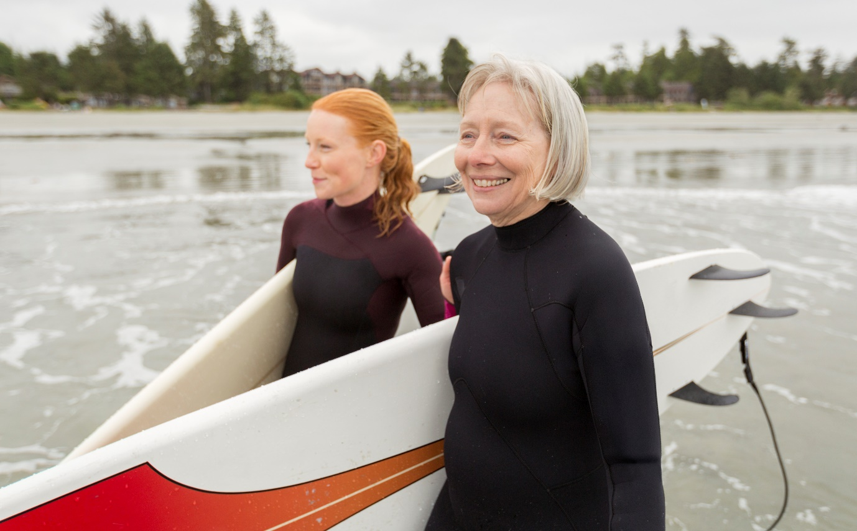To facilitate is to help a person by making things easier for them. Facilitation generally means the following:

* Helping the person set up their goals and desires
* Assisting the person in preparing pre-requirements such as the following:
  + Transportation
  + Documents
  + Permits
* Providing for the requirements during the opportunity, such as the following:
  + Guardianship
  + Preparation
  + Equipment
  + Company

Consider some of the best practices below. These practices facilitate opportunities for participation in activities. These activities address the person's individual needs.

* **Physical needs**
  + Ensure that their meals are healthy and nutritious.
  + Minimise hazards in their physical environment.
  + Help the person contact their personal doctor.
* **Social needs**
  + Confirm their attendance at events and arrange their transport as required.
  + Help them in using modern technologies for communication.
  + If appropriate, help the person create new relationships.
* **Cultural needs**
  + Confirm and accommodate any dietary/meal requirements.
  + Connect the person with other people of the same background.
  + Offer to help when they prepare for rituals and rites, if appropriate.
* **Spiritual needs**
  + Organise transport and care for a person to attend places of worship.
  + Offer to pray with them if both of you are comfortable doing it.
  + Respect their need for isolation if their religion or beliefs call for it.

Promotion and facilitation ultimately mean helping the person. As you support people, these two are essential. They ensure that the person addresses their needs. These take care of their wellbeing. Additionally, doing activities on their own establishes independence.

All activities that you will support are likely included in the individualised plan. You must then understand the plan as soon as possible. Also, your organisation may have relevant policies and procedures. Make sure to follow these.



|  |  |
| --- | --- |
|  | **Checkpoint! Let’s Review**   1. You must recognise or identify differences between people. 2. You must respect the differences between people. At the very least, never speak negatively about differences. 3. You must avoid imposing your own values and attitudes. Being self-aware will help. 4. You must support the person’s expression of their own identity and preferences. Never discriminate against a person for being different from you. 5. With an individualised plan, you must follow a person-centred approach. Here, it would be best if you considered the person’s individual needs and strengths. Stage of life and development are also matters to consider. 6. Identity and sexuality are factors to consider in the modern world. Recognition, respect and accommodation of these factors are necessary. 7. Promotion and facilitation require you to make it easier for the person. This is your goal when assisting the person in their activities. |

|  |  |
| --- | --- |
|  | Learning Activity for Chapter 1 Well done completing this chapter. You may now proceed to your **Learning Activity Booklet** (provided along with this Learner Guide)and complete the learning activities associated with this chapter.  Please coordinate with your trainer/training organisation for additional instructions and guidance in completing these practical activities. |

# II. Promote Independence

In this chapter, you will focus on the person’s independence. You will support, assist and encourage the growth and maintenance of their independence. This chapter builds upon the concepts discussed in Chapter 1 of this Learner Guide.

**Independence**

Recall that every human has the *right to autonomy*. This means that a person has the right to make decisions in matters affecting them. Their right to autonomy also allows them to do things they want to do. When you talk about a person’s independence, you refer to their right to autonomy.

**Self-Actualisation**

Self-actualisation is a concept first introduced by Abraham Maslow. A person only achieves self-actualisation by completing the following:

Self-actualised people will have essential qualities such as the following:

* Accepting that they have strengths and weaknesses
* Accepting that others have strengths and weaknesses
* Enjoying life as it is and attempting to maximise their experiences

Independence and self-actualisation are inexplicably linked. One may see self-actualisation as the result of gaining independence. In the context of this chapter, you will focus on helping the person gain independence. This satisfies the first two requirements for self-actualisation:

* Realising their full potential
* Developing their abilities completely

This chapter will introduce ideas on promoting independence. In this chapter, you will learn to do the following:

* Help the person to identify and acknowledge their strengths and self-care capacity
* Help find opportunities that use their strengths and communicate available support
* Inform and assist the person in accessing support services and resources
* Provide support that allows appropriate self-management of own service delivery
* Encourage the person to build, strengthen and maintain independence

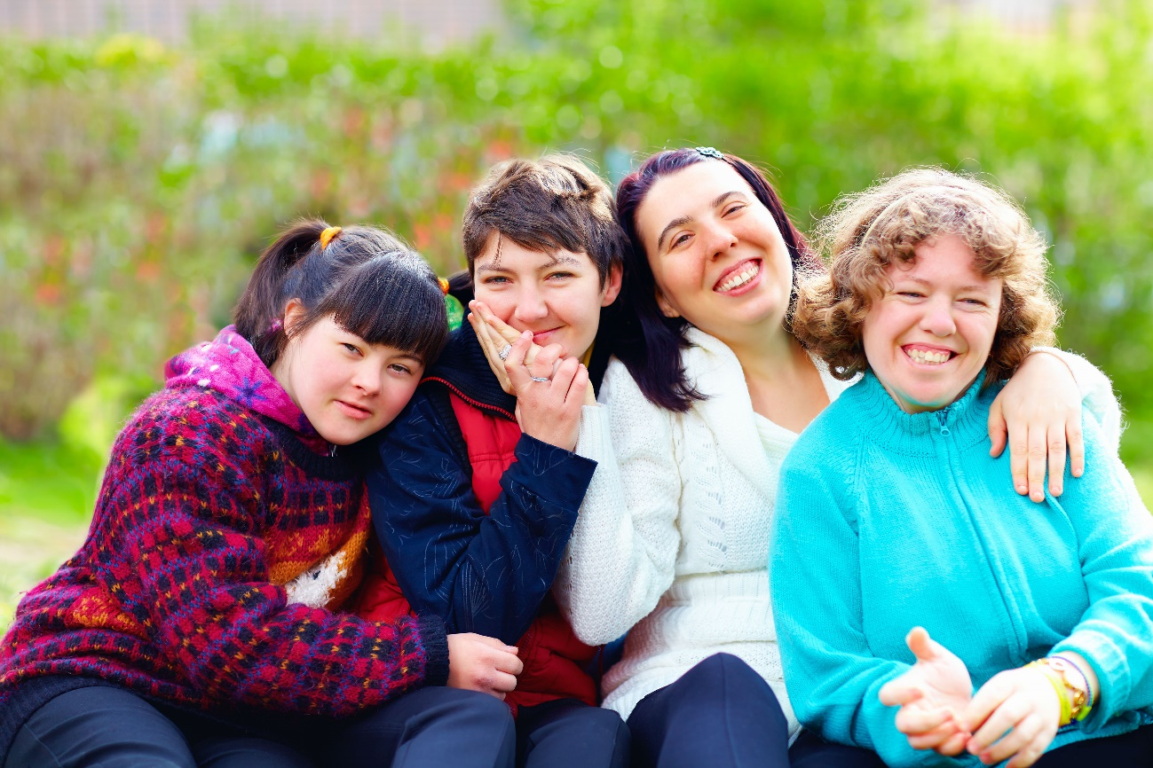

## Help the Person to Identify and Acknowledge Their Strengths and Self-Care Capacity

A person's strengths can be their capabilities and skills where they are good at. They can also be confident with these capabilities and strengths. Strengths may also refer to their best characteristics. It can also be something that they love to do.

In Subchapter 1.3 of this Learner Guide, you have learned to use a strengths-based approach. Here, you will learn to help identify and acknowledge the person’s strengths. These two are crucial for an effective strengths-based approach.

Self-care capacity refers to the ability of an individual to take care of themselves. This can be at varying levels of ability depending on the individual’s abilities and stage of life. A person with self-care capacity also understands their own needs. So, they are also able to express their needs to others. They can communicate if needed, the support they wish to receive.

### **2.1.1 Supporting the Person in Identifying Their Own Strengths and Self-Care Capacity**

To *identify* is to determine and establish. You know that strengths and self-care capacity are two different concepts. The following discussion will cover how to identify each of the two.

**Identifying Their Own Strengths**

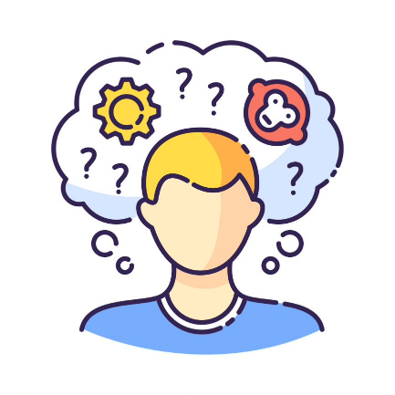Everyone has different strengths they can call upon. Also, some strengths develop at different life stages. Some of these strengths will last a lifetime. Some will deteriorate with age or physical ability. It would be best to consider these when supporting the person as they identify their strengths.

Identifying one’s strengths is a difficult task. Often, people are more aware and confident of their weaknesses. They hesitate to claim that they are good at something. But the best way to identify their strengths is still to ask them. You will find a process to do this on the next page.

There is a process that may help you and the person identify their strengths. Young people, people with disability, or older people may be unable to do this process. In such cases, you may work with their families, carers and other relevant people. Refer to the steps below.

1. **Have the person write down all the instances in which they think they did their best.** These can also be tasks that they love to do. These may come from any aspect of life.
2. **Have them come up with common themes from the list that they made.** These themes are overarching skills or traits that may be their strengths.
3. **Have them confirm by reflecting upon these strengths.** They can also make a more direct observation for a few days. These items are their strengths if they realise that they are good at or love it.

Below are examples of instances and possible strengths from the perspective of the person:

|  |  |
| --- | --- |
| **Instances** | **Possible Strengths** |
| * I make a list of items I buy before grocery shopping. * I love to arrange my clothes in my cabinet. * I never fail to fix my bed after waking up. | Organisation |
| * I want to learn to paint. * I love to make flower arrangements. * I have been knitting for the last five years. | Artistry |
| * I love meeting new people. * I can talk about anything under the sun. * I regularly check on my friends and family. | Friendliness |

The above process is one way to identify a person’s strengths. Your organisation may also have the procedures and tools for this task. Make sure to study and use these procedures and tools.

**Identifying Their Self-Capacity**

Self-care capacity is the ability of an individual to take care of themselves. Care is in the context of the person’s health. You may divide a person’s health into the following areas:

A checklist is often used to identify the person’s self-care capacity. Like strengths, this checklist works best if the person answers it. Sometimes, their family or carers may have to do it for them. Organisations may vary in the checklists that they use. Some may even use entirely different tools. You must then be familiar with your organisation-related procedures and tools.

Tools like self-care checklists will help you in the following:

* Confirming the person’s needs
* Confirming the person’s strengths
* Identifying preferences or considerations for the person
* Identifying suitable activities to address the person’s needs

Self-care checklists may use a rating scale and self-care items. These items may relate to the health areas listed above. There is a sample self-care checklist on the next page. It shows examples of self-care items that you may find in a self-care checklist.

|  |  |
| --- | --- |
|  | **Further Reading**  Self-care checklists are valuable tools for assessing a person’s health. These checklists find much use in mental health initiatives. Consider the sample self-care checklist found in the link below:  [A guide to self-care](https://lifeinmind.org.au/research/self-care) |

The table below is a sample self-care checklist. It shows examples of self-care items that you may find in a self-care checklist.

|  |  |
| --- | --- |
| **Sample Self-Care Checklist** | |
| Rate each item according to how well you think you are doing:  0 – I never do this; 1 – I barely do this; 2 – I sometimes do this; 3 – I always do this | |
| **Physical** | **Psychological** |
| I eat a balanced diet.  I exercise at least three times a week.  I sleep at least seven hours every day. | I do self-reflection.  I manage stress in my life.  I can disconnect from work. |
| **Emotional** | **Spiritual** |
| I allow myself to cry.  I spend time with people I care about.  I can praise myself for a job well done. | I value optimism and hope.  I have things that I find meaningful.  I am open to not knowing everything. |
| **Social** | **Professional** |
| I see my friends regularly.  I ask for help when I need it.  I can share secrets and hopes with someone I trust. | I have a peer support group.  I can take a break during workdays.  I have work tasks that I find exciting and rewarding. |

**Supporting the Person in Identifying Their Strengths and Self-Capacity**

As discussed, the process of identifying is best done by the person. Their answers to the questions give a more accurate assessment. In some cases, their families or carers may have to do it for them.

In all, you must be supportive. Guide them in the procedures and tools. Be familiar with your organisation’s policies. This is for you to answer any of their queries.

Be an active listener as they discuss their answers. You may take extra notes to understand the person better. Enable the person to talk honestly and assure them that you will respect their privacy.

### **2.1.2 Supporting the Person in Acknowledging Their Strengths and Self-Care Capacity**

To acknowledge something is to accept or admit it. A person must acknowledge their strengths and self-care capacity. As a support worker, helping them do this is essential to the success of the service plan. You can start by assisting them in realising the following strengths-based principles:

* **They have a unique set of qualities.** Further, it is their strengths and capacities that help them grow.
* **They have a responsibility to maintain and improve their wellbeing.** Anyone can think of any challenge as an opportunity for growth.
* **They must have the willingness to learn, improve and change.** Doing so allows for a more positive outlook on life.

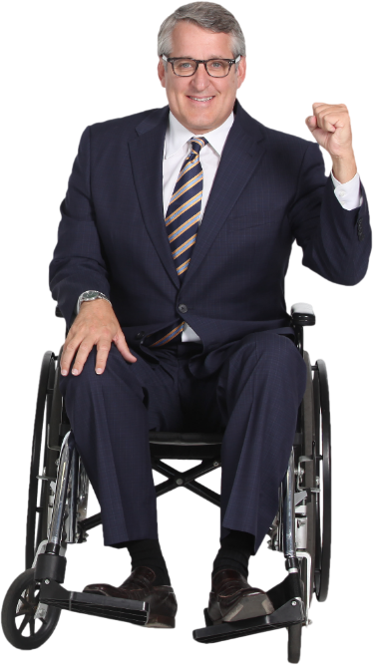When using strength-based approaches, you can:

* Assess the person's strengths and self-care capacity
* Use the person's strengths and self-care capacity in planning strategies
* Maximise the use of resources available that will benefit the person
* Induce hope by affirming their improvement and showing an appreciation for their capability
* Allow the person to choose what they want to do or how they want to work on their problems

You may encounter people with various strengths and capacities in your line of work. Some may also have circumstances that make it challenging to use their strengths. Consider the case study on the next page.

|  |  |
| --- | --- |
|  | **Further Reading**  Strengths-based approaches apply to many other practices. More information on strengths-based approaches is available through the link below:  [Strengths-based approaches for working with individuals](https://www.iriss.org.uk/resources/insights/strengths-based-approaches-working-individuals) |

To understand this topic better, consider the following case study:

|  |
| --- |
| **Harper the Painter**  Artist painting on canvas  Harper uses painting to support her Autism Spectrum Disorder (ASD). Recently, Harper broke her dominant hand because of an accident. The recovery time given by her doctor was at least 10 weeks. Harper feels lost as she can longer paint to cope with her condition.  Harper already uses one of her strengths to address an existing condition. Because of the accident, she has a new need to address. At least for the next 10 weeks, she must have a substitute support activity. You may then have to help her work on this.  In Harper’s case, you must help her realise that painting may not be her lone strength. You may find through a series of consultations that she is generally artistic. In this case, you may find substitute activities for painting.  The activities must consider that she cannot use her dominant hand for the time being. Digital art using tablet computers is a good one to consider. With digital technology, she can undo any mistakes or change her artwork. This setup allows her to work with her non-dominant hand. |

Harper must acknowledge that learning, improving and changing are essential in life. As you work with her, never fail to remind her of this. Part of helping people acknowledge is also to encourage them. Never be the reason for them to lose interest in what they do. As a support worker, you must guide them to grow and not decline.

|  |
| --- |
| **Multimedia**  Graphical user interface, application  Description automatically generated  You are often the best person who knows you. Support workers like you can only do so much in helping a person realise themselves. But motivating and informing them can go a long way. Learn more about knowing yourself using the video below:  [How To Know Yourself](https://www.youtube.com/watch?v=4lTbWQ8zD3w) |

|  |  |
| --- | --- |
|  | **Checkpoint! Let’s Review**   1. A person's strengths can be their capabilities and skills where they are good at. The best way to identify strengths is to ask the person. 2. Self-care capacity refers to the ability of an individual to take care of themselves. A checklist is often used to identify the person’s self-care capacity. 3. One may acknowledge their strengths and capacities if one accepts the following statements:    * They have a unique set of qualities.    * They have a responsibility to maintain and improve their wellbeing.    * They must have the willingness to learn, improve and change. |

## Help Find Opportunities That Use Their Strengths and Communicate Available Support

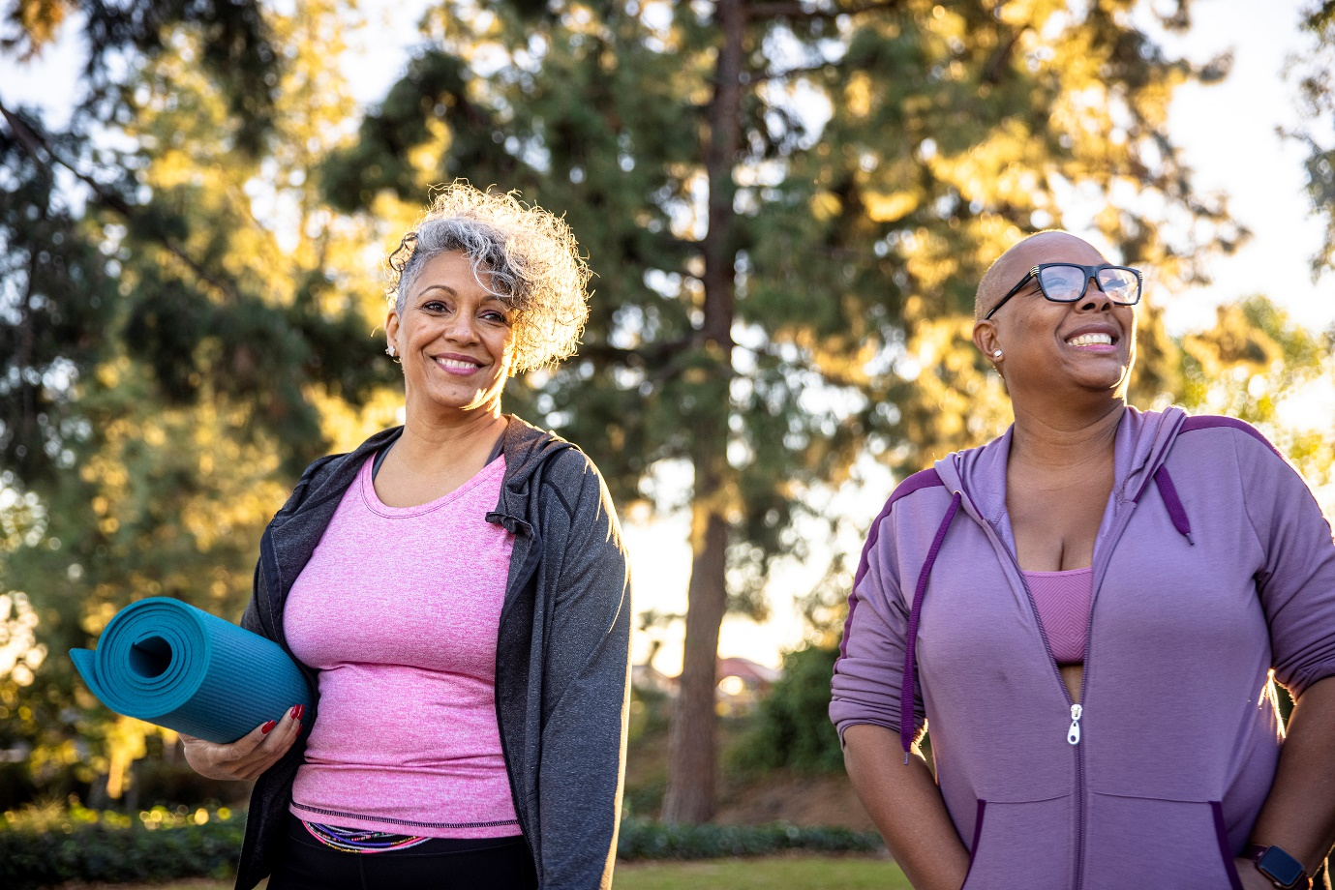

You will also help people find opportunities to use their strengths in your role. This step is essential if the person’s strengths are unique. It may also be that the person is reluctant to use their strengths. In this case, helping them find opportunities may lower their reluctance or anxiety.

You may also have to discuss the importance of using the available support. This information may motivate the person to start or continue their work. It also informs them and helps their decision-making process.

Many opportunities are available for most strengths. This is especially true for strengths related to hobbies. The opportunities must match the person’s strengths. Consider the pairs of strengths and opportunities in the table below.

|  |  |
| --- | --- |
| **Strengths** | **Possible Opportunities** |
| The person loves to run | If the person has no impeding medical condition, you may help them join local fun runs. |
| The person loves to paint | You may help the person find local interest groups and classes related to painting. |
| The person loves to cook and volunteer | You may recommend and help the person join nearby volunteer kitchens. |

After matching the strengths and opportunities, discuss essential opportunity factors with the person:

* **Cost**

Always check if the opportunities selected are affordable to the person.

* **Schedule**

Consider the person’s day-to-day activities and other important dealings.

* **Accessibility**

Ensure the opportunity is near the person’s location or at least accessible.

* **Effect on needs**

It may be that some opportunities can affect the needs of the person. Make sure that no negative effects result from opportunities.

* **Service needed**

The person may need other services to join prospective opportunities. For instance, they may need translation services for social activities.

Finally, you must remind them of the different support features they can use. Consider the following pointers:

In all, you must remember to uphold your duty of care. The person should never be near any possible harm. If they insist on joining dangerous opportunities, respect their dignity of risk. But do not forget to discuss the details of their actions with them. When in doubt, always consult your organisation’s policies and procedures.

|  |  |
| --- | --- |
|  | **Further Reading**  The Australian Charities and Not-for-profits Commission regulates organisations of its namesake. It also keeps a directory of these charities and not-for-profit organisations. You may find this helpful directory. The link to their website is available below:  [Australian Charities and Not-for-profits Commission](https://www.acnc.gov.au) |

|  |  |
| --- | --- |
|  | **Checkpoint! Let’s Review**   1. Many opportunities are available for most strengths. But opportunities must match the person’s strengths. 2. Knowing there is support may motivate a person to start or continue their work. 3. If the person insists on joining dangerous opportunities, respect their dignity of risk. But do not forget to discuss the details of their actions with them. |



## Inform and Assist the Person in Accessing Support Services and Resources

Services available will vary depending on the person’s needs. A person may also have many plans and services. Shown below are some of the common support services:

* **Residential care**

Residential care is a service that offers ongoing care in a residential care facility tailored to an individual’s needs. These needs may be associated with various circumstances, such as ageing or having health conditions.

* **Home and community care**

Home and community care services provide care and support services to assist individuals in continuing to live independently at home. Similar to residential care, their needs may come from various circumstances that make it difficult to live.

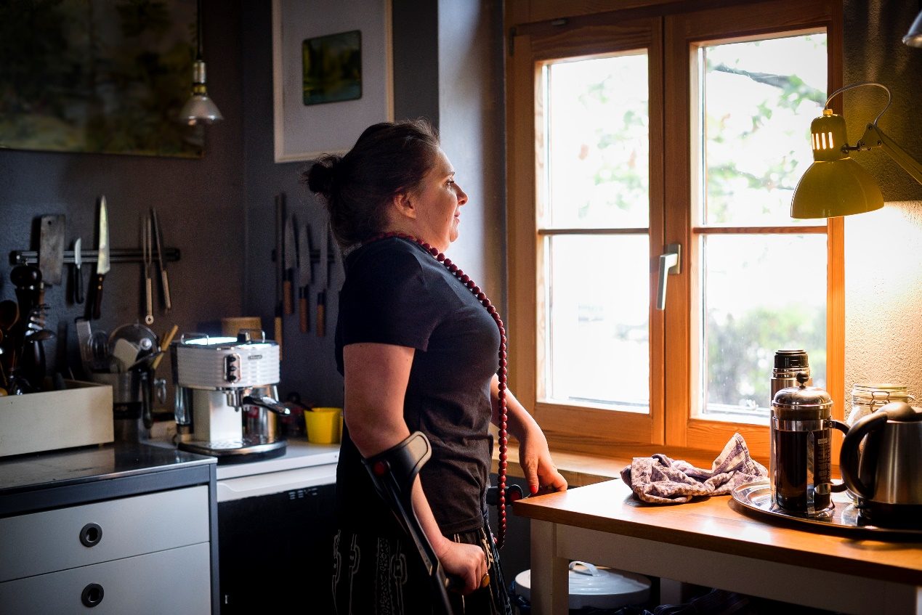

* **Aged care**

One of the more common sets of services offered and availed by older people. Aged care involves supporting older peple in their day-to-day lives. The level and duration of support can vary depending on the person’s needs. Some people need help with challenging tasks at home, such as laundry or cooking. Others enter aged care homes that offer all-day support and assistance.

* **Disability care**

Disability care is a more specialised service that some organisations can offer. This service prioritises the disability that limits living a typical life. These disabilities can be physical (e.g. a person who is deaf, has low eyesight, or has reduced mobility). It can also be cognitive and psychosocial (e.g. a person with memory loss or a person who has dementia).

* **Palliative care**

Palliative care is another specialised service that considers the person’s health condition. It aims to optimise quality of life and minimise suffering for people with serious complex illnesses. These conditions can include heart problems, dementia and cancers.

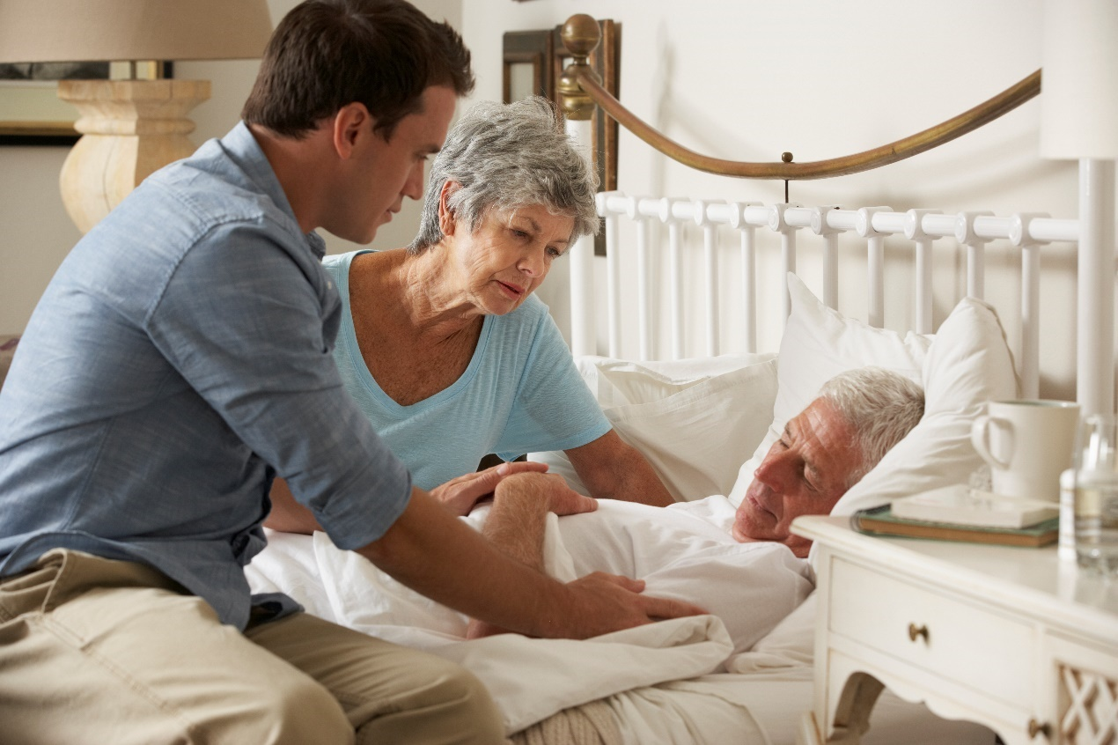

* **Respite service**

Respite service provides temporary relief to a person’s primary carer. A respite service provider collaborates with both the person and the carer. Collaboration ensures that the service provider addresses the person’s needs.

* **Primary health care for Aboriginal and Torres Strait Islander**

This service aims to provide primary health care services to the indigenous peoples. At the same time, there is an emphasis on respecting cultural and social differences.

* **Professional interpreting and translating service**

This type of service helps the culturally and linguistically diverse (CALD) to help them to communicate with other service providers. The provider must be familiar with the person’s background.



* **Child, youth and family intervention service**

This service deals with children, youth, or families. These people may be at risk, be vulnerable and want to change their lives. Specific services rendered can include home care, family support and early intervention.

* **Recreation, leisure and interest group**

A group like this includes various activities and interest groups that the person may join. Examples include sports, art, music, cooking, charity and community groups. Support workers must ensure that the person can act safely and securely.

* **Employment services**

These services help individuals in their careers and employment goals. Services can range from coaching, counselling and job placement, among others.

**Approaches to Service Delivery**

Services delivered will have different theoretical or philosophical approaches. Approach refers to what the worker adopts during interactions with the person. Examples of common approaches include the following:

Person-centred and strengths-based approaches are the focus of later discussions.

**Support Strategies**



How a support service will be delivered can involve many strategies. In general, these strategies must:

* Relate to a plan of action
* Support the care and wellbeing of a person
* Target a set outcome in support of a person

Consider the following strategies:

| **Support Strategies** | **Short Description** |
| --- | --- |
| **Individualised Support** | This involves supporting and addressing a person’s needs by considering their goals and preferences. |
| **Strengths-Based Planning** | Planning for a support service can take many forms. However, one of the best ways to do so is by considering the person’s strengths and using them to the service’s advantage. |
| **Self Managed Service Delivery** | This type of delivery can involve meeting regularly with the person, encouraging discussions about the care they are receiving, and giving them a chance to ask questions and be involved in the decision-making processes that impact them. |
| **Industry Consultation** | Consulting with any personnel or industry professional who has a say in the support and care of a person ensures you are gathering all the necessary information to create a holistic picture and understanding of the care a person receives. |

**Service Delivery Models**

The service delivery model is the actual structure of the service. In models, organisations apply different approaches to service delivery. In this context, service delivery models vary per organisation.

Examples of general service delivery models include the following:

* **Self-service** – Self-service delivery has the person deliver the service to themselves. The organisation usually helps in preparing and post-processing the service plan. Some organisations may also use some form of monitoring mechanism.
* **Professional service** – Professional or personal service has dedicated delivery worker/s for the person. The worker implements the service plan together with the person. The worker’s level of support usually depends on the person’s preferences.
* **Group service** – A group service has many people served together by one or more workers. Organisations use group services if many people share the same service or needs. Care facilities are good examples of this type of service.
* **On-demand service** – Organisations deliver on-demand services upon request. These services may be quick, small and urgent. An example of an on-demand service is respite care. In respite care, a temporary worker substitutes for a primary carer.
* **Customised service** – Customised or personalised services are what their name suggests. Services of this type consider the person’s preferences. The person is not limited to pre-packaged services.

Service delivery models will dictate how the delivery should proceed. These steps include before and after the delivery itself.

In general, most models follow the following steps:

1. **Pre-service** – This step includes referrals, assessments and endorsements.
2. **Planning** – This step includes designing, funding and assignment.
3. **Delivery** – This refers to the actual service delivered.
4. **Post-activity** – This step includes feedback, improvements and adjustments.
5. **Post-service** – This step includes cancellation, end-of-service, or transfer-of-service.

**Service Delivery Standards**

Service delivery standards ensure that everyone receives the same base level of quality. The government implements these standards according to different sectors.

The table below provides the links for the relevant standards of some sectors.

|  |  |
| --- | --- |
| **Sector** | **Standards** |
| Ageing support/aged care | [Quality Standards](https://www.agedcarequality.gov.au/providers/standards) |
| Disability support | [National Standards for Disability Services](https://www.dss.gov.au/our-responsibilities/disability-and-carers/standards-and-quality-assurance/national-standards-for-disability-services) |
| Out-of-home care | [An outline of National Standards for out-of-home care (2011)](https://www.dss.gov.au/our-responsibilities/families-and-children/publications-articles/an-outline-of-national-standards-for-out-of-home-care-2011) |
| Mental health support | [National Standards for Mental Health Services 2010 and implementation guidelines](https://www.health.gov.au/resources/publications/national-standards-for-mental-health-services-2010-and-implementation-guidelines) |
| Drug and alcohol treatment | [National Quality Framework for Drug and Alcohol Treatment Services](https://www.health.gov.au/resources/publications/national-quality-framework-for-drug-and-alcohol-treatment-services) |



The table below lists the eight Aged Care Quality Standards and how aged care service providers can comply with them:

|  |  |
| --- | --- |
| **Aged Care Quality Standards** | **How to Comply** |
| Consumer dignity and choice | Treat people with respect. |
| Ongoing assessment and planning with consumers | Consider risks to people’s wellbeing when providing care. |
| Personal care and clinical care | Provide people with the best care to meet their needs. |
| Services and support for daily living | Support people to take part in their community. |
| Organisation’s service environment | Ensure the environment is safe, welcoming and comfortable. |
| Feedback and complaints | Resolve any complaints from people. |
| Human resources | Hire enough workers to provide care for every person. |
| Organisational governance | Create a safe and inclusive organizational culture. |

The National Standards for Disability Services (NSDS) aims to guide a nationally consistent approach to disability services. Consider the six National Standards and how they can be applied when providing disability services:

|  |  |
| --- | --- |
| **National Standards** | **How They Can Be Applied When Providing Services** |
| **Rights** | The service must promote the different rights of the person. They must also ensure that the person experiences no abuse, neglect, violence, or harm. |
| **Participation and inclusion** | The service must create meaningful opportunities to encourage the person to participate in activities. It should also promote the person’s inclusion in relevant activities. |
| **Individual outcomes** | The service must be assessed, planned, delivered and reviewed according to the person’s strengths and goals. |
| **Feedback and complaints** | The service must seek feedback and use this information for service reviews and improvement. |
| **Service access** | The access to service must be fair, transparent and equal. |
| **Service management** | The service must have effective and accountable service management to maximise the individual’s outcomes. |

### **2.3.1 Informing the Person on How to Access Support Services and Resources**

As a support worker, you must ensure that you can address the person’s needs, goals and preferences. Part of this responsibility is helping the person access services and resources. You must be capable of answering questions relevant to the subject.

Shown below are some questions that the person might ask:

* Where and how can I get my needs?
* Does this address any of my needs?
* What are the benefits and disadvantages?
* Will I need other resources or requirements?
* How much do they cost, and can I afford them?



It is impossible to know every detail of services or resources that the person may need. At the very least, you must be familiar with where and how to find answers to their questions. Your organisation should have information on this subject that you can access. As always, never give incomplete or false answers to the person.

States and territories have dedicated resources for general community support. You can read through these resources to find possible services that you can use. You can access the resources using the links in the table below.

|  |  |
| --- | --- |
| **State or Territory** | **Community Support Resources** |
| Australian Capital Territory | [Community Services](https://www.communityservices.act.gov.au/) |
| Queensland | [Community support](https://www.qld.gov.au/community) |
| Victoria | [Communities](https://www.vic.gov.au/communities) |
| New South Wales | [Communities](https://www.facs.nsw.gov.au/) & Justice |
| Northern Territory | [Community support and care](https://nt.gov.au/community) |
| Tasmania | [Department of Communities Tasmania](https://www.communities.tas.gov.au/) |
| Western Australia | [Community services](https://www.wa.gov.au/service/community-services) |
| South Australia | [Services](https://dhs.sa.gov.au/services) |

The table below lists some providers and their resources according to different support sectors:

| **Sector** | **Service Providers and Resources** | **Description** |
| --- | --- | --- |
| Aboriginal and/or Torres Strait Islander primary healthcare | [Translating and Interpreting Service](https://www.tisnational.gov.au/) | A government-ran service for non-English speakers |
| [Language services](https://immi.homeaffairs.gov.au/settling-in-australia/settle-in-australia/language-services) | A government-initiated effort that provides language services for the verbal and written needs of those with limited English proficiency |
| Aged care | [Home | Aged Care Quality and Safety Commission](https://www.agedcarequality.gov.au/) | The lead government agency for aged care that provides authoritative information receives complaints and provides resolutions |
| [My Aged Care](https://www.myagedcare.gov.au/) | A website established to help older people navigate the aged care system to give more choice, more control and easier access to a full range of aged care services |
| Alcohol and other drugs | [Alcohol and Drug Foundation](https://adf.org.au/) | An information service that provides evidence-based information on drugs and drug prevention, fact sheets, pamphlets, research reports, videos, posters, and other resources |
| [Behaviours & risk factors](https://www.aihw.gov.au/reports-data/behaviours-risk-factors) | An up-to-date hub that provides relevant information on addressing issues such as alcohol and substance abuse |

|  |  |  |
| --- | --- | --- |
| **Sector** | **Service Providers and Resources** | **Description** |
| Allied health | [Indigenous Psychological Services](https://indigenouspsychservices.com.au/) | The only provider of psychology services for Indigenous peoples in Australia |
| [Community Mental Health Australia](https://cmha.org.au/) | This national coalition of health organisations was established to provide leadership and direction in promoting the benefits of mental health and recovery services across Australia |
| Child, youth and family intervention | [Child Abuse Prevention Service](https://www.capsau.org/) | A non-government, non-religious organisation that advocates for the prevention of child abuse |
| [Separated parents](https://www.servicesaustralia.gov.au/individuals/child-support) | A webpage that provides information on child support arrangements for separated parents |
| Community services | [ACOSS – Australian Council of Social Service](https://www.acoss.org.au/) | A national supporter of impoverished and disadvantaged groups |
| [Aged & Community Services Australia](https://www.acsa.asn.au/) | An organisation that focuses on the broader needs of older people |
| Disability | [National Disability Services](https://www.nds.org.au/) | Australia’s peak body for non-government disability service organisations |
| [Disability and Carers](https://www.dss.gov.au/disability-and-carers) | The government’s information hub for the latest efforts on disability services |
| Employment Services | [Workforce Australia for individuals](https://jobactive.gov.au/) | The Australian government’s job board, where job seekers can find opportunities |
| [NESA](https://nesa.com.au/) | A peak body helps connect employment service providers to disadvantaged job seekers |

### **2.3.2 Assisting the Person to Access Support Services and Resources**



In an ideal setting, the needed services are what your organisation offer. But it is also your responsibility to support the person’s access to other necessary services. Here are some ways to support the person in accessing services:

* Collaborating with the person and their families and carers
* Ensuring that the person understood all the information given to them
* Working with other relevant staff to enhance service and outcomes
* Providing them with accurate and relevant information about the available options
* Helping the person identify issues that may hinder them from accessing the service
* Encouraging the person to take the lead in decision-making activities and discussions
* Documenting discussions as per organisational reporting and recording requirements

**Contacting Service Providers**

The individuals and organisations you contact must address the needs of the person. Contacting other service providers will vary per organisation. You must then check your policies and procedures beforehand. Also, you can follow these best practices:

* Use your organisation’s directory of relevant individuals and organisations/services.
* Research offline through local advertisements, bulletins, or information boards.
* Consult with your supervisor and other trusted and experienced colleagues.
* Research online through search engines and online sources.
* Ask people you already know in the industry.

**Funding Models for Services**

The Australian government provides financial support to many support services. The person usually pays what they can afford in services as the government covers the rest. Other people may also opt to fund their services on their own.

Ageing and disability support both have dedicated entities due to their prevalence. Consider the following examples:

* **Commonwealth Home Support Programme (CHSP) –** The CHSP helps older Australians in accessing entry-level support services to live independently and safely at home.
* **National Disability Insurance Scheme (NDIS) –** The service provides financial and individualised support to people with disability, their families and carers. It is jointly funded and governed by the national and state/territory governments.

Details on other support services are on the *Services Australia* program. The table below shows the links for these resources:

|  |  |
| --- | --- |
| **Sector** | **Resources for Funding** |
| Ageing support/aged care | [My Aged Care](https://www.myagedcare.gov.au/) |
| Disability support | [Supports funded by the NDIS](https://www.ndis.gov.au/understanding/supports-funded-ndis) |
| Other sectors | [Services Australia](https://www.servicesaustralia.gov.au/) |

|  |  |
| --- | --- |
|  | **Checkpoint! Let’s Review**   1. Services available will vary depending on the person’s needs and preferences. 2. It is impossible to know every detail of services or resources that the person may need. At the very least, you must be familiar with where and how to find answers to their questions. 3. You are responsible for supporting the person’s access to other necessary services. 4. The individuals and organisations you contact must address the needs of the person. |

## Provide Support That Allows Appropriate Self-Management of Own Service Delivery

An independent person can practice self management. In the context of independence, one may define self management as:

* Taking responsibility for their wellbeing
* Taking responsibility for their behaviour
* Being able to change their behaviour when needed

Being able to self manage offers many advantages to the person, such as the following:

* The person would not need a constant partner to help them make positive changes
* It makes it easier for them to stop bad habits and start good ones
* It allows the person to have more control over their own life

The last point above shows that self management is part of individualised service. Recall that you want the person to take part, contribute and take the lead on the service delivery. You also want the person to self manage where appropriate. To self manage is to do tasks that they can do on their own.

The following practices promote self management as you support the person:

* 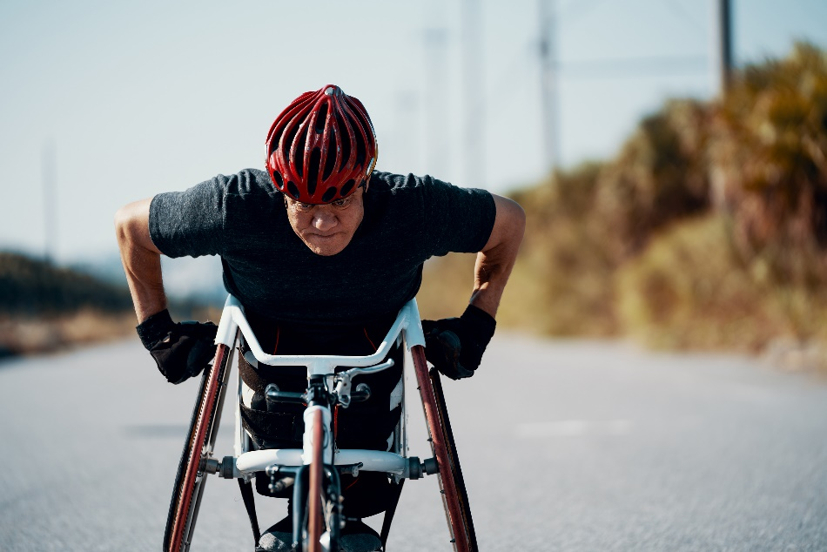Involving relevant people in planning, carrying out and following up on service plans
* Involving the person in the service planning
* Focusing on prevention and management
* Providing compassionate, person-centred service
* Endorsing other available resources that help address their needs
* Communicating with the person regularly to follow up on their progress
* Educating the person with the knowledge and skills for self management

Consider the table below to learn more about promoting self management:

|  |  |
| --- | --- |
| **Scenarios** | **Support That Allows Self Management** |
| A person who is blind needs to fill out a document, but it is only fillable by writing on a physical copy. | You will have to write the needed information on the document. To support the person’s self management, involve them in the process. For instance, you can read the instructions and needed information. The person can then give you the information or answer that you need to write. |
| An older person has a schedule for taking many medicines a day. The person has no physical condition but is quite forgetful. | You will have to make sure that the person takes their medicine on time. Since they are physically capable, you may avoid providing physical support. Instead, you can give them timely reminders. |
| A 13-year-old has suffered a leg injury that leaves them bedridden for weeks. They are unable to go to the bathroom and can only do bedside bathing. | You may have to support the person during bedside bathing. It would be best if you recognised that the person may still prefer to wash their body independently. You can then best assist them by setting up all needed materials. You can also clean up after they have finished. |

The previous examples show how you can support the person’s self management. As you support them, also consider the following:

You must recognise when a person can do the tasks on their own. The above considerations are a good place to start. You must still ensure that the service addresses the person’s needs. It would be best if you then found a balance between the different support activities you have to do.

|  |  |
| --- | --- |
|  | **Checkpoint! Let’s Review**   1. One may define self management as follows:    * Taking responsibility for their wellbeing    * Taking responsibility for their behaviour    * Changing their behaviour when needed 2. To self manage is to do tasks that you can do with minimal help. 3. Self management allows the person to have more control over their own life. 4. You must recognise when a person can do the tasks on their own. |

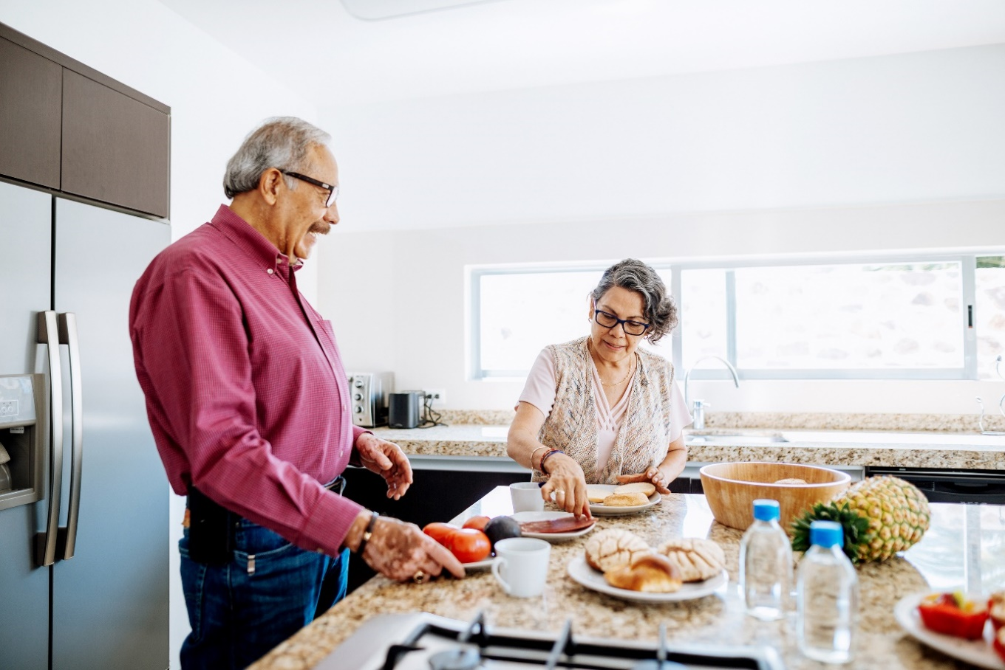

## Encourage the Person to Build, Strengthen and Maintain Independence

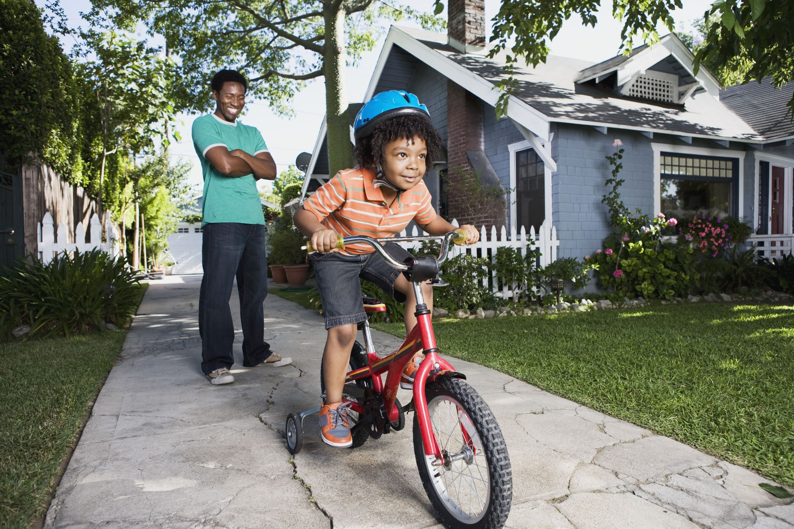

Independence is something that a person can gain or lose. In this context, you must understand three critical concepts:

* **Build**

To build is to gain, develop, or start. Some people may lose independence due to a condition or circumstance. You may then have to support them to gain it back.

* **Strengthen**

To strengthen is to increase or improve. You can consider independence as having levels to it. Then, you want the person to achieve the highest possible level of independence. This is where strengthening practices apply.

* **Maintain**

To maintain is to keep or continue. Independence is something that everyone must enjoy. You may then have to support the person in keeping their independence.

One may see ‘building’, ‘strengthening’ and ‘maintaining’ as separate processes. In many ways, these three apply to many best practices. For instance, a practice may build a person’s independence, but the person may keep the practice, as it helps maintain their independence.

Consider the following best practices to encourage the person to build, strengthen and maintain independence:

* **Provide tools that promote independence.**

Some people may need assistive technologies to cope with their condition. These can include hearing aids, walking sticks and more. Tools like these can allow the person to do some tasks independently.

* **Support physical wellbeing.**

Doing physical activities is the most tangible expression of independence. The person can best do these activities if they take care of their physical wellbeing. The next chapter of this Learner Guide will cover this point.

* **Promote a positive mindset.**

A positive mindset includes the following:

Promoting a positive mindset can include making the person do the following:

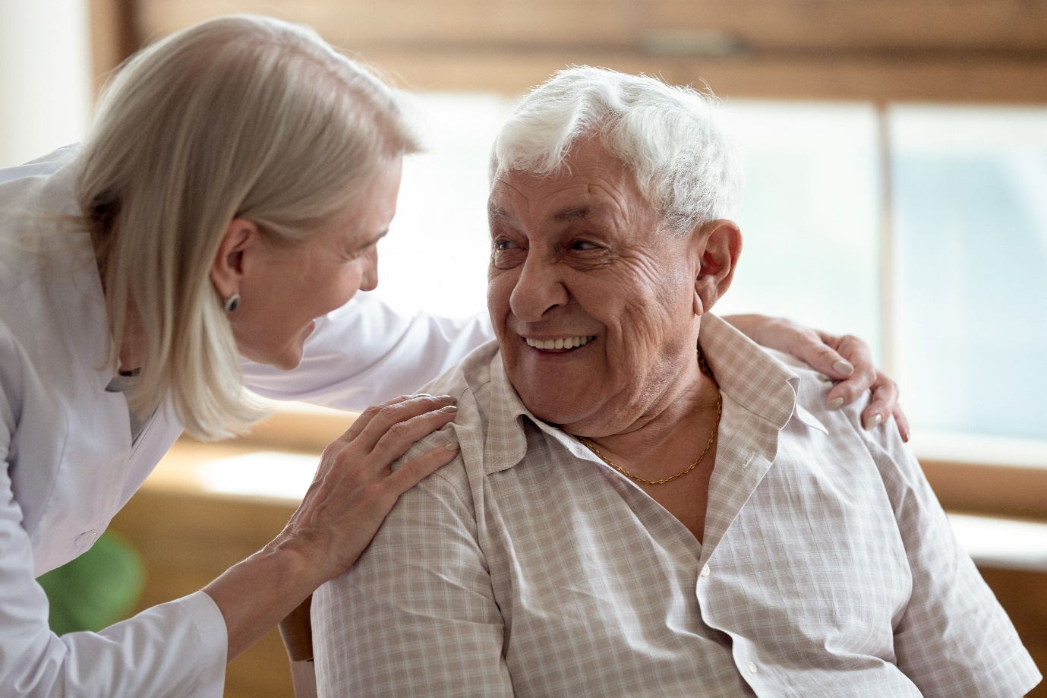

In the context of support work, the following will also be relevant:

* Involve the individual in creating and managing their self-care plan
* Provide opportunities for the individual to utilise their strengths and skills (e.g. let them choose their outfit and dress as much as possible)
* Motivate and encourage the individual to ensure they utilise their full skill set (e.g. participating in activities such as gardening, group outings etc.)
* Communicate regarding the tools and resources available to support them
* Assure them that you are there to help at any time if they need any support

To wrap up, recall that self-actualisation is the result of gaining independence. All the practices above then support an individual to become self-actualised.

|  |
| --- |
| **Multimedia**  Graphical user interface, application  Description automatically generated  Independence and self-management go together. People feel more independent if they can handle things independently, but circumstances like old age and disability can affect these two. The video below discusses the case of care providers:  [How to Promote Independence](https://www.youtube.com/watch?v=a8UliXksHhI) |

|  |  |
| --- | --- |
|  | **Checkpoint! Let’s Review**   1. One may gain or lose their independence. 2. Building, maintaining and strengthening independence go together harmoniously. 3. One can build, maintain and strengthen independence by doing the following:    * Provide tools that promote independence    * Support physical wellbeing    * Promote a positive mindset |

|  |  |
| --- | --- |
|  | Learning Activity for Chapter 2 Well done completing this chapter. You may now proceed to your **Learning Activity Booklet** (provided along with this Learner Guide)and complete the learning activities associated with this chapter.  Please coordinate with your trainer/training organisation for additional instructions and guidance in completing these practical activities. |

# III. Support Physical Wellbeing



A vital part of supporting a person is taking care of their physical health. This can mean taking on tasks they may not be able to do themselves, such as brushing their teeth or showering. It can also mean monitoring a person’s physical wellbeing. You may be constantly alert for signs of deterioration or change in your health.

**Wellbeing**

Wellbeing is a state that a person can achieve. There is no universal definition of wellbeing, but the following common points are usually part of achieving positive wellbeing:

* **Being healthy** – A healthy person has maximised their bodily functions. They can perform any tasks near their peak potential. Being healthy is not just the absence of disease, illness, or condition. For instance, a person with disability can maintain their best health by taking care of their other bodily functions.
* **Being happy** – Being happy is another subjective state with many possible considerations. A happy person usually experiences more positive emotions than negative ones. One can also define a happy person as someone with a positive general view of life.
* **Being prosperous** – A prosperous person can meet their material needs. In this sense, one can relate prosperity and financial capacity. A prosperous person is not necessarily wealthy. But having the financial capacity to afford basic material needs is the least level to reach.

You can divide wellbeing into different aspects or components. Complete wellbeing means satisfying the requirements for each component. The components of wellbeing include the following:

This chapter will focus on physical wellbeing. The next chapter will cover the rest of the list.

**Physical Wellbeing**

Physical wellbeing is the state of a person according to their physical health. It is being physically healthy and having a healthy body that enables a person to deal with the challenges of everyday life, fight off illnesses and function well.

**Basic Requirements for Good Health**

As mentioned previously, to be healthy is to maximise bodily functions. A healthy person can do their best with whatever condition they have. To be healthy requires a holistic approach to taking care of the body. In general, a healthy person should satisfy the following aspects:

* **Nutrition and hydration**

A healthy person eats a balanced diet that provides all the needed nutrients. A healthy person also eats enough to meet their energy requirements. They also generally avoid unhealthy foods.

A healthy person drinks enough liquids to hydrate their body. Liquids include water and other healthy drinks. Each person will need different amounts daily. A good rule to remember is to drink enough water when you feel thirsty.

* **Exercise**

A healthy person does enough physical activities to maintain many bodily functions. The muscles, lungs and heart are some body parts that need physical activities. Exercise is one way of engaging in physical activities. Doing so provides benefits such as preventing some health problems and keeping their body weight in check.

* **Hygiene**

Hygiene is a set of conditions or practices that a healthy person follows. Hygiene is generally associated with cleanliness and the prevention of diseases. In this sense, hygiene covers both personal and social space.

* **Lifestyle**

Lifestyle is the collection of beliefs and practices of a person. Lifestyle also involves all the choices a person makes that affect their health. A healthy lifestyle is a deliberate decision to think and do things that cause good health.

* **Oral health**

Oral health refers to the physical state of the mouth, encompassing the lips, teeth, gums, tongue and throat. A healthy mouth ensures you are free from oral diseases and conditions.

* **Mental health**

Mental health may refer to thoughts, behaviours and feelings. It may be more related to psychological, social, spiritual and cultural wellbeing. But there is a strong connection between mental health and physical wellbeing. In a way, there is a link between a person’s thoughts and actions. Good mental health then is having positive thoughts, behaviours and feelings. Reducing stress is one relevant practice, as stress is associated with mental illnesses.

Later in this chapter, you will find ways to meet the basic requirements of the abovementioned aspects. The next chapter will also discuss mental health.

This chapter will discuss the following that will help you support a person’s physical wellbeing:

* Promote and encourage daily living habits that contribute to healthy lifestyle
* Support and assist the person in maintaining a safe and healthy environment
* Recognise hazards and report according to organisational policies and procedures
* Identify and report variations in a person’s physical condition
* Recognise and report physical indications that may affect the person’s wellbeing
* Identify and report physical health situations beyond the scope of your role

## Promote and Encourage Daily Living Habits That Contribute to Healthy Lifestyle

Daily living habits are the tasks and activities a person does every day. For the most part, these tasks and activities sustain the person’s life. In this context, daily living habits can include the following:

A healthy lifestyle is a deliberate decision to think and do things that cause good health. A healthy lifestyle then involves doing daily living habits the right way. Below are requirements that promote positive daily living habits:

* **Healthy hygiene**
  + Ensure self-care tools and products are easily accessible.
  + Wash clothes, bedding and towels regularly.
  + Maintain a clean environment.
  + Set up a regular bath schedule.
* **Proper oral health**
  + Maintain a routine for brushing.
  + Visit the dentist for regular check-ups.
* **Healthy eating**
  + Set up regular mealtimes.
  + Provide healthy diet options.
  + Ensure an adequate amount of daily calorie intake.
* **Proper hydration**
  + Provide accessible drinking water.
  + Encourage regular fluid intake.
  + Monitor fluid intake.
* **Healthy sleeping**
  + Set up a regular sleep schedule.
  + Provide a comfortable place to sleep.
  + Aim for a good amount of sleep (six to eight hours).
  + Reduce distractions at least an hour before sleeping.
* **Regular exercise**
  + Encourage regular physical movement.
  + Make physical activities a part of their daily routine.
* **Healthy lifestyle**
  + Ensure quality sleep and rest through routines.
  + Consider social activities (e.g. organising transport).
  + Engage in likes and hobbies (e.g. reading and crafting).
* **Good mental health**
  + Use safe and predictable routines.
  + Support independence and social activities.
  + Demonstrate respect and sensitivity in all interactions.

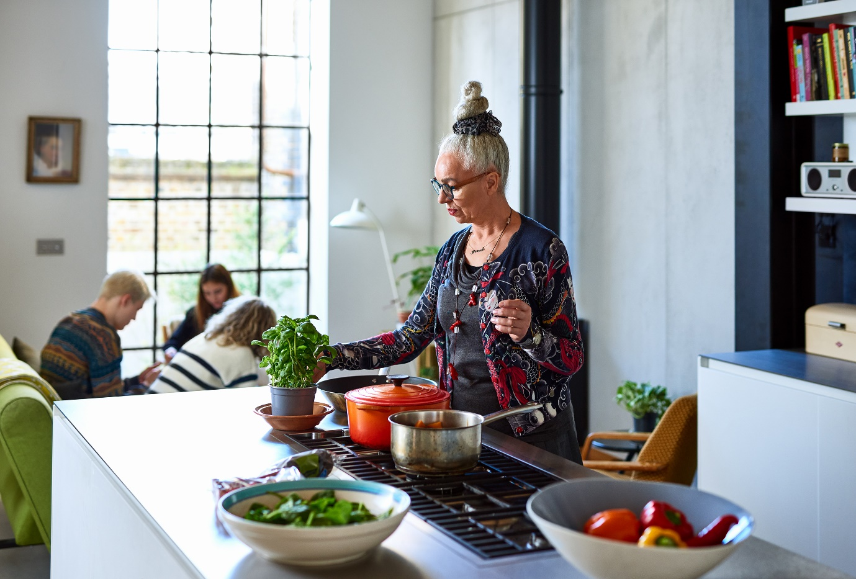

As a support worker, you must adhere to support requirements similar to those listed above. Your organisation will set these requirements, an overseeing government body or the person’s individualised plan.

Doing all these prevent or minimise the impact of issues on the person’s health and wellbeing. You will encounter these issues as you make progress with this Learner Guide. Examples include the following:

* Having a poor diet
* Living in a hazardous environment
* Obtaining a physical illness and/or injury
* Being isolated or withdrawn from social interactions and activities
* Having mental illness (e.g. depression, anxiety, dementia)
* Making poor lifestyle choices (e.g. little or no exercise, drinking, smoking, using drugs etc.)

**Promoting Daily Living Habits That Contribute to Healthy Lifestyle**

Promotion means raising or uplifting something. In the context of support work, promotion involves deliberate actions. These actions induce positive effects.

Consider the following best practices in promoting a healthy lifestyle:

* Considering the person's strengths and preferences in planning
* Introducing variations to reduce repetitiveness and blandness
* Involving the person in planning the activities



**Encouraging Daily Living Habits That Contribute to Healthy Lifestyle**

Encouragement means giving support, confidence and hope. To encourage someone is to persuade them to start or continue something.

Consider the following best practices in encouraging a healthy lifestyle:

* Discouraging unhealthy activities or choices
* Highlighting the benefits of healthy activities
* Celebrating small positive changes from lifestyle changes

Promoting and encouraging a healthy lifestyle involves regular prompting, encouragement and guidance. The person must realise that doing small daily activities can help in the long run. A healthy lifestyle builds up a person's physical wellbeing. This build-up, in turn, promotes the person's independence.



|  |  |
| --- | --- |
|  | **Further Reading**  The Australian Government has released guidelines on suitable physical activities and behaviour. Each age group have their own recommended information. Access these guidelines using the link below:  [Physical activity and exercise guidelines for all Australians](https://www.health.gov.au/health-topics/physical-activity-and-exercise/physical-activity-and-exercise-guidelines-for-all-australians)  The government also has guidelines on healthy eating habits. Access the complete compilation of guidelines in the link below:  [The Australian Dietary Guidelines](https://www.health.gov.au/resources/publications/the-australian-dietary-guidelines) |

|  |  |
| --- | --- |
|  | **Checkpoint! Let’s Review**   1. Daily living habits are the tasks and activities a person does every day. 2. A healthy lifestyle is a deliberate decision to think and do things that cause good health. 3. A healthy lifestyle involves doing daily living habits the right way. It builds up a person’s physical wellbeing. 4. Promoting and encouraging a healthy lifestyle involves regular prompting, encouragement and guidance. |

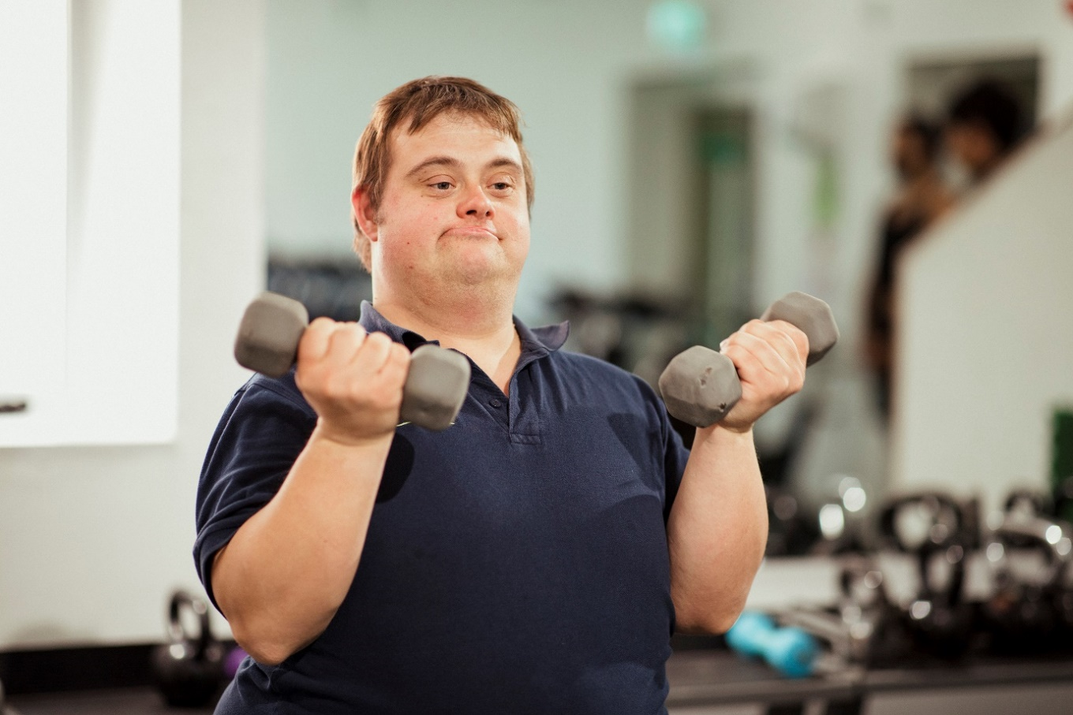

## Support and Assist the Person to Maintain a Safe and Healthy Environment

To perform your job properly, you may work in the following environments:

In all, you must ensure that the person is safe and healthy. A safe environment is free from unintentional harm. A healthy environment prevents people from contracting diseases and illnesses. Being healthy also means that you are safe. But for this discussion, safety will cover non-health elements. Ensuring a healthy and safe environment means supporting and assisting the person. Support in the context of your work means promoting positive aspects or changes. Supporting involves providing information and motivation. Assisting is providing real, tangible help and involves manual tasks with a corresponding goal or product.

**Maintaining a Safe Environment**

Safety covers elements that may cause unintentional harm. Maintaining safety means fixing, removing, or reducing these elements in your work. Examples of these unsafe elements are the following:

* Steep stairs
* Broken furniture
* Inactive fire alarms
* Some house chemicals
* Wet spots on the floor
* Exposed electrical wires
* Misplaced sharp objects
* Loose objects on the floor
* Unattended heating objects

**Supporting the Person in Maintaining a Safe Environment**

Sometimes, you may be unable to remove unsafe elements. In these cases, you will have to provide the solutions listed below:

* Encourage the person to use a walking aid, especially if they have reduced mobility.
* Inform the person of all the potential hazards around them. Updating them regularly about these hazards will also help.
* Encourage the person to seek help if they cannot do a task alone. Let them know that asking for help from time to time is normal.

**Assisting the Person in Maintaining a Safe Environment**

Below are some of the practices that assist the person in maintaining a safe environment:

* **Help move the vulnerable person if they live upstairs.** This way, they avoid using the stairs on their own.
* **Install handrails and anti-slip mats in the bathroom.** Handrails and anti-slip mats can help avoid slipping on the wet floor.
* **Keep sharp objects like scissors and kitchen knives in secure locations.** These items are essential but dangerous.
* **Keep cleaning products in secure locations.** These chemicals are often harmful when ingested.
* **Monitor heating elements like stoves and toasters.** Diligent monitoring during use will help reduce safety issues.

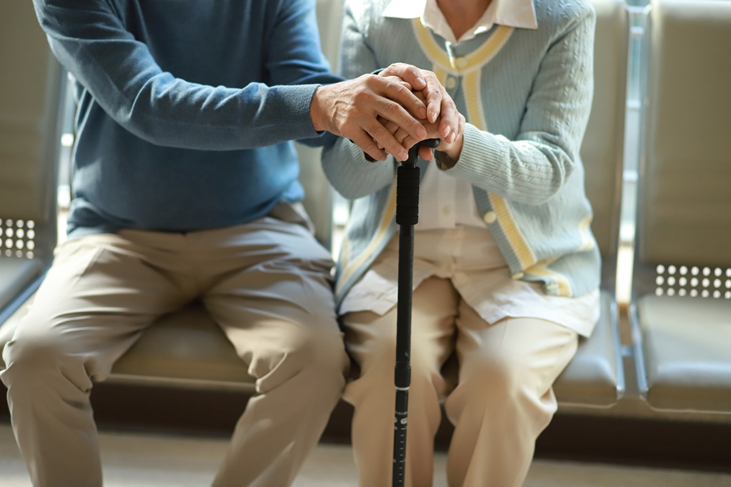

Supporting and assisting the person’s safe environment may come at different levels. It will come down to how much control you will have over the environment.

* You have higher control over places like community centres, offices and care facilities. Also, these places were likely built with safety in mind. There, you can directly practice your organisation’s safety policies and procedures.
* You have lesser control over the person’s own dwelling. It would be best if you balance your responsibilities, the current setup and the person’s preferences. Collaborating with the person and the household is then crucial.

**Maintaining a Healthy Environment**

A healthy environment prevents people from contracting diseases and illnesses. You must remove elements that may cause short-term and long-term health issues. Both living and non-living elements can cause diseases and illnesses. Consider the table below:

|  |  |
| --- | --- |
| **Unhealthy Living Elements** | **Unhealthy Non-living Elements** |
| * Mosquitoes * Bacteria * Moulds * Ticks * Flies * Rats | * Carbon monoxide * Poor ventilation * Pollen and dust * Asbestos * Viruses * Lead |

There are many ways to address unhealthy elements in most environments. In most cases, proper cleanliness and hygiene are practical solutions. This also means doing regular clean-ups of the premises.



**Supporting the Person in Maintaining a Healthy Environment**

From earlier, supporting is providing information and motivation. In this context, the following can help maintain a healthy environment:

* Encourage the person to maintain good hygiene.
* Educate the person about the common health hazards in their surroundings.
* Encourage the person to be vigilant of any health hazards that may arise. Have them report these hazards immediately.

**Assisting the Person in Maintaining a Healthy Environment**

The following best practices can also help in maintaining a healthy environment:

* **Avoid having stagnant water around the premises.** Clean water-bearing objects like vases at least once a week.
* **Pay closer attention to frequently used objects like doorknobs and railings.** Consider this when you clean the premises.
* **Wash fabric-based items like pillowcases and curtains regularly.** Make sure to have spare items to use.



* **Replace worn-out cleaning materials like rags and brooms.** Using worn-out materials can reduce the effectiveness of work.
* **Check perishable food items for growth or discolouration.** Discard these damaged items immediately.
* **Perform pest control measures for dire cases.** Do this when it is only absolutely necessary. Make sure to follow organisational policies and procedures for this.
* **Check if allergens are around.** For example, pet hairs can cause allergic reactions in some. Check if the person has this condition if pets are around.
* **Ensure that pipes, containers, and appliances do not leak any smoke or weird smell.** Consult the building custodian or the family for this.
* **Adapt to seasonal changes and the person’s preferences regarding ventilation.** Ventilation requirements may vary across seasons.
* **Be careful of harmful materials in the area.** Some old buildings use asbestos fibres and lead paint. The building custodian or the family might know if there are harmful materials like this in the area.

Like keeping it safe, control is essential for a healthy environment. It would be best to consider who has the highest authority on the premises. A homeowner will have the final say on matters related to their homes. Organisations will have a more significant influence on their facilities. Respecting and consulting the place’s primary caretaker is then essential for you.



|  |
| --- |
| **Multimedia**  Graphical user interface, application  Description automatically generated  A safe and healthy environment necessitates cleanliness. The video below discusses basic pointers for home upkeep:  [7 Principles of a Healthy Home—Nemours: Keeping a Healthy Home](https://www.youtube.com/watch?v=_utETAoJLJo) |

|  |  |
| --- | --- |
|  | **Checkpoint! Let’s Review**   1. Shield Tick with solid fillA safe environment is free from unintentional harm. 2. A healthy environment prevents people from contracting diseases and illnesses. 3. Safety covers elements that may cause unintentional harm. Maintaining safety means fixing, removing, or reducing these elements in your work. 4. You must remove elements that may cause short-term and long-term health issues. Both living and non-living elements can cause diseases and illnesses. 5. It would be best if you always considered who has the highest authority on the premises. Respecting and consulting the place’s primary caretaker is essential. |

## Recognise Hazards and Report According to Organisational Policies and Procedures



Keeping a person safe from harm is another way to support their physical wellbeing. You can reduce the risks of any harm occurring by being aware of hazards. A *hazard* is something that can cause harm to a person’s health, safety and wellbeing.

Consider the examples of hazards and their associated risks below:

|  |  |
| --- | --- |
| **Hazards** | **Risk** |
| Wet floor | Slipping |
| Very hot temperature | Dehydration |
| High salt intake | High blood pressure |

Hazard and risk are two terms that are often confused with each other. A hazard does not pose a risk unless people are exposed to it. On the other hand, a risk arises when people are exposed to a hazard. Recognising hazards is the first step in keeping the person safe from the harm these may bring. When aware of these hazards, you can start thinking of ways to address them and reduce the risk of harm.

**Recognising Hazards**

You can categorise hazards to identify better and address them. Consider the groups of hazards below.

* **Physical hazards**

Physical hazards are material objects or controllable conditions. Examples include knives, wet floors, steep stairs and unattended cooking gas stoves.

* **Environmental hazards**

Environmental hazards are mostly uncontrollable events and conditions. Examples include temperature outside, humidity, pollution and weather disturbances.

* **Physiological hazards**

Physiological hazards are objects, events, or conditions that cause health-related harm. Examples include the following:

* + Fatty foods can cause a heart attack
  + Sugar can cause a blood sugar spike
  + Pollen can cause an allergic reaction

You may have to assess the person’s lifestyle to determine the hazards. Assessed aspects will depend on the needs of the person. These may be the person’s current living conditions, relationships and day-to-day activities.

Your organisation should have all the policies and procedures to identify hazards. The assessment may include the following:

|  |  |
| --- | --- |
|  | **Further Reading**  The State of Victoria has good introductory coverage of identifying hazards. You can access it using the link below:  [Hazard identification, risk assessment and risk control](https://www.education.vic.gov.au/school/students/beyond/Pages/hazidentify.aspx) |

|  |
| --- |
| **Multimedia**  Graphical user interface, application  Description automatically generated  Home care workers for older people and people with disability encounter many hazards. Learn about the many hazards at home using the video below.  [Hazards and Risks for Homecare Workers in Aged Care and Disability](https://www.youtube.com/watch?v=FYWjlb7yogA) |



**Reporting Hazards According to Organisations Policies and Procedures**

It is part of your job role to report any hazard to prevent incidents in the workplace. Doing so will not only protect you, but it will also protect the person and everyone else.

Different organisations may have different policies for reporting hazards. There may be instances where hazards are reported verbally. In other cases, you would have to submit a written report.

For verbal reporting, you might have to consider the following:

Written reports serve as documentation of the hazards identified. You would need to know the template used by your organisation. An example of a form that your organisation may use is a Hazard Identification report form.

This includes details about the following:

* The location of the hazard identified
* A description of the hazard
* The affected persons
* The associated risks
* The control measures to prevent the hazard from occurring

The table below shows a template of a hazard identification form:

|  |  |  |  |  |  |  |
| --- | --- | --- | --- | --- | --- | --- |
| **Place Checked** | |  | | | | |
| **Prepared by** | |  | | | | |
| **Date Completed** | |  | | | | |
| **Hazard** | **Affected Persons** | | **Associated Risks** | **Control Measure** | | |
| **Control Measure for Implementation** | **Personnel Who Will Implement** | **Deadline for Implementation** |
|  |  | |  |  |  |  |

|  |  |
| --- | --- |
|  | **Checkpoint! Let’s Review**   1. A hazard can cause harm to the person’s health, safety and wellbeing. 2. A hazardous event occurs when a person experiences harm from a specific hazard. 3. Hazards may be one of the following:    * Physical hazards    * Environmental hazards    * Physiological hazards 4. You may have to assess the person’s lifestyle to determine the hazards present. |

## Identify and Report Variations in a Person’s Physical Condition

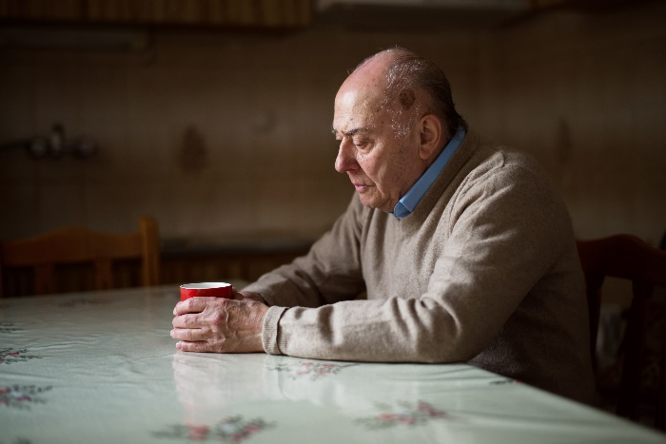Observing changes in a person's physical condition can alert you of additional care they might need. Changes in a person’s physical state can point to health and wellbeing issues. They may indicate a developing disease or discomfort that needs medical attention.

When monitoring for changes in a person’s physical condition, you can take a look at the following:

* **Appearance**

Variations in appearance are the easiest to check. These can include the following:

* **Ability**

A person may display a sudden ineptitude to some physical tasks. Besides the visible difficulty they show, the following are tell-tale signs:

* Exhibiting talking difficulties
* Having breathing difficulties
* Exhibiting hesitancy in moving
* Exhibiting limited physical movements
* **Behaviour**

A person may be able to hide certain physical appearances. They may also exert to mask their affected abilities. In these cases, variations in behaviour may come up. These variations can include the following:

* **Communication**

Ideally, the person should communicate any changes or conditions that they have. Communication can include the following:

* Talking about pain or discomfort
* Pointing to the painful or aching part of the body

**Reporting Variations in a Person’s Physical Condition**

Your organisation should also have the necessary policies and procedures for health monitoring. You should then be familiar with the tools and forms you may use.

For health monitoring, especially for physical conditions, you may encounter the following:

* **Progress notes**

Progress notes are medical records that track the person’s progress. They are usually detailed accounts of a person’s experience. Progress notes help in keeping track of the person’s health to detect signs and symptoms early. They can also help document the improving or worsening condition of the person.

* **Incident reports**

Incident reports are legal documents that you may do immediately after an incident. Incidents are any events that do happen and bring harm to a person. Incident reports contain the full details of the event. The details are helpful for both medical and legal use.

The table below shows a simple daily health questionnaire. A questionnaire can help you identify variations in physical condition. Take note that the questionnaire only shows some questions that you may use. Remember to use your organisation’s provided tool.

The person may be unable to answer the questions below. In such cases, the family member or carer must provide the answers. The form will instead document the observations made by the family or carer. Again, your organisation’s tools and forms should cover this.

|  |  |  |  |
| --- | --- | --- | --- |
| **Sample Daily Health Questionnaire** | | | |
| **Name** |  | | |
| **Date** |  | **Time** |  |
| **How does your head feel today?** | | | |
|  | | | |
| **Is your nose itchy or congested?** | | | |
|  | | | |
| **How does your mouth feel today?** | | | |
|  | | | |
| **Are you experiencing any unusual changes in smell or taste?** | | | |
|  | | | |
| **How do your neck and throat feel today?** | | | |
|  | | | |
| **Do you have a cough or shortness of breath?** | | | |
|  | | | |
| **Are there other symptoms you are experiencing?** | | | |
|  | | | |
| **Accomplished by** |  | | |

|  |  |
| --- | --- |
|  | **Checkpoint! Let’s Review**   1. Changes in a person’s physical condition can point to health and wellbeing issues. 2. When dealing with physical conditions, the following are useful indicators.    * Appearance    * Ability    * Behaviour    * Communication 3. A questionnaire can help you identify variations in physical condition. 4. The person may be unable to answer your questions. In such cases, a family member or carer must answer. |



## Recognise and Report Physical Indications that May Affect the Person’s Wellbeing

Aside from any changes, look out for how the person’s physical situations affect their overall wellbeing.

A person's physical situation may refer to any circumstance that affects them physically. This includes reduced mobility, injuries, or effects of illnesses such as being in pain. Environments that do not meet their needs are also things you may look into. Consider the following situations and indications that they are affecting the person’s wellbeing:

| **Physical Situation** | **Indications** |
| --- | --- |
| **Constant pain** | A person in constant pain will not only bear the pain itself but also its secondary effects, such as the following:   * Loss of sleep, leading to impaired function * Loss of focus, leading to low productivity |
| **Physical injury** | A person with some form of injury will not only experience pain but will also be physically limited. Injuries to limbs, for instance, can severely affect the person’s many activities and functions. |
| **Stairs** | People with reduced mobility may find stairs difficult to use. Vulnerable people include older people and people with reduced mobility. |
| **Climate and weather** | Extreme temperatures are harmful. For example, high temperatures can cause dehydration and heatstroke, and low temperatures make respiratory infections more common. |
| **Loud neighbourhood** | A loud neighbourhood can disrupt rest and sleep. A prolonged lack of proper sleep can cause short-term and long-term issues. |
| **Lack of public transportation** | Some people may live in areas away from public transport. This situation makes it difficult for them to travel. People with reduced mobility are at a disadvantage. |

|  |  |
| --- | --- |
| **Physical Situation** | **Indications** |
| **Lack of space for exercise** | People living in care facilities may lack private space for exercise. Others living in tiny homes may experience a similar limitation. Public spaces are great alternatives. But some people with health conditions may want to avoid them. |
| **Limited access to fresh produce** | Healthy eating is difficult in many ways. Access to healthy options like fresh produce is a known barrier to a healthy diet. High prices or the absence of these options are some of the causes. |

**Recognising If a Person’s Situation Affects Their Wellbeing**

You might work with people who may feel unwell but cannot or do not want to communicate these. Some might be uncomfortable with sharing their discomfort. Others might not know how to express their concerns adequately.

Some approaches you can try when recognising if the person's wellbeing is affected by their situation include the following:

* **Observation**

Throughout your working relationship, you will see them participate in different activities. If something feels different from their usual behaviour, it might be better to look into why this is so. You may ask the person, the family, or the carer. Your organisation will likely have the policies and procedures for this process. Regular consultations on matters like the physical situation are common.

* **Communication**

You may directly ask the person how they feel and what situation makes them feel that way. You can also ask their carer, friends and family for their own observations.

As a support worker, you will be closely working with them and gain a sense of familiarity. This sense of familiarity will be helpful in recognising if they are feeling stressed out or unwell. Building rapport and having empathy would make you more attentive.

**Reporting If a Person’s Situation Affects Their Wellbeing**

Organisational policies for reporting anything that affects a person's wellbeing usually revolve around the following:

* Whom to report
* What to report
* Where to document observations

Typically, these will also be recorded in the progress notes. The progress notes serve as the reference for any improvement in the person’s condition. It can also serve as the basis for additional support and care.

Organisations may have their templates. The following are things you can also include in your notes:

* The indicators observed
* The physical situation that affected their wellbeing
* Something that the person said about their wellbeing
* Relevant observations that family/carer shared
* Action items to help the person

|  |  |
| --- | --- |
|  | **Checkpoint! Let’s Review**   1. Physical situation refers to the person’s immediate environment. The physical situation also includes the elements surrounding the person. 2. There are many forms of negative physical situations. 3. Like other conditions, you must report variations in physical condition. |

## Identify and Report Physical Health Situations Beyond Scope of Your Role

Some physical health situations will need a professional response. As a support worker, you must learn to identify signs of these situations. It is also important to remember that you have limited responsibilities in responding. You will only have a reporting role unless you have the proper training.

**Recognising Physical Health Situations Beyond Your Role**

The table below lists some common health problems and their signs and symptoms:

|  |  |
| --- | --- |
| **Health Problem** | **Presentation** |
| **Hypertension** | Hypertension’s important sign is blood pressure.  Hypertension is having one or both:   * **Systolic** – Blood pressure greater than or equal to 140 mmHg * **Diastolic** – Blood pressure greater than or equal to 90 mmHg.   People with hypertension usually do not experience any symptoms. A few have reported headaches, nosebleeds and shortness of breath. Hypertension is in the presentation of heart attacks and strokes. Hypertension is also called *high blood pressure* or *elevated blood pressure*. |
| **Heart Attack** | A heart attack happens when a blood vessel in the heart gets blocked. Cholesterol build-up is the most common cause.  High cholesterol and hypertension are common signs that may lead to a heart attack. Symptoms of a heart attack include the following:   * Discomfort in the left-side arm, neck and back * Tightness and pain in the chest region * Dizziness and nausea * Shortness of breath * Vomiting |

| **Health Problem** | **Presentation** |
| --- | --- |
| **Stroke** | A stroke, or brain attack, happens for any of the two reasons:   * The brain does not receive enough oxygen * The blood vessels in the brain burst   The common cause of stroke is blood clots blocking the blood vessels in the brain. Common symptoms of a stroke are sudden manifestations of any of the following:   * Loss of balance and coordination * Severe numbness * Severe headache * Blurry vision * Confusion |
| **Type 2 Diabetes** | Type 2 diabetes is a condition where a person cannot use their body’s *insulin*. People with Type 2 diabetes have high amounts of sugar in their blood.  Symptoms may include the following:   * Blurry vision * Persistent fatigue * Frequent urination * Sudden weight loss * Unquenchable thirst * Slow healing of wounds |
| **Asthma** | Asthma is a lung condition described by the narrowing of airways. The narrowing causes the symptoms such as the following:   * Coughing * Wheezing * Chest tightening * Difficulty in breathing |

|  |  |
| --- | --- |
| **Health Problem** | **Presentation** |
| **Allergies** | Allergies are reactions of the immune system to some substances. The following are examples of possible allergens:   * Dust * Food * Pollen * Animal   High histamine in the blood is a sign of an allergy. Histamine causes the blood vessels to expand. Swollen blood vessels may then cause symptoms such as the following:   * Red eyes * Runny nose * Watery eyes * Itchy and swollen skin * Difficulty in breathing |
| **Cancer** | Cancer is a condition of abnormal cell growth. There are different types of cancer according to the affected cell. Professionals can test possible cancer cells in laboratories. Lumps may also form. These two are the common signs of cancer to consider.  Symptoms of cancer may include the following:   * Irregular bowel movement * Sudden weight loss * Abnormal bleeding * Persistent cough |
| **High Cholesterol** | Cholesterol levels should be no more than 5.5 mmol/L. Going above 5.5 is a sign of a high cholesterol condition. This condition is also called *hypercholesterolemia*.  High cholesterol has no symptoms. But people with high cholesterol levels may suffer from heart attacks or stroke. |

One may categorise health situations as emergency or non-emergency:

For emergencies, you must be familiar with your organisational procedures. These situations will usually involve calling 000 for first responders. You may have a medical professional on the premises. Their presence is common for more extensive facilities. In such cases, someone must call the attention of the professional immediately.

You can only administer intervention or response if:

* You are trained, qualified and certified
* You are capable at that very moment

As much as possible, professionals must handle emergencies.

For non-emergency situations, early detection and reporting are more important. These situations are usually for mild and acute health problems. As soon as you detect any sign or symptom, you must report this immediately.

If you need to administer medication, make sure that you are qualified. The person's individualised plan should explicitly identify you. Otherwise, seek the help of anyone identified and qualified to administer the medicine.

**Reporting Physical Health Situations Beyond Your Role**

You may have to report to the following personnel for detected health situations:

* The supervisor
* The medical personnel available
* The person's assigned medical professional

Like reporting other observations, you must know the answer to the following questions:

* What do you have to report?
* How should you do the report?
* How frequently should you report?
* Who do you approach for reports and updates?
* How do you contact them during emergencies?

You must be ready with all the information you may need to forward. These can include the following:

You must be familiar with your organisation's policies and procedures. Make sure to follow them correctly and honestly. Your prompt and proper response may be a difference-maker.

|  |  |
| --- | --- |
|  | **Further Reading**  In case of an emergency, you can call 000 for help. Other important information is in the reading below:  [Emergency Assistance and Support](https://www.australia.gov.au/phone-contacts)  [Service continuity and emergency events in aged care](https://www.health.gov.au/health-topics/aged-care/providing-aged-care-services/working-in-aged-care/service-continuity-and-emergency-events-in-aged-care) |

|  |  |
| --- | --- |
|  | **Checkpoint! Let’s Review**   1. Some situations will need a professional response. 2. For emergencies, you must be familiar with your organisational procedures. 3. For non-emergencies, early detection and reporting are more important. |



|  |  |
| --- | --- |
|  | Learning Activity for Chapter 3 Well done completing this chapter. You may now proceed to your **Learning Activity Booklet** (provided along with this Learner Guide)and complete the learning activities associated with this chapter.  Please coordinate with your trainer/training organisation for additional instructions and guidance in completing these practical activities. |

# IV. Support Social, Emotional and Psychological Wellbeing

The previous chapter focused on physical wellbeing. For the most part, physical wellbeing is expansive but manageable. Recall that wellbeing as a whole, though, includes many components. Some of these components include the following:

* **Psychological wellbeing**

Psychological wellbeing may involve the following elements:

* Self-control
* Self-determination
* Personal growth and development
* Purpose and meaning in life

A balance between challenging and rewarding life experiences also helps in psychological wellbeing. It is then the absence of mental illness, functioning at an emotional and behavioural level that is healthy and stable.

* **Social wellbeing**

Social wellbeing is the ability to have meaningful and satisfying interpersonal relationships with others. It also relates to the ability to adapt comfortably to different social situations and act appropriately in a variety of settings.

* **Spiritual wellbeing**

Spiritual wellbeing usually relates to the feeling of purpose and meaning in life. It is a very personal component that affects other physical components of living. In a way, it relates to realising and freely expressing faith, values, beliefs, principles and morals.

* **Cultural wellbeing**

Cultural wellbeing includes shared beliefs, customs, values, behaviours and identity. Cultural wellbeing is participating in cultural activities and the freedom to retain, interpret and express their arts, history, heritage and traditions.

* **Financial wellbeing**

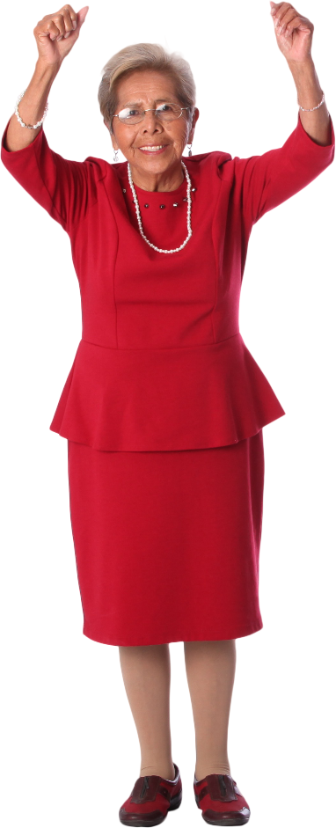Financial wellbeing is about financial security and freedom of choice. It is being able to meet current and ongoing financial obligations, feel secure in their financial future, and make choices to enjoy life.

* **Professional wellbeing**

Professional wellbeing has a positive outlook and sentiment on work or vocation. It may be having a sense of pride or fulfilment in what one does. Economic rewards may or may not matter. Professional wellbeing is then a state of wholeness that results from bringing into balance life, work, people and money.

This chapter focuses on supporting social, emotional and psychological wellbeing. In this chapter, you will learn to do the following:

* Promote self-esteem and confidence using positive and supportive communication
* Contribute to the person’s sense of security using safe and predictable routines
* Encourage and facilitate participation in activities according to networks and preferences
* Identify and seek help on aspects of support work outside the scope of job role
* Identify and report variations to a person’s wellbeing
* Identify cultural or financial issues impacting on the person’s wellbeing
* Identify the person’s risk and protective factors about to mental health
* Recognise and report abuse or neglect on the person
* Identify and report situations beyond scope of your own role

## Promote Self-Esteem and Confidence Using Positive and Supportive Communication



*Self-esteem* is how you see yourself. It may be how you rate or gauge your value or skills. How others perceive these values or skills is not relevant. Unlike self-esteem, *confidence* is how others see you. In this sense, confidence can also be how you present yourself. Skills-wise, being confident means practising what you intend to show.

Self-esteem and confidence show that an individual may have conflicting thoughts and behaviours. Ideally, a person must have high self-esteem and confidence. Some people lack one or both. You can usually describe them as shy, reserved, hesitant or sad.

You may find yourself helping a person develop their self-esteem and confidence. In doing so, positive and supportive communication can help. Communication can impact how others see themselves and their place in the community. Communication includes the language, preferences and behaviours that you project. These are all by-products of humans being social and sentient.

**Positive and Supportive Communication**

Positive communication is communication that is valuable, optimistic and friendly. Consider the following:

* **Valuable** – The receiver gains something useful
* **Optimistic** – The message evokes hope and confidence
* **Friendly** – The message does not intend to harm in any way

Supportive communication is communication that helps those experiencing distress. It involves a deliberate approach to counter distress by doing any of the following:

Positive and supportive communication helps with self-esteem and confidence by their very nature. Positive and supportive expressions or gestures help a person see themselves differently. These expressions may then help the person be more comfortable with others.

Positive and supportive communication work best. Below are some practices that incorporate positive and supportive communication.

* Acknowledge people when you first see them.
* Greet people by their name or the name they prefer.
* Be an active listener when someone is communicating with you.
* Talk to others as equals. Avoid language and tone that talk down to them.
* Respond with empathy. Never one-up or downplay someone’s feelings.
* Compliment when someone looks nice or changes their appearance.
* Acknowledge a person’s efforts and achievements.
* Show interest and purpose in the persons’ lives.
* Promote and support personal choices.
* Respect personal beliefs and culture.

|  |
| --- |
| **Multimedia**  Graphical user interface, application  Description automatically generated  Confidence is a necessary trait to get through life. As social creatures, humans need interaction to get by. People with issues with confidence may be at a disadvantage. The video below talks about how one can build confidence:  [3 tips to boost your confidence - TED-Ed](https://www.youtube.com/watch?v=l_NYrWqUR40) |

|  |  |
| --- | --- |
|  | **Checkpoint! Let’s Review**   1. Self-esteem is how you see yourself. Confidence is how others see you. 2. Ideally, a person must have high self-esteem and confidence. Some people lack one or both. 3. Communication can impact how others see themselves and their place in the community. 4. Positive and supportive communication involves using a respectful tone and body language. |

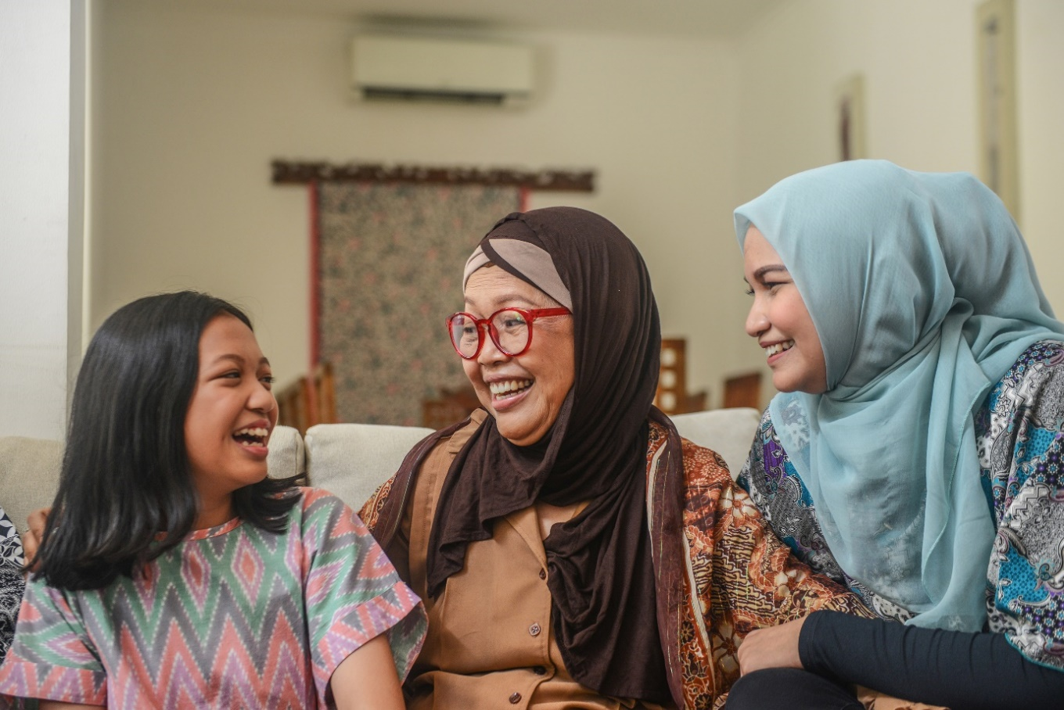

## Contribute to the Person’s Sense of Security Using Safe and Predictable Routines



Routines are tasks or activities done regularly. Regularity means having the exact requirements or results of every task completion. In this context, routines are predictable. With proper planning and implementation, routines can then be safe.

Safe and predictable routines make people feel secure. Knowing what will happen eases a person's anxiety. People with some conditions, such as autism, even use routines to cope.

You may have to help individuals set up a routine for their service. You may also provide services that are essentially routine tasks for the person. In these cases, consider some of the best practices below:

* **Maintain the balance between the plan's goals and the person's preferences.** The person's individualised plan should have established this balance or compromise. Consult your supervisor if related changes are to be made.
* **Ensure consistency of requirements used for routine tasks.** For instance, strive to follow the schedule provided for routines. Use the same materials that the person may prefer. Inform the person as soon as possible if there will be changes.
* **Review the safety of the person in any routine task constantly.** Take note of any signs that may call for changes in the service. Report these signs to the proper authority promptly.

Personal preferences affect routines that you may have in place. These preferences are central to the person's sense of security. The best practices and your organisation's policies and procedures prioritise these preferences. Consider the routines in the table below to better see the best practices above in action:

|  |  |
| --- | --- |
| **Routine** | **Some Personal Preferences to Consider** |
| **Daily medications** | Some people find it difficult to take medications in tablet form. You may ask their doctors to consider alternatives like those in liquid form. |
| **Daily care support** | Some people are more comfortable with one person as their care provider. They may have reservations when new carers come to replace or substitute. It is best to inform the person before the new carer comes. |
| **Daily meals** | Some people like to consume the same food items every day. If these food items are unhealthy, you may have to educate the person about them. Together, you may find alternatives. |

|  |
| --- |
| **Multimedia**  Graphical user interface, application  Description automatically generated  Support workers may involve themselves with the person’s routines. In these cases, being able to get along helps a lot. Learn more about how workers integrate themselves into their person’s life. The video below is a good start:  [A Day in the Life of an Aged Care Worker](https://www.youtube.com/watch?v=CaNv762hMqE) |

|  |  |
| --- | --- |
|  | **Checkpoint! Let’s Review**   1. Routines are tasks or activities done regularly. 2. Safe and predictable routines make people feel secure. 3. Personal preferences affect routines that you may have in place. 4. Contributing to the person’s sense of security in routines can involve the following:    * Maintain the balance between the plan's goals and the person's preferences.    * Ensure consistency of requirements used for routine tasks.    * Constantly review the safety of the person in any routine task. |

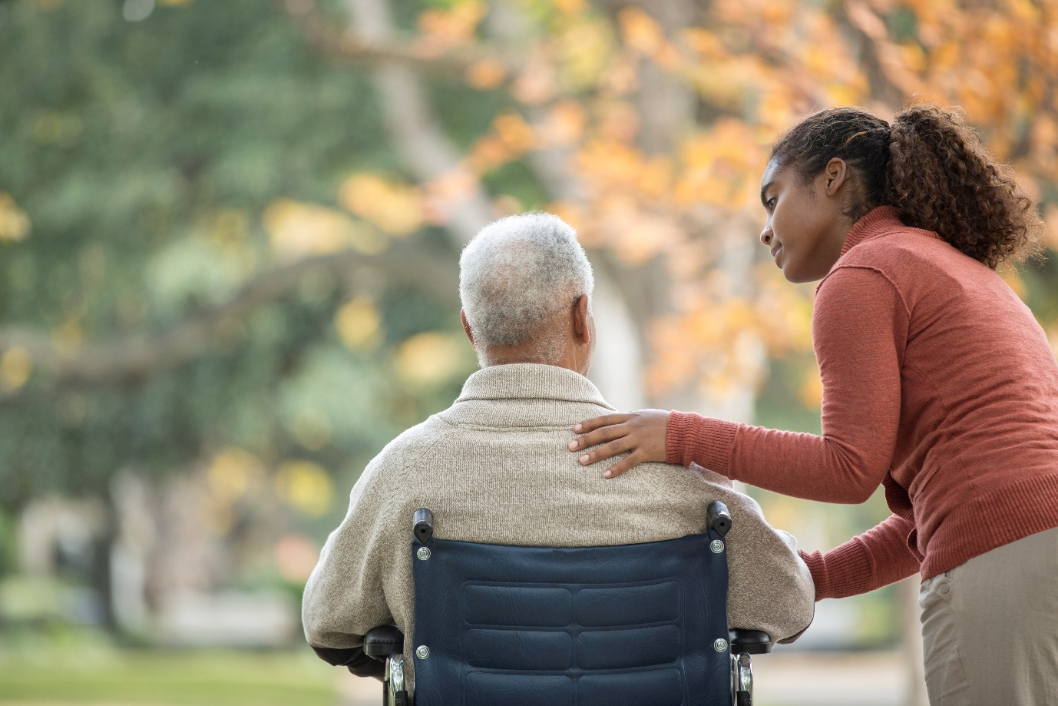

## Encourage and Facilitate Participation in Activities According to Networks and Preferences

Various activities feed into a person's social, emotional and psychological wellbeing. Of these activities, you can consider the following:

* **Social activities**

Social activities bring people together. There is communication and interaction in a meaningful and enjoyable way. Examples include the following:

* **Cultural activities**

Cultural activities help a person see themselves and their part in a community. These activities allow them to express their history, culture and identity. These activities occur in places like the following:

* **Spiritual activities**

Spiritual activities refer to those that fulfil a person’s spiritual beliefs. These activities enable the expression of connection with something greater. Examples include the following:

**Personal Preferences**

You may have to help a person join activities that align with their identity and preferences. Here, taking time to understand the person is essential. Consider the sample scenarios below.

* A person may be active in community sports events but may not be keen on joining other community events.
* A person may disclose that they are gay, but you cannot assume that they are comfortable joining pride parades.
* A Jewish person does not have to attend a synagogue every week.

Asking the person is still the best way to learn more about them. You can also identify and use their existing support activities. Only then can you help them establish activities that address their needs.

**Encouraging Participation**

Recall the essence of encouragement from Subchapter 3.1 of this Learner Guide. Encouragement means giving support, confidence and hope. To encourage someone is to persuade them to start or continue something.

Encouraging a person to join activities may be challenging. However, it would be best if you exerted every effort for them to be active. Activities stimulate the person’s wellbeing.

Below are a few of the best practices to consider:

* Where appropriate, respond positively to their related interests. Often, all they need is a simple validation to pursue or continue. Positive words from you can help the person get encouraged.
* Related to the first practice is to show respect for their preferences. You may be unfamiliar with some of their cultural or spiritual activities. Respecting their actions is enough to encourage them to pursue or continue.
* Forward a feeling that the planned activity is useful or relevant. Some people may have lingering doubts or are holding back. Words of encouragement will help counter these negative factors.

**Facilitating Participation**

Recall facilitation from Subchapter 1.5 of this Learner Guide. To *facilitate* is to help a person by making things easier for them. It generally means that:

* You help the person set up their goals and desires
* You assist the person in preparing pre-requirements such as the following:
* You provide for the requirements during the opportunity, such as:
  + Guardianship
  + Preparation
  + Equipment
  + Company

There are many activities that a person can enjoy. But the best activities are those within or near their community. As a support worker, you must be familiar with local groups and services that offer these. Your organisation may have a directory that you can use. But you must update yourself with relevant events and activities in your area. This way, you can better inform and help the person.

Consider the following resources from various national entities. These may help encourage or help a person to join activities:

|  |  |
| --- | --- |
| **Resources** | **Short Description** |
| [Calendar of Cultural and Religious Dates](https://www.homeaffairs.gov.au/about-us/our-portfolios/multicultural-affairs/about-multicultural-affairs/calendar-of-cultural-and-religious-dates) | The Department of Home Affairs compiled information on significant dates. These dates refer to holidays and celebrations across many cultures and religions. |
| [Community Visitors Scheme (CVS)](https://www.health.gov.au/our-work/community-visitors-scheme-cvs) | CVS is a government program for older people. It connects volunteers and older individuals for friendship and company. |
| [Families and Children Activity](https://www.dss.gov.au/our-responsibilities/families-and-children/programmes-services/parenting/families-and-children-activity) | The Department of Social Services organises activities for vulnerable families and children. The link provided introduces the initiative in detail. |
| [Seniors Connected Program](https://www.dss.gov.au/communities-and-vulnerable-people-programs-services/seniors-connected-program) | The Seniors Connected Program is a government scheme for older Australians. It has many projects that address loneliness among older people. |
| [Collection of physical activity and sedentary behaviour guidelines for all ages](https://www.health.gov.au/resources/collections/collection-of-physical-activity-and-sedentary-behaviour-guidelines-for-all-ages) | This collection of documents from Department of Health and Aged care endorses physical activity and sedentary guidelines for different age groups and circumstances. |
| [Leisure](https://www.disabilitygateway.gov.au/leisure) | The government-backed Disability Gateway provides a lot of information for people with disability. This website includes links and resources for various leisure activities. |
| [Looking after yourself while supporting someone](https://www.headtohealth.gov.au/giving-support/looking-after-yourself-carer) | The Head to Health by the Department of Health focuses on mental health. It has online and digital resources for supporting people with mental health issues. |

**Existing and New Networks**

Individuals may have existing support networks. The network may include friends, family, co-workers and other important people. These individuals can help the person in many ways. For one, they can motivate the person to join activities. They may even take part in the planned activities themselves.

You can identify the existing network through the following:

New networks are also something to consider. Building new friendships and relationships can stimulate growth in the person’s wellbeing. Like existing networks, new ones can also help in many ways.

A person may build new networks during their participation in activities. They may also develop new ones from other experiences. Sometimes, old friends may even resurface.

You can help the person build and maintain new networks with the following practices:

The following are some organisations with support network functions that you can consider for your support plan:

|  |  |
| --- | --- |
| **Support Network** | **Short Description** |
| [Relationships Australia](https://relationships.org.au/) | A leading provider of relationship support services for individuals, families and communities |
| [Indigenous Psychological Services](https://indigenouspsychservices.com.au/) | The only provider of psychology services for Indigenous peoples in Australia |

|  |  |
| --- | --- |
|  | **Checkpoint! Let’s Review**   1. Various activities feed into a person's social, emotional and psychological wellbeing. 2. You may have to help a person join activities that align with their identity and preferences. 3. The best activities are those within or near the person. 4. Support networks can help the person in many ways. |



## Identify and Seek Help on Aspects of Support Work Outside the Scope of Job Role

You may find yourself in situations beyond your job description as a support worker. Consider the following scenarios:

* **Joining social activities**
  + The person may ask you to join their inner circle of friends.
  + The person may ask you to play an unfamiliar sport with them.
* **Joining cultural activities**
  + The person may ask you to join activities you are unfamiliar with.
  + The person may offer food that may give you allergic reactions.
* **Joining spiritual activities**
  + The person may want you to join them in spiritual services unaligned with your beliefs.
  + The person may ask you to do spiritual services on their behalf.
* **Extending specialised services**
  + The person may ask you to do home repairs that you cannot do.
  + The person may want you to provide interpretation services you are not trained to do.

**Recognising Aspects of Supporting a Person’s Wellbeing Outside the Scope of Knowledge, Skills and Job Role**

Your responsibilities must be well-defined. Your job description and your role in your organisation should take care of this. Your skills and knowledge should also align with your duties and responsibilities. Ideally, you already have the necessary background and training before working. Considering all these, you should have a solid basis for what you can and cannot do.

The scenarios in the previous section are examples of work outside of your scope. In general, these scenarios can fall into any of the following categories:

* Work that is outside your defined responsibilities
* Work that may cause harm to you or the person
* Work that is beyond your skills and knowledge
* Work that infringes on your personal life

The above categories are good points when confronted by a scenario. Ask yourself if it fits in any of the categories. Then, apply your organisation's relevant policies and procedures.

**Supporting a Person's Wellbeing Within the Scope of Knowledge, Skills and Job Role**

As a support worker, you then work within the limits of your role. As you provide support, consider the following best practices:

* **Establish a clear work-role boundary.** The introduction of this Learner Guide has a brief discussion on this.
* **Make sure that the person is aware of your role and responsibilities.** This step is where having a plan is essential. Plans that the person helped create must reflect your role and skills.
* **Learn to decline invitations respectfully.** Having a professional relationship with the person is always important.

**Seeking Help**

Some requests and needs of the person are valid. Consider the example of the need for home repairs and interpretation services. It is then essential for you to help them address this.

Consulting with your supervisor and organisation is the best first step to take. Some needs may call the service of other providers. Your organisation should then help the person find these providers. Services like interpretation and education fit this step.

Some concerns may need the attention of the person's family or carer. These are especially true for more personal or trivial matters. The need for home repairs is an excellent example to consider.

|  |
| --- |
| **Multimedia**  Graphical user interface, application  Description automatically generated  Setting professional boundaries when closely working with one person can be challenging. The following video provides good information on the subject:  [Professional Boundaries for Caregivers](https://www.youtube.com/watch?v=yl7jLCyMxfE) |



|  |  |
| --- | --- |
|  | **Checkpoint! Let’s Review**   1. It would be best to establish a clear work-role boundary. 2. Make sure that the person is aware of your role and responsibilities. 3. Learn to decline any invitations respectfully. 4. Consulting with your supervisor and organisation is the best first step to take. 5. Some concerns may need the attention of the person's family or carer. |

## Identify and Report Variations to a Person’s Wellbeing

Just like observing the person's physical wellbeing, you must also recognise changes in the following:

* Social wellbeing
* Emotional wellbeing
* Psychological wellbeing

It would be best to keep an eye out for any changes or variations in these components. Changes can point to issues that impact a person’s health wellbeing.

**Recognising Variations in Social, Emotional and Psychological Wellbeing**

Social, emotional and mental wellbeing are connected and tend to overlap. If there is an issue with one of these aspects, the overall wellbeing of the person is likely affected. Indicators of emotional concerns and issues include the following:

The indicators listed above may reflect changes in the person’s wellbeing. You may also consider other variations that involve changes in mood or behaviour. Examples of these include the following:

|  |  |
| --- | --- |
| **Changes in Mood** | **Changes in Behaviour** |
| * Being easily agitated * Having suicidal thoughts * Exhibiting unusual restlessness * Experiencing chronic sadness or anxiety * Exhibiting sudden changes in affection * Being tearful or crying frequently * Being sad or happy for no apparent reason * Displaying a different mood not seen before | * Experiencing chronic fatigue * Exhibiting changes in eating habits * Exhibiting changes in sleeping patterns * Starting to push people away * Withdrawing from people * Displaying a different body language than before * Being uneasy about a particular people or group * Losing interest in activities that they used to love |

**Reporting Variations in Social, Emotional and Psychological Wellbeing**

Changes in wellbeing are usually recorded in progress notes as well. Remember to check if the details you recorded are accurate and correct. Since these notes are updated regularly, it is easier to spot patterns and irregularities in the person's mood and behaviour.

Organisational policies and procedures might require you to report these to your supervisor. If the variations are due to issues outside your scope of work, you would also have to report these to other professionals. Changes in social, emotional and psychological wellbeing may be precursors to other problems. Detected variations may point to issues in mental health and abuse. The next few subchapters will discuss these.

|  |  |
| --- | --- |
|  | **Further Reading**  Social isolation and loneliness are common signs of affected wellbeing. Learn more about it and the government's efforts. The link below is an excellent place to start:  [Social isolation and loneliness](https://www.aihw.gov.au/reports/australias-welfare/social-isolation-and-loneliness-covid-pandemic) |

|  |  |
| --- | --- |
|  | **Checkpoint! Let’s Review**   1. Social, emotional and mental wellbeing are intertwined. Variations on one affect the other. 2. Variations of concern include the following:    * Changes in mood    * Changes in behaviour 3. Variations in social, emotional and psychological wellbeing may be precursors to other problems. 4. You must report variations related to social, emotional and psychological wellbeing. Reporting is the same as other negative signs or observations from earlier. |



## Identify Cultural or Financial Issues Impacting on the Person’s Wellbeing

Culture and finances play a significant role in personal wellbeing. Issues surrounding these factors can cause distress to anyone. Cultural diversity and economic disparity make it difficult for some to live.

**Cultural Issues**

Due to Australia's cultural diversity, you may work with people who have a different culture from your own. The key is to remain empathetic and recognise differences.

Culture is something that is shared between a group of people. If a person is far from other people who share the same culture, they can feel at a loss. Some issues may include the following:

* Feeling like they are 'losing' their identity
* Not being able to practice their customs
* Feeling embarrassed to follow their traditions because they feel different

To confirm cultural issues impacting their wellbeing, you must know what the person values. While you may not have deep knowledge of other cultures, you should have an idea of people's different customs and beliefs. It would also help the person to continue interacting with their cultural community.

Another cultural issue that can affect the person is racism. Due to their culture and race, they might encounter situations such as the following:

A person who experiences the situations above may feel uncomfortable or unsafe. This can greatly affect their wellbeing because their sense of self is also targeted.

As you talk with someone about cultural issues, consider the following:

**Confirming Financial Issues**

Finances cover how one earns and manages money. Money makes it easy to manage economic power. A person with lots of money can access many resources. But problems may arise when one cannot earn, manage or spend money.

Consider the following financial issues in the context of money:

* **Issues with earning money**
  + Unemployment
  + Inadequate compensation
  + Lack of access to safe loans
  + Scams and other illegal activities
* **Issues with managing money**
  + Lack of access to formal banking
  + Restricted access to own money
  + Stolen money or valuable items
  + Irresponsible spending

A person who lacks buying power is at a disadvantage. They may not afford basic needs such as food, clothing and shelter. They may not enjoy activities that help in developing their wellbeing. In this context, you may have to refer them to appropriate services, such as financial counselling or financial support.

Considering the following reasons that may cause financial issues:

Talking about finances can be a sensitive topic for some people. When confirming issues:

* **Let them understand why you are talking about their financial issues.**

Explain why you are talking about finances and how this will help their wellbeing.

* **Affirm their feelings.**

Affirming their feelings makes them feel understood. They will be more open in talking about difficult topics if they feel safe.

* **Set boundaries.**

Let them know that discussing finances does not mean you will give them monetary help.

|  |
| --- |
| **Multimedia**  Graphical user interface, application  Description automatically generated  The Department of Social Services runs the Migrant Resource Centre. Learn more about this through the video below:  [Stop it at the Start - The shared culture of respect](https://www.youtube.com/watch?v=nIuv8vJXsv8) |

|  |  |
| --- | --- |
|  | **Checkpoint! Let’s Review**   1. Cultural diversity and economic disparity make it difficult for some people to live. 2. Some people may target others based on their culture. 3. A person who lacks buying power is at a disadvantage. 4. You must know the person’s experiences and help them process them. |



## Identify the Person’s Risk and Protective Factors About Mental Health



Earlier, you noted the relationship between social, emotional and psychological wellbeing. Also, the root cause for any problems is usually emotional concerns and issues. Subchapter 4.5 of this Learner Guide gave some variations to consider.

Emotional concerns and issues are a subset of mental health concerns. In brief, mental health combines social, emotional and psychological wellbeing. Mental health is best understood by describing a mentally healthy person.

A mentally healthy person can do the following:

* The capacity to learn new things
* The ability to form and maintain relationships
* The ability to be motivated and be productive
* The ability to manage everyday stresses of life
* The ability to deal with change and uncertainty
* The knowledge of their strengths and weaknesses
* The capacity to feel, express and manage a range of emotions

**Risk and Protective Factors of Mental Health**

Risk factors are entities or situations that can cause negative effects. The opposite happens with protective factors, where positive effects come up. A person may experience deterioration in the qualities listed above. This deterioration may happen if exposed to mental health risk factors. Conversely, mental health protective factors may prevent deterioration or reverse its effects.

The table below shows both risk and protective factors for mental health:

|  |  |
| --- | --- |
| **Social and Cultural Factors** | |
| **Risk Factors** | **Protective Factors** |
| * Fears * Anxiety * Religion * Isolation * Ethnicity * Loneliness * Relationships * A reduced sense of purpose * Recent negative life events | * Exercise * Healthy diet * Quality sleep * Connections with others * Interactions with family and friends * Regular physical, mental and social activity * Active participation in spiritual or religious community events |

|  |  |
| --- | --- |
| **Physical Factors** | |
| **Risk Factors** | **Protective Factors** |
| * Age * Smoking * Family history * Health problems * Injury and illness * Abuse and neglect * Living arrangements * Alcohol and drug use | * Exercise * Healthy diet * Quality sleep * Regular activities * Good hygiene practices * Connections with others * Regular medical check-ups * Relaxation activities (e.g. meditation) |

Mental health issues have gained attention over the last few years. Some unexplained health concerns and dangerous behaviours are now considered to be valid mental health issues. Consider the two common issues encountered by many around the world:

* **Depression**

Depression is a common and serious medical illness that causes feelings of sadness and/or a loss of interest in activities you once enjoyed. Risk factors of depression include the following:

The known protective factors of depression include the following:

* **Substance abuse**

Substance use disorder is a disease that affects a person's brain and behaviour and leads to an inability to control the use of a legal or illegal drug or medication. Risk factors include the following:

The known protective factors of substance abuse include the following:

**Determining Risk and Protective Factors of Mental Health**

The previous table shows some of the factors to consider for mental health. The risk factors were also grouped according to some components of wellbeing. In this context, mental health is a way of looking at wellbeing from a specific view. But factors that affect it may still come from other components of wellbeing. The factors provided are not exhaustive. It would be best if you referred to the person's individualised plan for any mental health considerations. Your organisation should also provide you with the needed knowledge. This case is valid if you are working with mentally vulnerable people.

|  |  |
| --- | --- |
|  | **Further Reading**  The Australian government has a good primer on current mental health discussions. Access this resource through the link below:  [About mental health](https://www.health.gov.au/health-topics/mental-health-and-suicide-prevention/about-mental-health) |

|  |  |
| --- | --- |
|  | **Checkpoint! Let’s Review**   1. Mental health is an amalgamation of social, emotional and psychological wellbeing. 2. Mental health is a way of looking at wellbeing from a specific view. 3. Several risk factors can cause poor mental health. But several protective factors can counter the risk ones. |

## Recognise and Report Abuse or Neglect on the Person

Recognising signs of abuse and neglect is vital so that you can act immediately. It would be best to learn how to spot abuse and neglect. You should also know your organisation’s policies and procedures for these things. This is important in protecting the physical and mental safety of the people in your service. Missing signs of abuse and neglect will further harm the affected person.

### **4.8.1 Recognising Possible Indicators of Abuse or Neglect**

Abuse and neglect are two different forms of negative behaviour. The following discussion will elaborate on each.

**Abuse and Its Forms**

*Abuse* is the improper treatment of one person by another. The abuser is usually someone with leverage. The victim experiences violence or cruelty.

A worker can abuse a person during service. Family members can also abuse their relatives. Some people are especially vulnerable to abuse. Vulnerable persons may not understand or remember what is happening to them. They may also be very dependent on others for their day-to-day needs. Older people and people with cognitive disabilities are especially vulnerable.

Here are some examples of why some people are more vulnerable to abuse:

* **The person may have issues with coordination.** Someone can excuse the person’s bruises and sprains due to falling.
* **The person may report a family member threatening them.** The family member may then insist that the person only recalls an event they saw on television.
* **The person may need help with bathing and dressing**. A worker can use this as an excuse for inappropriate touching.

Below are the common forms of abuse:

|  |  |
| --- | --- |
| **Form of Abuse** | **Examples** |
| **Physical Abuse** | * Hitting or slapping the person * Shoving or yanking the person * Forcing the person to swallow or take medication |
| **Sexual Abuse** | * Touching the person inappropriately * Forcing the person to do sexual acts * Forcing the person to watch sexual acts |
| **Emotional Abuse** | * Yelling at or threatening the person * Humiliating the person or blaming them * Isolating the person from their support system |
| **Financial Abuse** | * Stealing the person’s money or belongings * Blocking the person’s access to their money or belongings |

**Neglect and Its Forms**

Neglect is when a worker, family member, or carer fails to meet a person’s needs in care. It means depriving a person of their basic rights. Below are examples of forms of neglect:

|  |  |
| --- | --- |
| **Form of Neglect** | **Examples** |
| **Physical Neglect** | * Not providing a person with food, water, or shelter * Not meeting the person's medical needs * Not giving the person clothing appropriate for the season |
| **Emotional Neglect** | * Ignoring the person or not speaking to them * Not visiting the person in their home or residential facility |
| **Financial Neglect** | * Not providing the person with the agreed amount of money for financial support * Delaying and missing payments |

**Recognising Abuse or Neglect**

Some indicators of abuse and neglect are not as visible as others. Here are some indicators you should watch out for:

| **Form of Abuse** | **Physical Indicators** | **Behavioural Indicators** |
| --- | --- | --- |
| **Physical Abuse** | * Showing injuries or bruising on the face, head and/or neck * Exhibiting head injury symptoms (i.e. drowsiness, vomiting, fits) * Having unexplained accidents or injuries * Showing unexplained fractures, dislocations and/or sprains * Experiencing pain when moving or showing restricted movement * Having unexplained bruises, bite marks, cuts, burns, scratches | * Providing inconsistent explanations regarding their injuries * Avoiding or being fearful of a person * Experiencing sleep disturbances (e.g. nightmares, bed-wetting) * Exhibiting changes in behaviour (e.g. aggression, withdrawal, excessive compliance) * Overusing or underusing sedation * Feeling fear or anxiety |
| **Emotional Abuse** | * Exhibiting speech disorders * Gaining or losing weight * Bed-wetting or bed soiling with no medical cause * Vomiting or having diarrhea * Having frequent headaches, nausea or abdominal pains | * Feeling worthless, having extremely low self-esteem, self-abuse, or self-destructive behaviour * Exhibiting extreme attention-seeking behaviour and other behavioural disorders (e.g. disruptiveness, aggressiveness, bullying) * Being excessively compliant * Being depressed, confused and/or fearful * Feeling lonely and/or helpless |

|  |  |  |
| --- | --- | --- |
| **Form of Abuse** | **Physical Indicators** | **Behavioural Indicators** |
| **Sexual**  **Abuse** | * Disclosing directly or indirectly * Describing sexual acts * Exhibiting trauma (e.g. bleeding around genitals, chest, rectum or mouth) * Exhibiting difficulty in walking or sitting * Having internal injuries (e.g. tears or bruising), pain or itching on genitalia, anus or perineal region * Having torn, stained or blood-stained underwear or bedclothes * Having unexplained sexually transmitted infections (STIs) * Accumulating money or gifts * Exhibiting incontinence | * Repeating the words ‘bad’ or ‘dirty’ * Exhibiting self-destructive behaviour, like self-mutilation * Exhibiting sudden behavioural changes (e.g. depression, agitation, crying, anger, violence, absconding, or seeking comfort and security beyond the usual amount) * Making inappropriate advances towards others * Experiencing sleep disturbances, refusing to go to bed and/or going to bed fully clothed * Developing eating disorders * Refusing to shower or showering constantly * Exhibiting changes in social patterns, refusing to attend their usual places * Experiencing anxiety when near suspected abuser or when they can foresee contact with the suspected abuser |

|  |  |  |
| --- | --- | --- |
| **Form of Abuse** | **Physical Indicators** | **Behavioural Indicators** |
| **Financial Abuse** | * Having restricted access to or no control over personal funds or bank accounts * Keeping no records or having incomplete records of expenditures and purchases * Missing money, valuables or property * Being forced to change will or other legal documents * Being unable to find the money for basics such as food, clothing, transport costs and bills * Taking large withdrawals or exhibiting big changes in banking habits or activities * Transferring properties when the person is no longer able to manage their own financial affairs | * Stealing from others * Borrowing money * Begging * Experiencing fear, stress and anxiety |

The following indicators may signal a presence of physical neglect:

|  |  |
| --- | --- |
| **Physical Indicators** | **Behavioural Indicators** |
| * Being hungry, thirsty, and losing a lot of weight * Having poor hygiene * Having poor hair texture * Wearing inappropriate or inadequate clothing for weather conditions * Having inadequate shelter or accommodation * Worsening health problems ed due to mismanagement of medications * Having improper health or dietary practices that endanger their health or development * Exhibiting unexplained conditions such as hypothermia, dehydration or pressure sores | * Requesting, begging, scavenging or stealing food * Experiencing constant fatigue, listlessness or falling asleep * Disclosing directly or indirectly * Longing for company * Isolating socially * Expressing anxiety about being alone or abandoned * Displaying inappropriate or excessive self-comforting behaviours |

For emotional and financial neglect, emotional and financial abuse factors may be used.

Indicators for physical neglect may also point to emotional or financial neglect.

Observe how a person acts around their peers, family, or friends. Notice the differences between specific people. For example, they may act cheerful and then turn shy and quiet when a particular family member arrives.

It would help if you also noted any changes in behaviour, such as eating or sleeping patterns. Some signs you notice might be symptoms of health problems. In such cases, you must address them with their health professionals.

|  |  |
| --- | --- |
|  | **Further Reading**  *Exploitation* is benefiting from someone’s work or possessions using unfair practices. Exploitation usually involves fooling a person or manipulating their emotions. The article below talks about financial exploitation among older people:  [Elder Financial Exploitation](https://www.napsa-now.org/get-informed/exploitation-resources/) |

### **4.8.2 Reporting of Possible Indicators of Abuse or Neglect**

It is a legal requirement to report suspected cases of abuse or neglect. Organisations have the legal obligation to report allegations or incidents of assault. Suppose abuse or neglect of an individual by another person has occurred. In that case, whether it is a staff member, family member or even a stranger, there is a duty of care to report this to management or authorities.

Workplace-specific protocols that may be in place include the following:

**Mandatory Reporting**

*Mandatory reporting* is the responsibility of reporting suspected instances of abuse. It is also sometimes called compulsory reporting. Professionals, service workers and support workers all have this responsibility. You should know the mandatory reporting laws in your line of work. Familiarise yourself with the reporting policies and procedures of your organisation. This will help you protect the rights of the people in your care.

**Mandatory Reporting for Older People**

The *Aged Care Act 1997* introduced the Serious Incident Response Scheme (SIRS). This requires workers like you to report the abuse of people in care. It defines an incident as the occurrence or suspected event of abuse, including the following:

Workers have to report incidents to the proper authorities. They must file a report to the Department of Health or the police within 24 hours of the incident. Your organisation must respond to these reports as soon as possible. Each report must be recorded, including implemented actions to address it. The only exception to this reporting is if the offender has cognitive impairment.

The Serious Incident Response Scheme (SIRS) also protects mandatory reporters. The protection states the following:

* The law protects the reporter from criminal or civil responsibility.
* The employer cannot punish a reporter for reporting a valid incident.
* The employer must protect the reporter from threats and victimisation.

Each state and territory have a resource for reporting abuse towards older people. Below are some of these resources:

|  |  |
| --- | --- |
| **State/Territory** | **Resource for Reporting Abuse** |
| Australian Capital Territory | [Abuse of Older Persons](https://www.communityservices.act.gov.au/seniors/elder-abuse) |
| New South Wales | [Ageing and Disability Abuse Helpline](https://www.facs.nsw.gov.au/resources/statistics/ageing-and-disability-abuse-helpline) |
| Northern Territory | [Elder abuse](https://www.cotant.org.au/information/elder-abuse/) |
| Queensland | [Elder Abuse Prevention Unit](https://www.eapu.com.au/) |
| South Australia | [Aged Rights Advocacy Service Inc.](http://www.sa.agedrights.asn.au/) |
| Tasmania | [Advocacy Tasmania](https://advocacytasmania.org.au/i-need-some-help/) |
| Victoria | [Seniors Rights Victoria](https://seniorsrights.org.au/) |
| Western Australia | [Advocare](https://www.advocare.org.au/) |

**Mandatory Reporting for Children**

Support workers for children must report to the following reporting authorities:

|  |  |
| --- | --- |
| **State/Territory** | **Reporting Authority** |
| Australian Capital Territory | [Child and Youth Protection Services](https://www.communityservices.act.gov.au/ocyfs/children/child-and-youth-protection-services) |
| New South Wales | [Communities & Justice](https://www.facs.nsw.gov.au/) |
| Northern Territory | [Department of Territory Families, Housing and Communities](https://tfhc.nt.gov.au/#:~:text=Territory%20Families%2C%20Housing%20and%20Communities%20provides%20support%20services%20across%20child,Find%20out%20more%20about%20us.) |
| Queensland | [Department of Children, Youth Justice and Multicultural Affairs](https://www.cyjma.qld.gov.au/) |
| South Australia | [Department for Child Protection](https://www.childprotection.sa.gov.au/) |
| Tasmania | [Department of Communities Tasmania](https://www.communities.tas.gov.au/) |
| Victoria | [Health and Human Services](https://www.dhhs.vic.gov.au/) |
| Western Australia | [Department of Communities](https://www.wa.gov.au/organisation/department-of-communities) |



**Mandatory Reporting for People With Disability**

States and territories have laws that specify mandatory reporting for disability support workers. The table below includes general information for reporting abuse and neglect:

|  |  |
| --- | --- |
| **State/Territory** | **Information for Reporting Cases of Abuse or Neglect** |
| Australian Capital Territory | [Search](https://www.communityservices.act.gov.au/search?query=Abuse+or+neglect+of+a+person++with+disability)  [Do you need to report abuse or neglect of people with disability](https://www.jobaccess.gov.au/people-with-disability/do-you-need-report-abuse-or-neglect-people-with-disability) |
| New South Wales | [Ombudsman New South Wales](https://www.ombo.nsw.gov.au/news-and-publications/publications/guidelines/disability-reportable-incidents/initial-and-early-response-to-abuse-or-neglect-of-disability-services) |
| Northern Territory | [Crime and the law](https://nt.gov.au/law/crime) |
| South Australia | [Disability-related complaints and feedback](https://www.sa.gov.au/topics/care-and-support/disability/complaints) |
| Tasmania | [Tasmania - Get help](https://www.cyda.org.au/get-help)  [Children, Youth and Families](https://www.communities.tas.gov.au/children) |
| Victoria | [National Disability Abuse and Neglect Hotline](https://www.betterhealth.vic.gov.au/health/serviceprofiles/national-disability-abuse-and-neglect-hotline-service) |
| Western Australia | [Disability services](http://www.disability.wa.gov.au/Global/Publications/For%20disability%20service%20providers/Quality/Factsheet_What_do_I_do_if_I_am_concerned_about.pdf)  [People with Disability](https://www.police.wa.gov.au/Our-Community/Community-Diversity-and-Substantive-Equality/People-with-Disability) |

|  |  |
| --- | --- |
|  | **Further Reading**  Learn more about how national laws protect the abuse reporter. The Australian Law Reform Commission has an extensive discussion in the link below:  [Reporting abuse](https://www.alrc.gov.au/publication/elder-abuse-a-national-legal-response-alrc-report-131/14-safeguarding-adults-at-risk/reporting-abuse/)  More information on the reporting requirements is available below. The link is specific to support workers for older people:  [Serious Incident Response Scheme](https://www.agedcarequality.gov.au/sirs)  More information on the reporting requirements is available below. The link is specific to support workers for children:  [Mandatory reporting of child abuse and neglect](https://aifs.gov.au/cfca/publications/mandatory-reporting-child-abuse-and-neglect#:~:text=If%20you%20require%20assistance%20or,danger%20call%20Police%20on%20000.) |

**Reporting of Issues Surrounding Abuse**

You should be familiar with your organisation’s policies and procedures related to abuse. If you notice possible signs of abuse or neglect, make a closer observation. Try to come up with an explanation for these signs. You must report these observations, even if it turns out that no abuse or neglect is happening.

The following are instances when you should report an incident:

* You witness abuse happening first-hand
* You observe signs of neglect in the person
* The person tells you that no one is caring for them
* The person tells you that someone is abusing them
* Staff or family members tell you that they have seen abuse happening



Organisations should have their own policy for reporting cases of abuse and neglect. These policies will include procedures for reporting, such as the following:

* Steps for reporting
* To whom should you report
* What to do when you witness abuse happening
* Informing an older person that you are reporting abuse on their behalf
* What to do if an older person does not consent to a report
* What to do after you report an incident

There are steps you might follow when spotting signs of abuse. Your organisation may have different steps, but the idea would be generally similar. Below is an example:

**Managing Issues Surrounding Abuse**

Here are some good and bad practices when dealing with situations and issues of abuse and neglect:

* **Do the following:**
  + Seek help from your direct supervisor.
  + Follow your organisation’s policies and procedures for reporting incidents and abuse.
  + Maintain the privacy and confidentiality of the people involved in the situation.
  + Follow procedures for mandatory reporting in your state or territory.
* **Do not do the following:**
  + Investigate on your own.
  + Confront the perpetrator of the abuse.
  + Share information about the situation with your family and friends.
  + Provide advice and counsel to the person involved in situations of abuse.

|  |  |
| --- | --- |
|  | **Checkpoint! Let’s Review**   1. Abuse is the improper treatment of one person by another. 2. Neglect is when a worker, family member, or carer fails to meet a person’s needs in care. 3. You are required to report and manage signs of abuse or neglect. 4. Always refer to your organisation’s policies and procedures or consult your supervisor. |

## Identify and Report Situations Beyond Scope of Your Own Role

Some situations will need a professional response. As a support worker, you must learn to identify signs of these situations. It is also important to remember that you have limited responsibilities in responding. You will only have a reporting role unless you have the proper training.

**Identifying Situations Beyond Scope of Own Role**

There are difficult situations in social, emotional and psychological wellbeing. Consider the examples below:

* **Suicidal thoughts**



Suicidal thoughts are having thoughts and ideas about ending one's own life. Suicidal thoughts are usually a symptom of a significant mental health issue. The following are some causes of suicidal thoughts:

* + Abuse
  + Remorse
  + Substance abuse

The person talking about the following may be a sign of suicidal thoughts:

* + Wanting to die
  + Having extreme guilt or shame
  + Being a burden to others

Other possible behaviours to watch out for are the following:

* + Researching ways to die
  + Exhibiting extreme mood swings
  + Eating or sleeping less
  + Abusing substances

You must use the person's medical history together with any observations made. A person with a history of suicidal thoughts and tendencies is usually at risk. Some observations made may only point to less severe issues. But being cautious is part of your responsibilities.

* **Signs of Mental Deterioration**

*Mental deterioration* refers to changes in a person’s mental state causing a decline in cognitive function, i.e. in memory, reasoning and comprehension. Mental deterioration occurs when a person experiences any of the following:

Common signs to consider for mental deterioration include the following:

* + Memory loss
  + Extreme mood swings
  + Compulsive behaviour
  + Sudden change in personality

Any sudden change in the person's thinking and behaviour is a sign to consider. This is especially true for the more vulnerable older people. Some forms of mental deterioration have no known solid cause. For these forms, family history and genetic predisposition can help.

* **Signs of abuse**

The previous sections of this Learner Guide covered abuse in general. In some cases, apparent signs of abuse may be present. These signs may be physical, emotional, or behavioural.

Examples of these signs include the following:

**Reporting to the Relevant Persons**

You may have to report to the following personnel for detected situations:

* The supervisor
* The proper authorities
* The medical personnel available
* The person's assigned medical professional

Like reporting other observations, you must know the answer to the following questions:

* What do you have to report?
* How should you do the report?
* How frequently should you report?
* Who do you approach for reports and updates?
* How do you contact them during emergencies?

You must be familiar with your organisation's policies and procedures. Make sure to follow them correctly and honestly. Your prompt and proper response may be a difference-maker.

|  |  |
| --- | --- |
|  | **Checkpoint! Let’s Review**   1. Some situations need a professional response. 2. Situations on social, emotional and psychological wellbeing share some signs. These signs are usually changes in behaviour and thinking. 3. You must be familiar with your organisation’s policies and procedures. |



|  |  |
| --- | --- |
|  | **Learning Activity for Chapter 4**  Well done completing this chapter. You may now proceed to your **Learning Activity Booklet** (provided along with this Learner Guide)and complete the learning activities associated with this chapter.  Please coordinate with your trainer/training organisation for additional instructions and guidance in completing these practical activities. |

# References

ACOSS. (2019). *ACOSS – Australian Council of Social Service*. <https://www.acoss.org.au/>

Advocacy Tasmania Inc. (n.d.). *Things are looking up, we’re here to help*. Retrieved November 15, 2021, from <https://advocacytasmania.org.au/i-need-some-help/>

Advocare. (n.d.). *Advocare | Protecting older peoples rights in WA*. Retrieved November 15, 2021, from <https://www.advocare.org.au/>

*Age Discrimination Act 2004* (Cth). <https://www.legislation.gov.au/Series/C2004A01302>

Aged & Community Care Providers Association. (2021). *Aged & Community Care Providers Association*. <https://acsa.asn.au/>

Aged Rights Advocacy Service (ARAS). (2017). *Aged Rights Advocacy Service*. <http://www.sa.agedrights.asn.au/>

Alcohol and Drug Foundation. (2021, August 30). *Drug information directory*. <https://adf.org.au/resources/drug-information-directory/>

Australian Human Rights Commission. (2015). *Face the facts: Cultural diversity*. <https://humanrights.gov.au/our-work/education/face-facts-cultural-diversity>

*Australian Human Rights Commission Act 1986* (Cth). <https://www.legislation.gov.au/Series/C2004A03366>

Australian Institute of Health and Welfare. (2017, July 17). *Behaviours & risk factors*. <https://www.aihw.gov.au/reports-data/behaviours-risk-factors>

Australian Institute of Health and Welfare. (2021, September 16). *Social isolation and loneliness*. AIHW. <https://www.aihw.gov.au/reports/australias-welfare/social-isolation-and-loneliness-covid-pandemic>

CAPSAU.ORG. (n.d.). *CAPS – Child abuse prevention service*. Retrieved December 15, 2021, from <https://www.capsau.org/>

CareChannel. (2019, June 15). *How to promote independence* [Video]. YouTube. <https://www.youtube.com/watch?v=a8UliXksHhI>

Children and Young People with Disability Australia. (n.d.). *Tasmania - Get help*. Retrieved June 22, 2023, from <https://www.cyda.org.au/get-help>

*Civil Liability Act 1936* (SA). [https://www.legislation.sa.gov.au/lz/c/a/civil liability act 1936.aspx](https://www.legislation.sa.gov.au/lz/c/a/civil%20liability%20act%201936.aspx)

*Civil Liability Act 2002* (Tas). <https://www.legislation.tas.gov.au/view/whole/html/inforce/current/act-2002-054>

*Civil Liability Act 2002 No 22* (NSW). <https://legislation.nsw.gov.au/view/html/inforce/current/act-2002-022>

*Civil Liability Act 2002* (WA). <https://www.legislation.wa.gov.au/legislation/statutes.nsf/main_mrtitle_149_homepage.html>

*Civil Liability Act 2003* (Qld). <https://www.legislation.qld.gov.au/view/html/inforce/current/act-2003-016>

*Community Mental Health Australia*. (2017).<https://cmha.org.au/>

Commonwealth of Australia. (n.d.-a). *Emergency assistance and support*. Retrieved December 14, 2021, from <https://www.australia.gov.au/phone-contacts>

Commonwealth of Australia. (n.d.-b). *Leisure*. Disability Gateway. Retrieved December 15, 2021, from <https://www.disabilitygateway.gov.au/leisure>

Commonwealth of Australia. (n.d.-c). *People and communities*. Australian Bureau of Statistics. Retrieved November 24, 2021, from <https://www.abs.gov.au/statistics/people/people-and-communities>

Commonwealth of Australia. (n.d.-e). *Services Australia*. Retrieved December 13, 2021, from <https://www.servicesaustralia.gov.au/>

Commonwealth of Australia. (n.d.-f). *Workforce Australia for individuals*. Workforce Australia. Retrieved December 15, 2021, from <https://www.workforceaustralia.gov.au/>

Commonwealth of Australia. (2010, December). *National standards for mental health services 2010 and implementation guidelines*. Department of Health and Aged Care. <https://www.health.gov.au/resources/publications/national-standards-for-mental-health-services-2010-and-implementation-guidelines>

Commonwealth of Australia. (2011, July 1). *An outline of national standards for out-of-home care (2011)*. Department of Social Services. <https://www.dss.gov.au/our-responsibilities/families-and-children/publications-articles/an-outline-of-national-standards-for-out-of-home-care-2011>

Commonwealth of Australia. (2013a, December 1). *National standards for disability services*. Department of Social Services. <https://www.dss.gov.au/our-responsibilities/disability-and-carers/standards-and-quality-assurance/national-standards-for-disability-services>

Commonwealth of Australia. (2013b). *Gender stereotypes and norms*. The Good Society. <https://thegoodsociety.gov.au/guidebook/years-10-12-guidebook/chapter-2---influences/gender/gender-stereotypes-and-norms>

Commonwealth of Australia. (2016, July 1). *Do you need to report abuse or neglect of people with disability*. Job Access. <https://www.jobaccess.gov.au/people-with-disability/do-you-need-report-abuse-or-neglect-people-with-disability>

Commonwealth of Australia. (2017a, June 8). *Reporting abuse*. Australian Law Reform Commission. <https://www.alrc.gov.au/publication/elder-abuse-a-national-legal-response-alrc-report-131/14-safeguarding-adults-at-risk/reporting-abuse/>

Commonwealth of Australia. (2017b, June 27). *2016 Census data reveals “no religion” is rising fast*. Australian Bureau of Statistics. <https://www.abs.gov.au/AUSSTATS/abs@.nsf/mediareleasesbyReleaseDate/7E65A144540551D7CA258148000E2B85>

Commonwealth of Australia. (2018). *Translating and Interpreting Service (TIS National)*. Department of Home Affairs. <https://www.tisnational.gov.au/>

Commonwealth of Australia. (2019a). *Australian Charities and Not-for-profits Commission*. Australian Charities and Not-for-profits Commission. <https://www.acnc.gov.au/>

Commonwealth of Australia. (2019b). *Home | Aged Care Quality and Safety Commission*. Aged Care Quality and Safety Commission. <https://www.agedcarequality.gov.au/>

Commonwealth of Australia. (2019c). *My aged care*. My Aged Care. <https://www.myagedcare.gov.au/>

Commonwealth of Australia. (2019d). *Understanding behaviour support and restrictive practices*. NDIS Quality and Safeguards Commission. <https://www.ndiscommission.gov.au/regulated-restrictive-practices>

Commonwealth of Australia. (2019e, July 15). *The Australian dietary guidelines*. Department of Health and Aged Care. <https://www.health.gov.au/resources/publications/the-australian-dietary-guidelines>

Commonwealth of Australia. (2019f, December 3). *National quality framework for drug and alcohol treatment services*. Department of Health and Aged Care. <https://www.health.gov.au/resources/publications/national-quality-framework-for-drug-and-alcohol-treatment-services>

Commonwealth of Australia. (2020a). *Education*. Australian Bureau of Statistics. <https://www.abs.gov.au/statistics/people/education>

Commonwealth of Australia. (2020b, September 24). *Language services*. Department of Home Affairs. <https://immi.homeaffairs.gov.au/settling-in-australia/settle-in-australia/language-services>

Commonwealth of Australia. (2021a). *Population*. Australian Bureau of Statistics. <https://www.abs.gov.au/statistics/people/population>

Commonwealth of Australia. (2021b). *Racism is not acceptable*. <https://www.australia.gov.au/helpstopracism>

Commonwealth of Australia. (2021c, May 7). *Physical activity and exercise guidelines for all Australians*. Department of Health and Aged Care. <https://www.health.gov.au/health-topics/physical-activity-and-exercise/physical-activity-and-exercise-guidelines-for-all-australians>

Commonwealth of Australia. (2021, May 21). *Collection of physical activity and sedentary behaviour guidelines for all ages.*  Department of Health and Aged Care. <https://www.health.gov.au/resources/collections/collection-of-physical-activity-and-sedentary-behaviour-guidelines-for-all-ages>

Commonwealth of Australia. (2021d, June 2). *Disability myths and stereotypes*. Australian Public Service Commission. <https://www.apsc.gov.au/working-aps/diversity-and-inclusion/disability/disability-myths-and-stereotypes>

Commonwealth of Australia. (2021e, June 29). *General social survey: Summary results, Australia*. Australian Bureau of Statistics. <https://www.abs.gov.au/statistics/people/people-and-communities/general-social-survey-summary-results-australia/latest-release>

Commonwealth of Australia. (2021f, August 17). *Standard 1. Consumer dignity and choice*. Aged Care Quality and Safety Commission. <https://www.agedcarequality.gov.au/providers/standards/standard-1>

Commonwealth of Australia. (2021g, August 23). *Overview of restrictive practices*. Aged Care Quality and Safety Commission. <https://www.agedcarequality.gov.au/resources/overview-restrictive-practices>

Commonwealth of Australia. (2021h, November 29). *Quality standards*. Aged Care Quality and Safety Commission. <https://www.agedcarequality.gov.au/providers/standards>

Commonwealth of Australia. (2021i, December 10). *Separated parents*. Services Australia. <https://www.servicesaustralia.gov.au/separated-parents>

Commonwealth of Australia. (2022a, March 8). *About mental health*. Department of Health and Aged Care. <https://www.health.gov.au/health-topics/mental-health-and-suicide-prevention/about-mental-health>

Commonwealth of Australia. (2022b, August 12). *National disability representative organisations*. Department of Social Services. <https://www.dss.gov.au/our-responsibilities/disability-and-carers/program-services/consultation-and-advocacy/national-disability-peak-bodies#14>

Commonwealth of Australia. (2022c, September 12). *Families and children activity*. Department of Social Services. <https://www.dss.gov.au/our-responsibilities/families-and-children/programmes-services/parenting/families-and-children-activity>

Commonwealth of Australia. (2022d, September 21). *Estimates of Aboriginal and Torres Strait Islander Australians*. Australian Bureau of Statistics. <https://www.abs.gov.au/statistics/people/aboriginal-and-torres-strait-islander-peoples/estimates-aboriginal-and-torres-strait-islander-australians/latest-release>

Commonwealth of Australia. (2022e, November 29). *Seniors connected program*. Department of Social Services. <https://www.dss.gov.au/communities-and-vulnerable-people-programs-services/seniors-connected-program>

Commonwealth of Australia. (2022f, December 9). *Service continuity and emergency events in aged care*. Department of Health and Aged Care. <https://www.health.gov.au/health-topics/aged-care/providing-aged-care-services/working-in-aged-care/service-continuity-and-emergency-events-in-aged-care>

Commonwealth of Australia. (2022g, December 12). *Serious incident response scheme*. Aged Care Quality and Safety Commission. <https://www.agedcarequality.gov.au/sirs>

Commonwealth of Australia. (2023). *Looking after yourself while supporting someone.* Head to Health. <https://www.headtohealth.gov.au/giving-support/looking-after-yourself-carer>

Commonwealth of Australia. (2023, January 12). *Multicultural Affairs.* Department of Home Affairs. <https://www.homeaffairs.gov.au/about-us/our-portfolios/multicultural-affairs/about-multicultural-affairs/calendar-of-cultural-and-religious-dates>

Commonwealth of Australia. (2023, June 1). *Community Visitors Scheme.* Department of Health and Aged Care. <https://www.health.gov.au/our-work/community-visitors-scheme-cvs>

Community Services Directorate. (2013, August 9). *Search*. <https://www.communityservices.act.gov.au/search?query=Abuse+or+neglect+of+a+person++with+disability>

Community Services Directorate. (2019). *Home - Community services*. Community Services. <https://www.communityservices.act.gov.au/>

Community Services Directorate. (2021, August 25). *Abuse of older persons*. Community Services. <https://www.communityservices.act.gov.au/seniors/elder-abuse>

Community Services Directorate. (2022a, November 2). *Child and youth protection services*. Community Services. <https://www.communityservices.act.gov.au/ocyfs/children/child-and-youth-protection-services>

Community Services Directorate. (2022b, December 7). *Office of the Senior Practitioner*. Community Services. <https://www.communityservices.act.gov.au/quality-complaints-and-regulation/office-of-the-senior-practitioner>

Council on the Ageing (Northern Territory) Inc. (2016). *Elder abuse*. COTA Northern Territory for senior Territorians. <https://www.cotant.org.au/information/elder-abuse/>

Crown Copyright, NSW Ombudsman. (2011). *Home*. Ombudsman New South Wales. <https://www.ombo.nsw.gov.au/news-and-publications/publications/guidelines/disability-reportable-incidents/initial-and-early-response-to-abuse-or-neglect-of-disability-services>

*Department for Child Protection*. (2019). <https://www.childprotection.sa.gov.au/>

Department of Social Services, Australian Government. (2019, January 17). *Stop it at the start - The shared culture of respect* [Video]. YouTube. <https://www.youtube.com/watch?v=nIuv8vJXsv8>

DHS. (2022, December 12). *Services*. Department of Human Services. <https://dhs.sa.gov.au/services>

*Disability Discrimination Act 1992* (Cth). <https://www.legislation.gov.au/Series/C2004A04426>

Elder Abuse Prevention Unit. (n.d.). *Promoting the right of all older people to live free from abuse | Elder Abuse Protection Unit*. Retrieved December 15, 2021, from <https://www.eapu.com.au/>

Government of Western Australia. (2022, November 28). *Disability services*. Retrieved December 15, 2021, from <http://www.disability.wa.gov.au/Global/Publications/For%20disability%20service%20providers/Quality/Factsheet_What_do_I_do_if_I_am_concerned_about.pdf>

Exceptional Homecare Inc. Training. (2021, April 30). *Professional boundaries for caregivers* [Video]. YouTube. <https://www.youtube.com/watch?v=yl7jLCyMxfE>

*Freedom of Information Act 1992* (WA). <https://www.legislation.wa.gov.au/legislation/statutes.nsf/law_a290.html>

Government of South Australia. (2022). *Office of the Public Advocate*. <http://www.opa.sa.gov.au/>

Government of Tasmania. (n.d.). *Office of the Senior Practitioner*. Department of Premier and Cabinet. Retrieved December 15, 2021, from <https://www.communities.tas.gov.au/disability/office-of-the-senior-practitioner>

Government of Tasmania. (2021a). *Children, youth and families*. Department of Communities Tasmania. <https://www.communities.tas.gov.au/children>

Government of Tasmania. (2021b). *Home*. Department of Communities Tasmania. <https://www.communities.tas.gov.au/>

Government of Western Australia. (2022, October 31). *People with disability*. Western Australia Police Force. <https://www.police.wa.gov.au/Our-Community/Community-Diversity-and-Substantive-Equality/People-with-Disability>

Government of Western Australia. (2022, December 14). *Department of Communities*. WA.gov.au. <https://www.wa.gov.au/organisation/department-of-communities>

Indigenous Psychological Services. (n.d.). *Home*. Retrieved December 15, 2021, from <https://indigenouspsychservices.com.au/>

*Information Act 2002* (NT). <https://legislation.nt.gov.au/en/Legislation/INFORMATION-ACT-2002>

*Information Privacy Act 2009* (Qld). <https://www.legislation.qld.gov.au/view/html/inforce/current/act-2009-014>

Kiama Municipal Council. (2015, May 22). *A day in the life of an aged care worker* [Video]. YouTube. <https://www.youtube.com/watch?v=CaNv762hMqE>

McCarthy, C. [Conor McCarthy]. (2016, December 8). *Hazards and risks for homecare workers in aged care and disability* [Video]. YouTube. <https://www.youtube.com/watch?v=FYWjlb7yogA>

National Disability Insurance Scheme Agency. (2021, November 24). *Supports funded by the NDIS*. NDIS. <https://www.ndis.gov.au/understanding/supports-funded-ndis>

*National Disability Insurance Scheme (Restrictive Practices and Behaviour Support) Rules 2018* (Cth)*.* https://www.legislation.gov.au/Series/F2018L00632

*National Disability Services*. (2019). <https://www.nds.org.au/>

National Institute of Aging (NIA). (n.d.). *10 Myths about aging*. Retrieved November 25, 2021, from <https://www.nia.nih.gov/health/10-myths-about-aging>

Nemours. (2017, April 28). *7 Principles of a healthy home—Nemours: Keeping a healthy home* [Video]. YouTube. <https://www.youtube.com/watch?v=_utETAoJLJo>

NESA. (2017). *NESA*. <https://nesa.com.au/>

New South Wales Ministry of Health. (n.d.). *A guide to self-care*. Life in Mind. Retrieved November 29, 2021, from <https://lifeinmind.org.au/research/self-care>

Northern Territory Government of Australia. (2015). *Crime and the law*. NT.GOV.AU. <https://nt.gov.au/law/crime>

Northern Territory Government of Australia. (2017). *Community support and care*. NT.GOV.AU. <https://nt.gov.au/community>

Northern Territory Government of Australia. (2021). *Homepage*. Department of Territory Families, Housing and Communities. <https://tfhc.nt.gov.au/>

Northern Territory Government of Australia. (2022, August 25). *Northern Territory national disability insurance scheme restrictive practices authorisation*. NT Health. <https://health.nt.gov.au/professionals/restrictive-practices-authorisation>

Office of the Australian Information Commissioner. (2022). *Australian privacy principles quick reference*. <https://www.oaic.gov.au/privacy/australian-privacy-principles/australian-privacy-principles-quick-reference>

*Personal Information Protection Act 2004* (Tas). <https://www.legislation.tas.gov.au/view/html/inforce/current/act-2004-046>

Plan International. (2019, October 22). *Sexual orientation? Gender identity? What’s the difference?* [Video]. YouTube. <https://www.youtube.com/watch?v=C63Xn--i13o>

*Privacy Act 1988* (Cth). <https://www.legislation.gov.au/Series/C2004A03712>

*Privacy and Data Protection Act 2014* (Vic). <https://www.legislation.vic.gov.au/in-force/acts/privacy-and-data-protection-act-2014/027>

*Privacy and Personal Information Protection Act 1998 No 133* (NSW). <https://legislation.nsw.gov.au/view/html/inforce/current/act-1998-133>

Queensland Human Rights Commission. (n.d.). *Sexuality case studies*. Retrieved December 15, 2021, from <https://www.qhrc.qld.gov.au/resources/case-studies/sexuality>

*Racial Discrimination Act 1975* (Cth). <https://www.legislation.gov.au/Series/C2004A00274>

Relationships Australia. (n.d.). *– Relationships Australia*. Retrieved May 3, 2022, from relationships.org.au/.

Seniors Rights Victoria. (n.d.). *Get help for professionals*. Retrieved December 15, 2021, from <https://seniorsrights.org.au/get-help/get-help-for-professionals/>

*Sex Discrimination Act 1984* (Cth). <https://www.legislation.gov.au/Series/C2004A02868>

State Government of Victoria. (2021, April 29). *Communities*. Vic.gov.au. <https://www.vic.gov.au/communities>

State of New South Wales (Department of Communities and Justice). (2016). Communities & Justice. *Family & community services*. <https://www.facs.nsw.gov.au/>

State of New South Wales (Department of Communities and Justice). (2019, November 20). Communities & Justice. *Ageing and disability abuse helpline*. <https://www.facs.nsw.gov.au/resources/statistics/ageing-and-disability-abuse-helpline>

State of New South Wales (Department of Communities and Justice). (2021, December 21). Communities & Justice. *Restrictive practices authorisation portal*. <https://www.facs.nsw.gov.au/providers/deliver-disability-services/restrictive-practices-authorisation-portal>

State of Queensland (Department of Children, Youth Justice and Multicultural Affairs). (n.d.). *Department of Children, Youth Justice and Multicultural Affairs*. Retrieved December 15, 2021, from <https://www.cyjma.qld.gov.au/>

State of Queensland (Department of Seniors, Disability Services and Aboriginal and Torres Strait Islander Partnerships). (2021). *Department of Seniors, Disability Services and Aboriginal and Torres Strait Islander Partnerships*. <https://www.dsdsatsip.qld.gov.au/>

State of Victoria. (n.d.). *National disability abuse and neglect hotline*. BetterHealth Channel. Retrieved December 15, 2021, from <https://www.betterhealth.vic.gov.au/health/serviceprofiles/national-disability-abuse-and-neglect-hotline-service>

State of Victoria. (2019, September). *Authorisation process for the use of regulated restrictive practices by registered NDIS providers*. Families, Fairness and Housing. <https://providers.dffh.vic.gov.au/authorisation-process-use-regulated-restrictive-practices-registered-ndis-providers>

State of Victoria (Department of Education and Training). (2018, October 9). *Hazard identification, risk assessment and risk control*. <https://www.education.vic.gov.au/school/students/beyond/Pages/hazidentify.aspx>

TED-Ed. (2015, October 6). *3 tips to boost your confidence - TED-Ed* [Video]. YouTube. <https://www.youtube.com/watch?v=l_NYrWqUR40>

The Government of South Australia. (2021). *Privacy in South Australia*. State Records. <https://archives.sa.gov.au/managing-information/releasing-information-and-privacy/privacy-south-australia>

The Government of South Australia. (2022, July 1). *Disability-related complaints and feedback*. SA.GOV.AU. <https://www.sa.gov.au/topics/care-and-support/disability/complaints>

The School of Life. (2019, June 5). *How to know yourself* [Video]. YouTube. <https://www.youtube.com/watch?v=4lTbWQ8zD3w>

The State of Queensland. (n.d.). *Community support*. Retrieved November 16, 2021, from <https://www.qld.gov.au/community>

United Nations. (1948, December 10). *Universal declaration of human rights*. <https://www.un.org/en/about-us/universal-declaration-of-human-rights>

Warren, D., Qu, L., Baxter, J. (2020, August). *Families then & now: How we worked*. Institute of Family Studies. <https://aifs.gov.au/publications/how-we-worked>

*Work Health and Safety Act 2011* (ACT). <https://www.legislation.act.gov.au/a/2011-35/>

*Work Health and Safety Act 2011* (Cth). <https://www.legislation.gov.au/Series/C2011A00137>

*Work Health and Safety (National Uniform Legislation) Act 2011* (NT). <https://legislation.nt.gov.au/Legislation/WORK-HEALTH-AND-SAFETY-NATIONAL-UNIFORM-LEGISLATION-ACT-2011>

*Wrongs Act 1958* (Vic). <https://www.legislation.vic.gov.au/in-force/acts/wrongs-act-1958/127>

**End of Document**